PART 1: CONCENTRATIONS 1-3. PHYSICAL MANIPULATION
Most of you did not push at least one of the last three concentrations far enough. I encourage you to pick one of your pieces and create MULTIPLE layers and risk taking. So, you will use the first 45 minutes of class to do any or all of the following one of your previous concentration pieces: (take a photo of it right now before you begin)

1. Cut it up!! -- increase the relationship of positive and negative space by cutting your composition into two or three pieces that work together. (stagger them, leave some space between them, mount the pieces onto another surface.) | 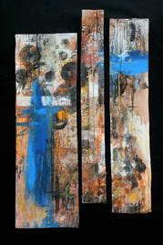

2. Add Movement Lines!!--- bring the viewers eye to the focal point using movement lines. Use thin acrylic paint lines, oil pastel, charcoal, or large paper lines to add these lines. Lines can be vertical/ horizontal, strait, organic, curvilinear, scumbling, etc. | 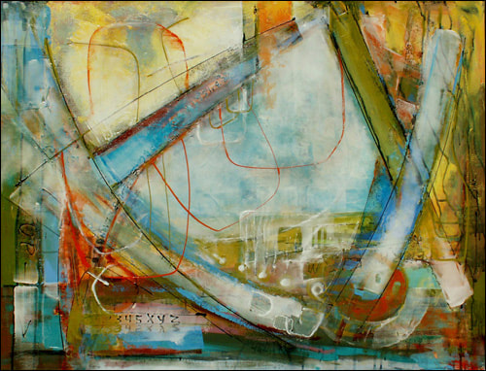

3. Masking Tape Lines!!--- These lines bring another layer and it can lead the viewers eye to the focal point. You can use colored tape, manilla, color over the manilla, or paint over the masking tape and then remove it to leave the negative space. | 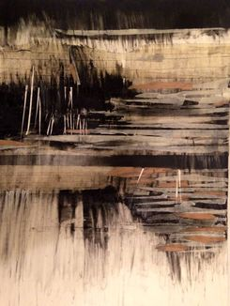

4. Add Text!!--- Using text can add a focal point, fill in some negative space, work as a movement line to the focal point, add texture to your background, or provide more meaning within the work itself. You can choose to add text with charcoal, pen, acrylic paint, or collaged onto the background. | 