Student Name:
Lesson: Wheel Throwing BOWL or VASE
Circle the number in pencil that best shows how well you feel that you completed that criterion for the assignment. |  | Excellent | Good | Average | Needs Improvement
Criteria 1 – Bowl or Vase Form: Students have successfully made an even bowl or vase with even thickness. Walls are not too thick. |  | 10 | 9 – 8 | 7 | 6 or less
Criteria 2 – Interior base: students have compressed the clay at the base (no cracks.) The interior base is flattened and even. |  | 10 | 9 – 8 | 7 | 6 or less
Criteria 3 – Foot/ Trimming: students have successfully trimmed the excess clay to enhance the curve of the bowl or vase. A foot has been added and evenly trimmed. |  | 10 | 9 – 8 | 7 | 6 or less
Criteria 4 – Glazing/ Surfacing: Creative, well-thought out glazing and/or surfacing techniques applied with good craftsmanship. Even coats of glaze. Glaze enhances the form. (no glaze on bottom of the form) |  | 10 | 9 – 8 | 7 | 6 or less
Criteria 5 – Effort: took time to develop idea & complete project? (Didn’t rush.) Good use of class time? |  | 10 | 9 – 8 | 7 | 6 or less
Criteria 6 – Craftsmanship – Neat, clean & complete? Skillful use of the art tools & media? |  | 10 | 9 – 8 | 7 | 6 or less
Total: 60  (possible points) | Grade:
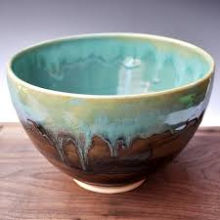

Student Name:
Lesson: Wheel Throwing BOWL or VASE
Circle the number in pencil that best shows how well you feel that you completed that criterion for the assignment. |  | Excellent | Good | Average | Needs Improvement
Criteria 1 – Bowl or Vase Form: Students have successfully made an even bowl or vase with even thickness. Walls are not too thick. |  | 10 | 9 – 8 | 7 | 6 or less
Criteria 2 – Interior base: students have compressed the clay at the base (no cracks.) The interior base is flattened and even. |  | 10 | 9 – 8 | 7 | 6 or less
Criteria 3 – Foot/ Trimming: students have successfully trimmed the excess clay to enhance the curve of the bowl or vase. A foot has been added and evenly trimmed. |  | 10 | 9 – 8 | 7 | 6 or less
Criteria 4 – Glazing/ Surfacing: Creative, well-thought out glazing and/or surfacing techniques applied with good craftsmanship. Even coats of glaze. Glaze enhances the form. (no glaze on bottom of the form) |  | 10 | 9 – 8 | 7 | 6 or less
Criteria 5 – Effort: took time to develop idea & complete project? (Didn’t rush.) Good use of class time? |  | 10 | 9 – 8 | 7 | 6 or less
Criteria 6 – Craftsmanship – Neat, clean & complete? Skillful use of the art tools & media? |  | 10 | 9 – 8 | 7 | 6 or less
Total: 60  (possible points) | Grade:

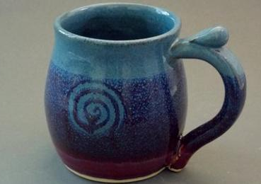
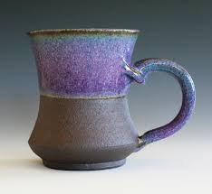

Student Name:
Lesson: Wheel Throwing MUG
Circle the number in pencil that best shows how well you feel that you completed that criterion for the assignment. |  | Excellent | Good | Average | Needs Improvement
Criteria 1 – Mug Form: Students have successfully made an even bowl or vase with even thickness. Walls are not too thick. students have compressed the clay at the base (no cracks.) The interior base is flattened and even. |  | 10 | 9 – 8 | 7 | 6 or less
Criteria 2 – Mug Handle: students have used one of the handle techniques to successfully create a handle to match the form of the mug. The handle feels comfortable in the grip. Handle is attached properly, no cracks or breaks. |  | 10 | 9 – 8 | 7 | 6 or less
Criteria 3 – Foot/ Trimming: students have successfully trimmed the excess clay to enhance the curve of the bowl or vase. A foot has been added and evenly trimmed. |  | 10 | 9 – 8 | 7 | 6 or less
Criteria 4 – Glazing/ Surfacing: Creative, well-thought out glazing and/or surfacing techniques applied with good craftsmanship. Even coats of glaze. Glaze enhances the form. (no glaze on bottom of the form) |  | 10 | 9 – 8 | 7 | 6 or less
Criteria 5 – Effort: took time to develop idea & complete project? (Didn’t rush.) Good use of class time? |  | 10 | 9 – 8 | 7 | 6 or less
Criteria 6 – Craftsmanship – Neat, clean & complete? Skillful use of the art tools & media? |  | 10 | 9 – 8 | 7 | 6 or less
Total: 60  (possible points) | Grade:

Student Name:
Lesson: Wheel Throwing MUG
Circle the number in pencil that best shows how well you feel that you completed that criterion for the assignment. |  | Excellent | Good | Average | Needs Improvement
Criteria 1 – Mug Form: Students have successfully made an even bowl or vase with even thickness. Walls are not too thick. students have compressed the clay at the base (no cracks.) The interior base is flattened and even. |  | 10 | 9 – 8 | 7 | 6 or less
Criteria 2 – Mug Handle: students have used one of the handle techniques to successfully create a handle to match the form of the mug. The handle feels comfortable in the grip. Handle is attached properly, no cracks or breaks. |  | 10 | 9 – 8 | 7 | 6 or less
Criteria 3 – Foot/ Trimming: students have successfully trimmed the excess clay to enhance the curve of the bowl or vase. A foot has been added and evenly trimmed. |  | 10 | 9 – 8 | 7 | 6 or less
Criteria 4 – Glazing/ Surfacing: Creative, well-thought out glazing and/or surfacing techniques applied with good craftsmanship. Even coats of glaze. Glaze enhances the form. (no glaze on bottom of the form) |  | 10 | 9 – 8 | 7 | 6 or less
Criteria 5 – Effort: took time to develop idea & complete project? (Didn’t rush.) Good use of class time? |  | 10 | 9 – 8 | 7 | 6 or less
Criteria 6 – Craftsmanship – Neat, clean & complete? Skillful use of the art tools & media? |  | 10 | 9 – 8 | 7 | 6 or less
Total: 60  (possible points) | Grade:

