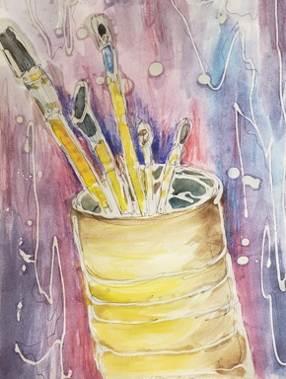
Watercolor Batik

--------------------------------------------------------------

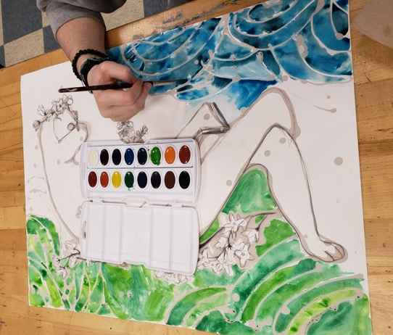
STEPS TO FOLLOW:
- Set up a simple still life using at least 3 items.
- Draw out the still life with contour/continuous contour line.
- Flip over the paper and draw one more option on the back side.
- Next, you will trace over your line with melted wax using the tjanting tools. (see Mrs. Denison’s demo)
- After you have applied the wax, you will use watercolor and colored pencil to add color to the batik.
- Once all the color has been added, you will melt out the wax using an iron and newsprint paper. (see demo)
- Finally, you may add additional lines with sharpie or colored pencil.

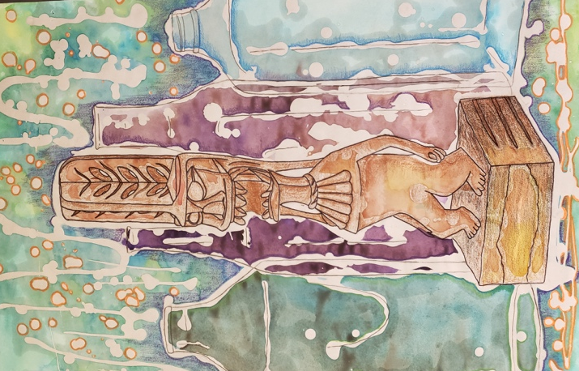

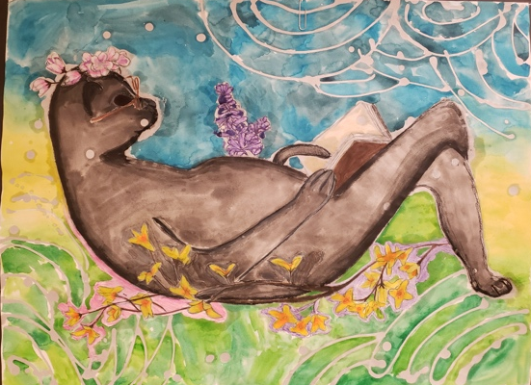

Student Name:  Lesson: Watercolor Batik |  |  | Class Period:
Circle the number that best shows how well you feel that you completed that criterion for the assignment. |  | Excellent | Good | Average |  | Needs Improvement
Criteria 1 – Composition; Students picked a subject matter that filled the page and created an interesting area of focus. |  | 10 | 9 – 8 | 7 |  | 6 or less
Criteria 2 – Color: Students successfully used watercolor and colored pencil creating unity throughout the composition with their choice of colors and application. |  | 10 | 9 – 8 | 7 |  | 6 or less
Criteria 3 – Values: students successfully created depth within the composition by adding darker and lighter areas of shading with either watercolor or colored pencil. |  | 10 | 9 – 8 | 7 |  | 6 or less
Criteria 4 – Effort: took time to develop idea & complete project? (Didn’t rush.) Good use of class time? |  | 10 | 9 – 8 | 7 |  | 6 or less
Criteria 5 – Craftsmanship – Neat, clean & complete? Skillful use of the art tools & media? |  | 10 | 9 – 8 | 7 |  | 6 or less
Total: 50  (possible points) | Grade: /50 =

