Final Study Guide:

For the final, you need to be able to name a 12-step color wheel:

Be able to explain the various color schemes:

1. Monochromatic
2. Analogous
3. Complementary

Explain tint vs. shade

Tell what each color complement pair is

Be able to define the elements of design:

1. Line
2. Shape
3. Value
4. Color
5. Space
6. Texture
7. Form

Be able to explain the following:

1. Contour Drawing
2. Blind Contour Drawing
3. View Finder
4. Thumbnail Sketches
5. Contrapposto

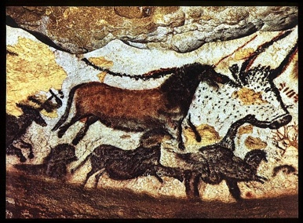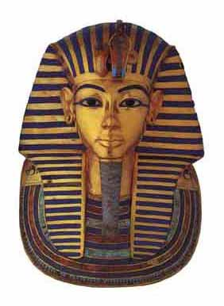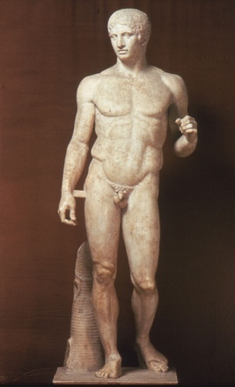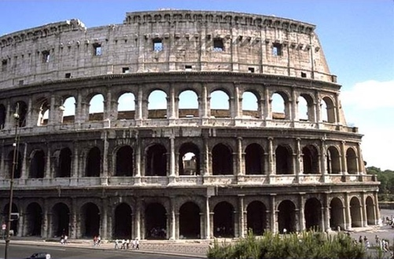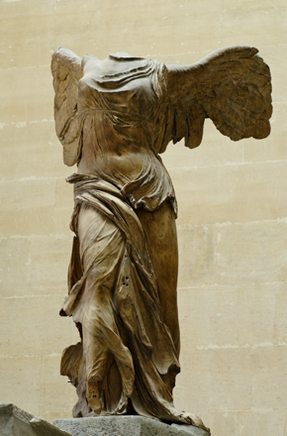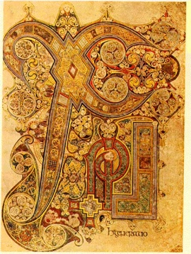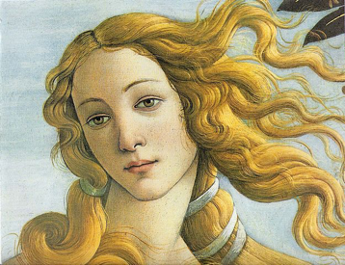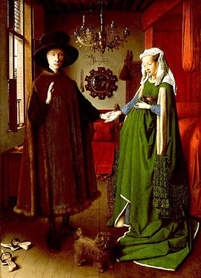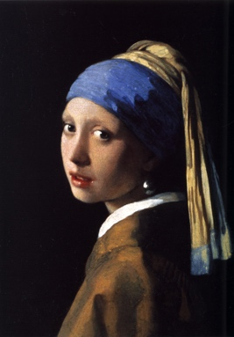Be able to put these pictures in the proper time period:

1. Prehistoric
2. Egyptian
3. Greek
4. Roman
5. Early Christian
6. Byzantine
7. Medieval
8. Gothic
9. Early Renaissance
10. High Renaissance
11. Northern Renaissance
12. Baroque