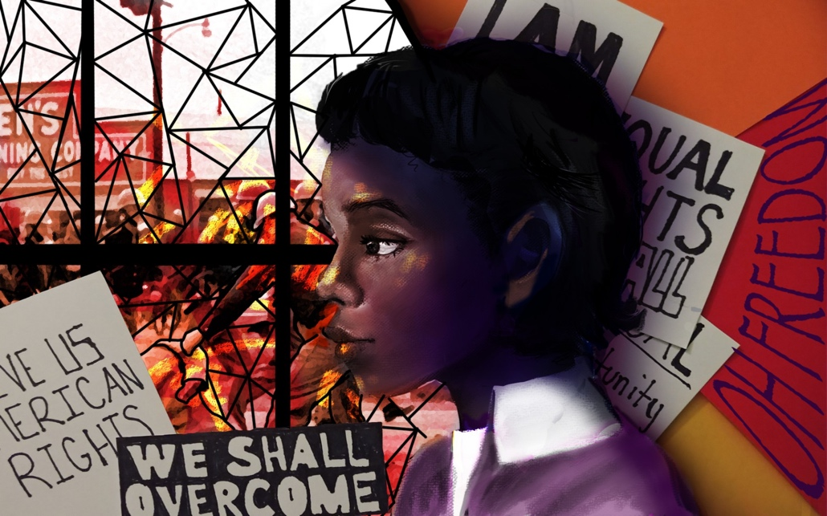

**Objective: Students will create an artwork for the ArtEffect Competition** <https://www.lowellmilkencenter.org/competitions/arteffect-project>

**Criteria for Judging:**

**Creative Interpretation of the Unsung Hero’s Story**Finished work demonstrates thoughtful, self-directed and independent ideas that are personally relevant in exploring visually how the Unsung Hero created positive change in history by improving the lives of others through their actions.

**Project Quality**The student’s mastery of the subject is apparent in the concept, composition and execution of the work, and reveals a sense of quality, attention to detail and time spent on the work. The final product demonstrates an understanding of and expertise in the medium being used and its capabilities.

**Project Impact**The project’s design and execution demonstrates an intent to share the Unsung Hero’s story widely in order to raise awareness and create positive community impact. The student has documented the reach of his/her project in a clear and compelling manner.

The Lowell Milken Center for Unsung Heroes works with students and educators across diverse academic disciplines to develop history projects that highlight role models who demonstrate courage, compassion and respect. Through our unique [project-based learning](https://lowellmilkencenter.org/project-based-learning/) approach, students discover, develop and communicate the stories of Unsung Heroes who have made a profound and positive impact on the course of history. By championing these Unsung Heroes, students, educators and communities discover their own power and responsibility to effect positive change in the world

**Unsung Heroes Portrait**

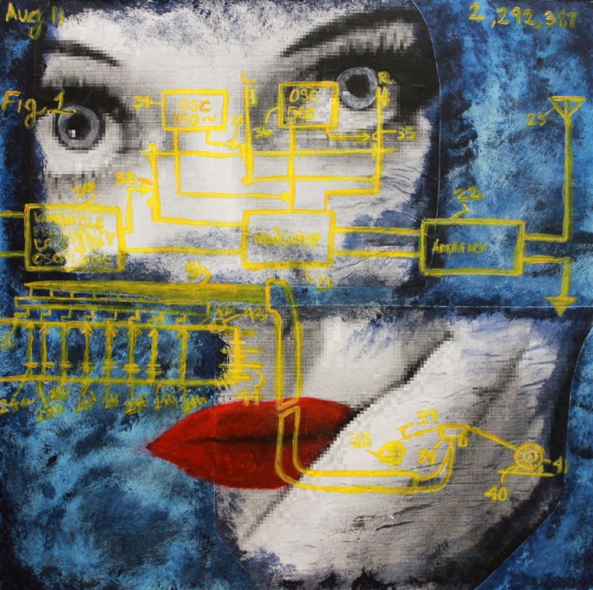

Don’t have the right body positioning? Use your classmates to pose for you and take a photo to help with proportions.

**Your choice of media is up to you!**

**You must include some collage surface manipulation. (see mrs. Denison’s demo)**

**You must include a portrait that is a likeness of your chosen hero.**

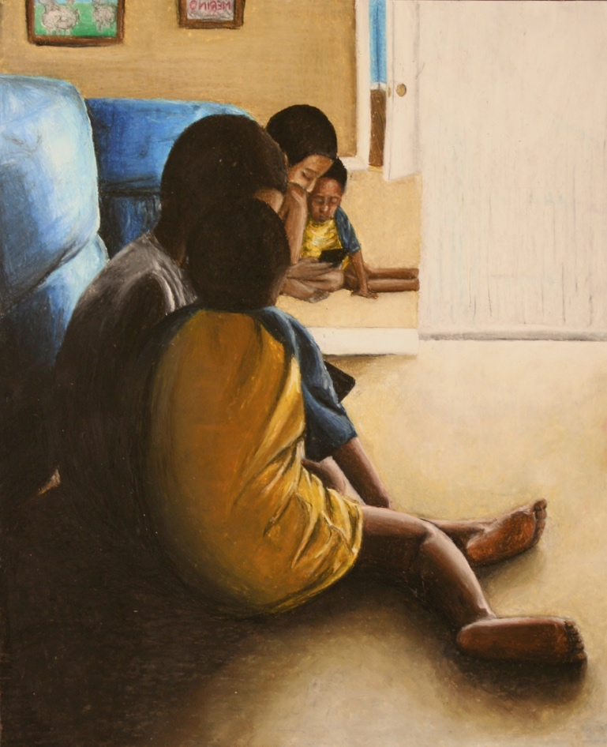

**Your choice of media is up to you!**

**You must include some collage surface manipulation. (see Mrs. Denison’s demo)**

**You must include a portrait that is a likeness of your chosen hero.**

Proportions in Portraits are Important!!!

Be sure to get a good photograph of the person you will use in your image. If YOU take the photograph it is better so that you do not have to deal with copyright infringement.

If you cannot take the photo yourself, perhaps use a friend to help you model the action of the body of your hero. Take a photo and use that image for best proportions.—see samples

Objective:

You will create a portrait based on a hero around you. This can be any hero of your choosing. Their act of heroism can be simple, yet meaningful.

This image will be for this year’s PTSA Reflections competition: <http://www.georgiapta.org/reflections/>

**PTSA Reflections: “Heroes around Me”---Portrait**

