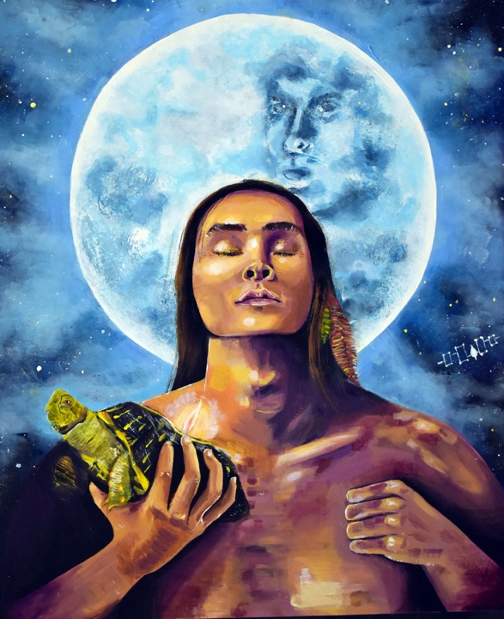
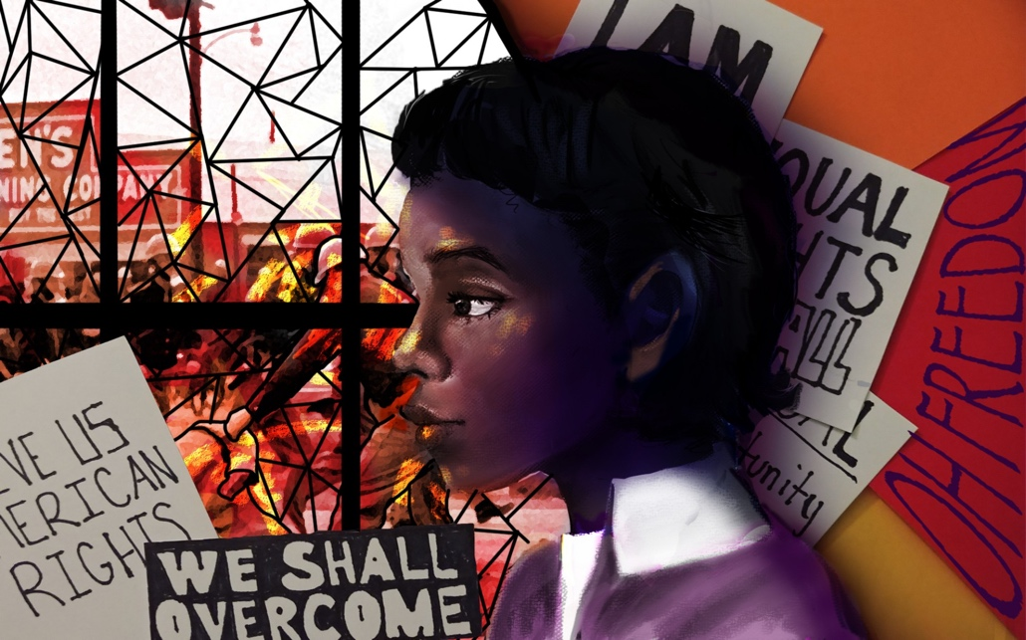
Your choice of media is up to you!

You must include some collage surface manipulation. (see Mrs. Denison’s demo)

You must include a portrait that is a likeness of your chosen hero.

Don’t have the right body positioning? Use your classmates to pose for you and take a photo to help with proportions.
Unsung Heroes Portrait
The Lowell Milken Center for Unsung Heroes works with students and educators across diverse academic disciplines to develop history projects that highlight role models who demonstrate courage, compassion and respect. Through our unique project-based learning approach, students discover, develop and communicate the stories of Unsung Heroes who have made a profound and positive impact on the course of history. By championing these Unsung Heroes, students, educators and communities discover their own power and responsibility to effect positive change in the world
Objective: Students will create an artwork for the ArtEffect Competition https://www.lowellmilkencenter.org/competitions/arteffect-project
Criteria for Judging:
Creative Interpretation of the Unsung Hero’s Story
Finished work demonstrates thoughtful, self-directed and independent ideas that are personally relevant in exploring visually how the Unsung Hero created positive change in history by improving the lives of others through their actions.
Project Quality
The student’s mastery of the subject is apparent in the concept, composition and execution of the work, and reveals a sense of quality, attention to detail and time spent on the work. The final product demonstrates an understanding of and expertise in the medium being used and its capabilities.
Project Impact
The project’s design and execution demonstrates an intent to share the Unsung Hero’s story widely in order to raise awareness and create positive community impact. The student has documented the reach of his/her project in a clear and compelling manner.

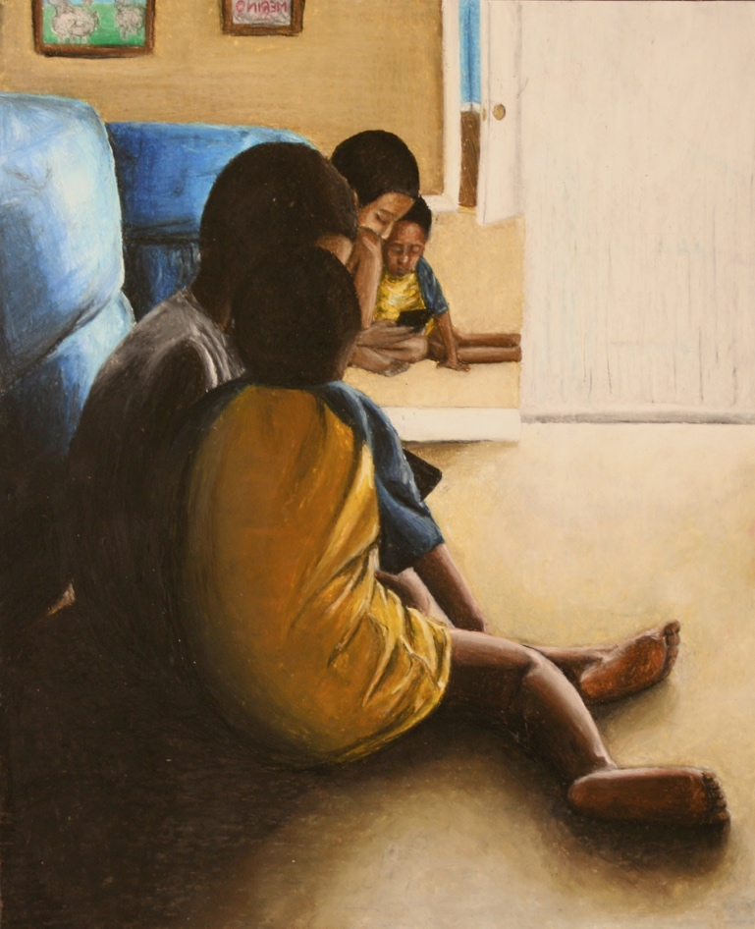
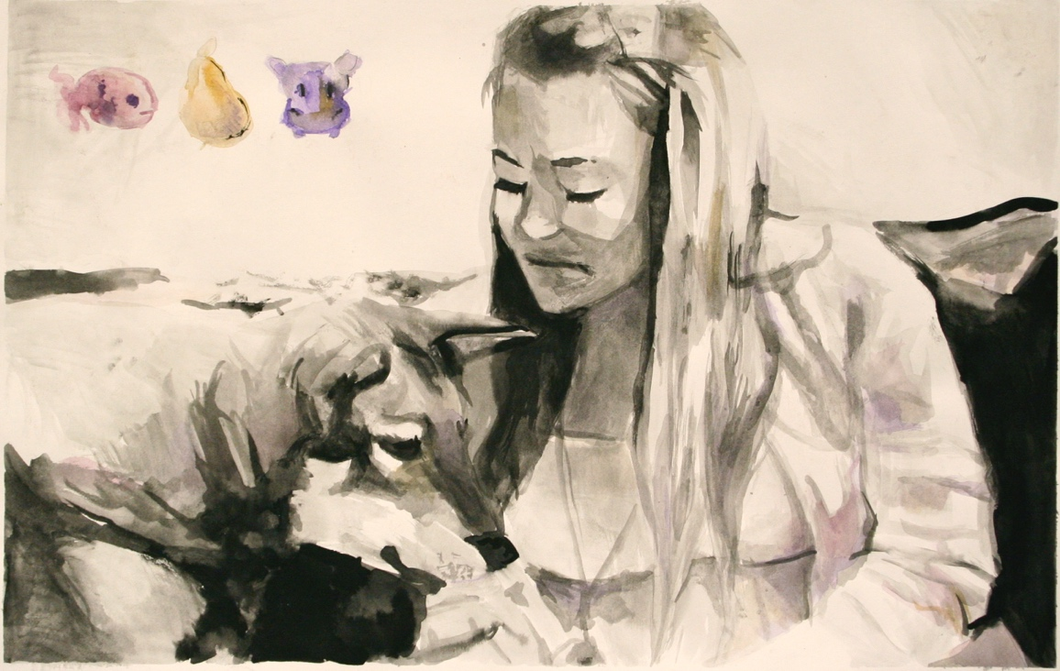
Proportions in Portraits are Important!!!
Be sure to get a good photograph of the person you will use in your image. Think about interesting angles/ foreshortening when you take your photograph.

Objective:
They say that humans spend 95% of their lives in uneventful moments, but we as humans usually document the only the most eventful moments such as, birthdays, graduations, births, and special occasions. As artist, we have the opportunity to make these ordinary moments extraordinary. Looking at human nature can be very interesting if you choose to look closely. You will create a figurative work based on a simplistic time in a friend or family member’s life. The overall goal is to connect the viewer with the person represented in the work.
- One completed intimate portrait of a friend or family member. ¾ to full body portrait. This work should represent the person in a personal way.
- Students should create a unique source of light or innovative color use.

Intimate Portrait: A look at human behavior

Your choice of media is up to you!

You must include some collage surface manipulation. (see Mrs. Denison’s demo)

You must include a portrait that is either full body or ¾ of a person.

Amos Bronson Alcott – American teacher, writer, philosopher, and reformer who pioneered new ways of interacting with young students that avoided traditional punishment.
Cher Ami – Pigeon that saved over 200 soldier’s lives during WWI by transporting a message tied to her leg through enemy territory.
Virginia Apgar – American obstetrical anesthesiologist, best known as the inventor of the Apgar score, a way to quickly assess the health of a newborn child immediately after birth.
Katherine Buckner Avery – Nurse who broke social boundaries to improve rural health care in Louisiana.
Karl Ernst von Baer - Estonian scientist who contributed greatly to the establishment of the field of embryology, including Baer's laws of embryology, upon which Charles Darwin based much of his research on evolution.
Mary Bickerdyke – Civil war nurse who revolutionized wartime medical care and built almost 300 field hospitals with the help of U.S. Sanitary Commission agents.
Emily Newell Blair – American writer, suffragist and feminist in Carthage, Missouri, who co-founded the League of Women Voters and eventually became the national vice chairman of the Democratic Party.
Dorothy Buell – An American educator and nature preservationist who became the founder and first president of the Save the Dunes council, a nonprofit group dedicated to preserving the Dunelands along Lake Michigan.
Eugene Wilson Caldwell – Electrical engineer, physician and inventor credited with major developments in the science of diagnostic radiology.
Joshua Chamberlain – American college professor best known for his heroic participation in the Battle of Gettysburg.
Jerrie Cobb - American female aviator and member of the Mercury 13 group of women selected to undergo physiological screening tests at the same time as the original Mercury Seven astronauts, as part of a private, non-NASA program.
Will Counts – American photojournalist most renowned for drawing the nation's attention to the desegregation crisis that was happening in 1957 at Little Rock Central High School in Little Rock, Arkansas.
Emma Darling Cushman – American nurse who saved the lives of thousands of Armenian children during the Armenian genocide.
Jonathan Daniels – Episcopal seminarian and civil rights activist who was assassinated in 1965.
Annie Divine – Civil rights activist who made instrumental contributions to what would eventually become the Voting Rights Act of 1965.
Dr. Gunnar Dybwad – Important supporter of self-advocacy movement for education rights of the mentally handicapped.
Jane Elliott – American educator and social activist who created and promoted the “Blue eyes-Brown eyes” experiment in response to the assassination of Martin Luther King, Jr. to teach her students about discrimination and racism that became a transformative teaching tool.
Mitsuye Endo – Woman who challenged Japanese-American internment during WWII until it was ultimately ended by the United States Supreme Court in 1945.
Olaudah Equiano – Freed slave active in the abolitionist movement in England and influential in passage of the Abolition of the Slave Trade Act 1807.
Therese Frare – Photojournalist credited with capturing the image that “changed the face of AIDS” that ran on a 1990 cover of LIFE magazine.
Frederick III, Elector of Saxony – One of the first notably ardent supporters of Martin Luther, whom he hid in the aftermath of the Diet of Worms, giving Luther time to translate the Bible into German, which would eventually lead to the breakup of Catholic hegemony in Europe.
Sarah Bradlee Fulton – One of the first female spies for George Washington during the Revolutionary War, she played a critical role in the fight for freedom.
Kadambini Ganguly – The first Indian-educated woman to become a doctor, Kadambini Ganguly was also a social activist and one of India’s first female college graduates.
Sister Matylda Getter – Polish Catholic nun and member of the Żegota resistance organization, which in saved the lives of hundreds of Jewish children from the Warsaw Ghetto in WWII.
Elizabeth Jennings Graham - 19th century teacher and civil rights figure, Graham insisted on her right to ride on an available New York City streetcar at a time when all such companies were private and most operated segregated cars.
U.S. Colonel Gail Halvorsen – An accomplished United States military pilot known as the Berlin Candy Bomber during WWII because he organized operations that dropped candy from miniature parachutes to German children during the Berlin Airlift from 1948 to 1949.
Alice Seeley Harris – An English missionary and an early documentary photographer whose work helped to expose the human rights abuses in the Congo.
Douglas Hegdahl - A United States Navy sailor who was a prisoner of war during the Vietnam War. After his early release by North Vietnam, upon returning to the United States, he was able to provide the names and personal information of other POWs as well as revealing the conditions in the prison camp.
Aiko Herzig-Yoshinaga – Woman who discovered the government report that re-opened three Supreme Court cases and led to Congress approving reparations for Japanese-Americans relocated to internment camps during WWII.
Hiawatha – Pre-colonial Mohawk chief of the Onandaga, attributed with uniting the five northern Iroquois tribes into the Iroquois confederacy.
Andrew Jackson Higgins – American shipbuilder created the WWII “Higgins boat” that gave Allied forced a wartime advantage.
Lewis Hine – Accomplished American photographer and child labor activist.
Lt. Colonel Tran Ngoc Hue – Former lieutenant colonel with the 1st Infantry Division Army of the Republic of Vietnam who received the Silver Star, the American military’s highest award for heroism on the battlefield for aiding American soldiers in the Vietnam War.
Jigonhsasee – An influential figure in the establishment of the Iroquois confederacy.
Florence Kelley – Influential child labor rights activist in the late 1800s who was the first Executive Secretary of the National Consumers League.
Frances Kelsey – Pharmacologist and physician who, as a reviewer for the FDA, refused to authorize a birth defect-inducing drug.
Noor Inayat Khan - was a wartime British secret agent of Indian descent, first female radio operator sent into Nazi-occupied France by the S.O.E.
Horace King – Born a slave in 1807 in South Carolina, considered the most respected bridge builder of the 19th century Deep South.
Sofia Kovalevskaya – The first major Russian female mathematician and one of the first women to work as editor for a scientific journal.
Hedy Lamar – An Austrian-born American film actress and inventor who helped invent radio technology to combat Nazis in WWII.
Dorothea Lange – Depression-era American documentary photographer and photojournalist.
Ralph Lazo – Only known non-spouse, non-Japanese American teen who voluntarily relocated to a World War II Japanese internment camp, Manzanar, to protest the war practice.
Eugene Lazowski – Doctor who saved over 8,000 Polish Jews during WWII by injecting them with a vaccine that mimicked typhus so that the Nazis quarantined them, rather than deporting them to concentration camps.
Huddie “Lead belly” Ledbetter – Influential American folk and blues musician.
Henrietta Swan Leavitt - American astronomer who discovered the relation between the luminosity and the period of Cepheid variable stars. Though she received little recognition in her lifetime, it was her discovery that first allowed astronomers to measure the distance between the Earth and faraway galaxies.
Justus von Liebig – German chemist who made major contributions to agricultural and biological chemistry, and was considered the founder of organic chemistry.
John Lomax – American teacher, pioneering musicologist, and folklorist who did much for the preservation of American folk music.
Curt Lowens – Polish-born Holocaust survivor who helped save 100 Jewish children as a member of the Dutch resistance. He also rescued two downed American airmen and served as an interpreter during WWII. After the wars end, he became an actor in America.
Clara Luper – Civil rights activist and teacher in Oklahoma City and pioneer of integration in the 1950's.
Sylvia Mendez – Civil rights activist whose landmark 1946 desegregation case paved the way for Brown vs. Board of Education.
Meva Mikusz – Teenage Polish girl who rescued and raised two-year-old girl from the Czortkow Ghetto in 1942 during WWII.
Inez Milholland - Important figure in women’s suffrage movement, who led a march of 8,000 suffragettes in 1913 and continued fighting for the right to vote until her untimely death in 1916.
Lilla Day Monroe – 19th century journalist and suffragette who fought for voting rights in Kansas.
William Lewis Moore – Postal worker and Congress of Racial Equality member who staged lone protests against racial segregation.
Pauli Murray – An American civil rights activist who made a large impact on the women's rights movement as a lawyer, Episcopal priest and author.
Muhammad ibn Musa Al-Khwarizmi – Considered father of algebra and grandfather of computer science and oversaw the translation of Greek and Indian mathematical and astronomical works, preserving them through the European dark ages.
Rosli Naf – Swiss Red Cross nurse, notable for taking great risks to save the lives of 90 Jewish children from Nazi-controlled France during WWII.
Robert Nesbit – Head of pulpit committee of the Ebenezer Baptist Church where Dr. Martin Luther King Jr. was reverend minister from 1960 until his assassination.
Jan Opletal – Activist who catalyzed widespread student activism and served as a model for Nazi defiance in 1930s.
Emmeline Pankhurst – British political activist and leader of the British suffragette movement who helped women win the right to vote.
Kendall Reinhardt – A student in 1957 at Central High School in Little Rock, Arkansas, who befriended and stood up for members of the Little Rock Nine, the group of black students who attempted to attend classes to desegregate the school, but were at first barred from entering.
Bernice Sandler – American women's rights activist known for being instrumental in the creation of Title IX.
Abdol Hossein Sardari - Iranian diplomat credited with saving thousands of Jews in Europe. Referred to as the, "Schindler of Iran".
Irena Sendler – A polish social worker during WWII who saved 2,500 Jewish children from the Nazis by smuggling them out of the Warsaw Ghetto between 1942 and 1943. Arranging for safe hiding places and families to adopt them.
Elizabeth Horton Sheff – Civil rights activist who led a lawsuit to rectify educational inequities between urban/suburban schools.
Adam Shoemaker – Minister and teacher of Abraham Lincoln credited with influencing the future president’s anti-slavery stance.
Gene Shoemaker – An esteemed scientist and astronomer who founded astrogeology, Gene Shoemaker is the only person to date whose ashes have been buried on the moon.
Walter Sommers – World War II veteran who helped desegregate lunch counters at the height of the Civil Rights Movement.
John Snow – Public heath advocate from the 19th century who played a major role in containing the 1854 Cholera outbreak in London.
Anna Smith Strong – Only female member of George Washington's Culper Spy Ring during the American Revolution.
Sergeant Stubby – Dog that is the most decorated animal in American military history.
Helen Taussig – American doctor who is the founder of pediatric cardiology.
Vivien Thomas - an American laboratory supervisor who developed a procedure used to treat blue baby syndrome in the 1940s
Sheyann Webb – Known as the “smallest freedom fighter,” when she was 8-years-old during the civil rights movement she joined Martin Luther King Jr. in the march from Selma to Montgomery, Alabama known as Bloody Sunday.
Pavel Weiner – A young boy incarcerated at the Terezin concentration camp who confronted adversity through secret newspapers during WWII.
Elizabeth "Tex" Williams - American photographer and first female graduate of the Photographic Division School at Fort Monmouth, NJ as a member of Women’s Army Corp in 1944, who became an official army photographer during WWII.
Frances Elizabeth Williams – American actress, activist, organizer, and community worker, Williams was the first black woman to run for the California State Assembly in 1948 on the Progressive Ticket.
Robert R. Williams – An influential American chemist who first synthesized thiamin (vitamin B) and advocated for fortified foods to be distributed in the United States and across the globe to prevent malnutrition.
Maurice Willows - American doctor and member of Red Cross who played critical role in bringing medical aid to victims of Tulsa Race Riots of 1921.
L. Alex Wilson – A journalist during the civil rights movement whose life was put at risk when he was beaten by police trying to cover the desegregation of Central High School by the Little Rock Nine in Arkansas in 1957.
Sir Nicholas Winton - British humanitarian who arranged the rescue of 669 children, most of them Jewish, from Czechoslovakia on the eve of the WWII, finding homes for the children and facilitating their safe passage to Britain.
Jacob Valentine II – A nature activist who worked to save the Sandhill cranes population and establish Mississippi Sandhill Crane Refuge.
Minoru Yasui – Japanese orchardist who started the first Supreme Court case testing the constitutionality of Japanese internment.

