Student Name:
Lesson: Hand built Teapot based on favorite novel or literary character
Circle the number in pencil that best shows how well you feel that you completed that criterion for the assignment. |  | Excellent | Good | Average | Needs Improvement
Criteria 1 – Teapot Form: Created a successful teapot form using hand building techniques. (student has added a body, spout, knob & lid, and handle) |  | 10 | 9 – 8 | 7 | 6 or less
Criteria 2 – Literary connection: student has successfully added details or symbols to represent the book and/or literary character throughout the teapot. |  | 10 | 9 – 8 | 7 | 6 or less
Criteria 3 – Decoration/ Surfacing: Creative, well-thought out glazing and/or surfacing techniques applied with good craftsmanship. |  | 10 | 9 – 8 | 7 | 6 or less
Criteria 4 – Effort: took time to develop idea & complete project? (Didn’t rush.) Good use of class time? |  | 10 | 9 – 8 | 7 | 6 or less
Criteria 5 – Craftsmanship – Neat, clean & complete? Skillful use of the art tools & media? |  | 10 | 9 – 8 | 7 | 6 or less
Total: 50  (possible points) | Grade:
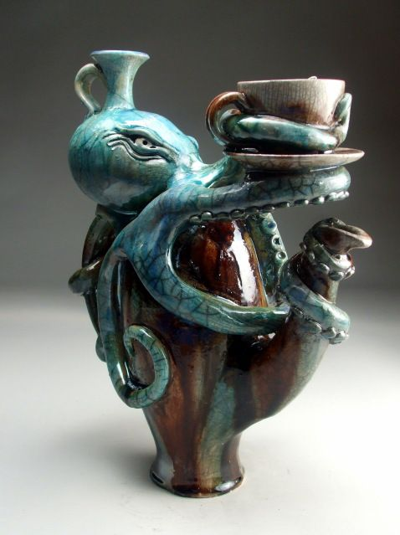
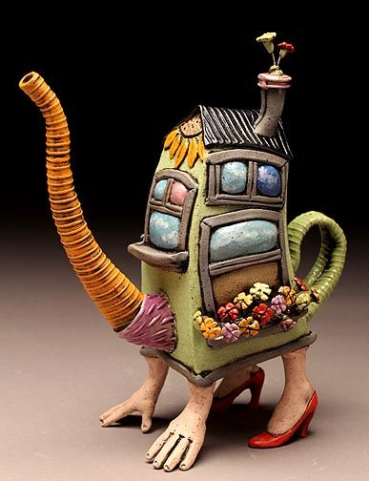
Step 1: First brainstorm about your favorite book or literary character. What are the symbols represented by that book or character? (on back)

Step 2: Next create 2-3 practice sketches of the how your teapot will look. Add practice designs on how you would like to decorate your teapot. Think about what handbuilt techniques you will use to create the teapot.

Step 3: Create the body of your teapot. Use any handbuilding technique to create the main body of your teapot.

Step 4: Next make the spout. With brush handle or chopstick, roll up a thinner sheet of clay into a tube. Rock the spout gently on a flat surface to make it look even and round. Make a few spouts to choose from.

Step 5: Knob and Lid. The knob can be any style you choose. Use a clay knife to make the lid cut and make the cut on an angle so that the lid has support and sits on the body. Cutting the lid on an angle like this removes the need for a gallery to be added to the body. The lid can be an organic shape to indicate the direction, or you can put little matching marks on the lid and body to line it up.

Step 6: Attach the spout. Hold the spout up to the body, and mark an outline around it where it will attach. Set the spout aside, then make several small strainer holes within the outlined area. Score the marked areas on the body and the spout before attaching.

Step 7: Make and attach the handle.

Step 8: Create finishing details. Focus on CRAFTSMANSHIP!!

Step 9: Dry SLOWLY. Sometimes the lid will not fit if it was separated during the drying process due to warping. It is safer to let the whole teapot dry and go through the bisque firing as one piece.

---------based on your favorite book or literary character----------------
Handbuilt Teapot

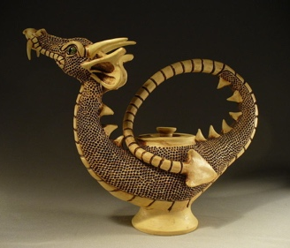
What book or character will you base your teapot on?

What are some symbols to represent that book or character?

Below, design two versions of your teapot. It needs a body, spout, knob & lid and handle.

Be sure to annotate what technique you will use for each part. (pinch pot, slab, coil, additive, subtractive, underglaze, sgraffito, textures, etc.)

