Student Name:

Lesson: Subtractive Self Portrait
Circle the number in pencil that best shows how well you feel that you completed that criterion for the assignment. |  | Excellent | Good | Average | Needs Improvement
Criteria 1 – Proportion: Accuracy of facial features. Facial features look like those from your photograph. The grid was used to get accurate detail. |  | 10 | 9 – 8 | 7 | 6 or less
Criteria 2 – Subtractive Value: Used eraser to pull out the lights of the face. Value is accurate from the photograph. (value was not created by erasing out entire areas and then drawing them back in.) |  | 10 | 9 – 8 | 7 | 6 or less
Criteria 3 – Value Details: Kneaded and detail erasers used to get accuracy of details as well as going back in with limited charcoal. |  | 10 | 9 – 8 | 7 | 6 or less
Criteria 4 – Effort: took time to develop idea & complete project? (Didn’t rush.) Good use of class time? |  | 10 | 9 – 8 | 7 | 6 or less
Criteria 5– Craftsmanship – Neat, clean & complete? Skillful use of the art tools & media? |  | 10 | 9 – 8 | 7 | 6 or less
Total: 50  (possible points) /50 pts | Grade:
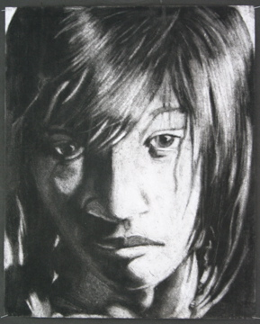
STEPS TO FOLLOW:
- First, students will completely shade a piece of white paper with black charcoal sticks.
- Next, students will grid their photograph by folding it into 16 equal sections.
- Students can then lightly grid the charcoal areas to help with proportion.
- Students will then take a large eraser and use a subtractive method to draw the lightest areas. You will “draw the light” by erasing out the brightest areas from the photograph.
- Students will attempt to only “draw with the eraser” throughout the project, focusing in on the highlights within the photograph.
- Then students will lightly erase out mid-tone areas so that much of it remains gray like that in the photograph.
- If needed, students may come back in with MINIMAL charcoal to add darker darks if needed in detail areas.
- Finally, students will grade themselves using the rubric below and turn in their final artwork, rubric and photograph, paper-clipped together and put in the class box.

---------------------- Charcoal Drawing -------------------------------------
Subtractive Portrait

