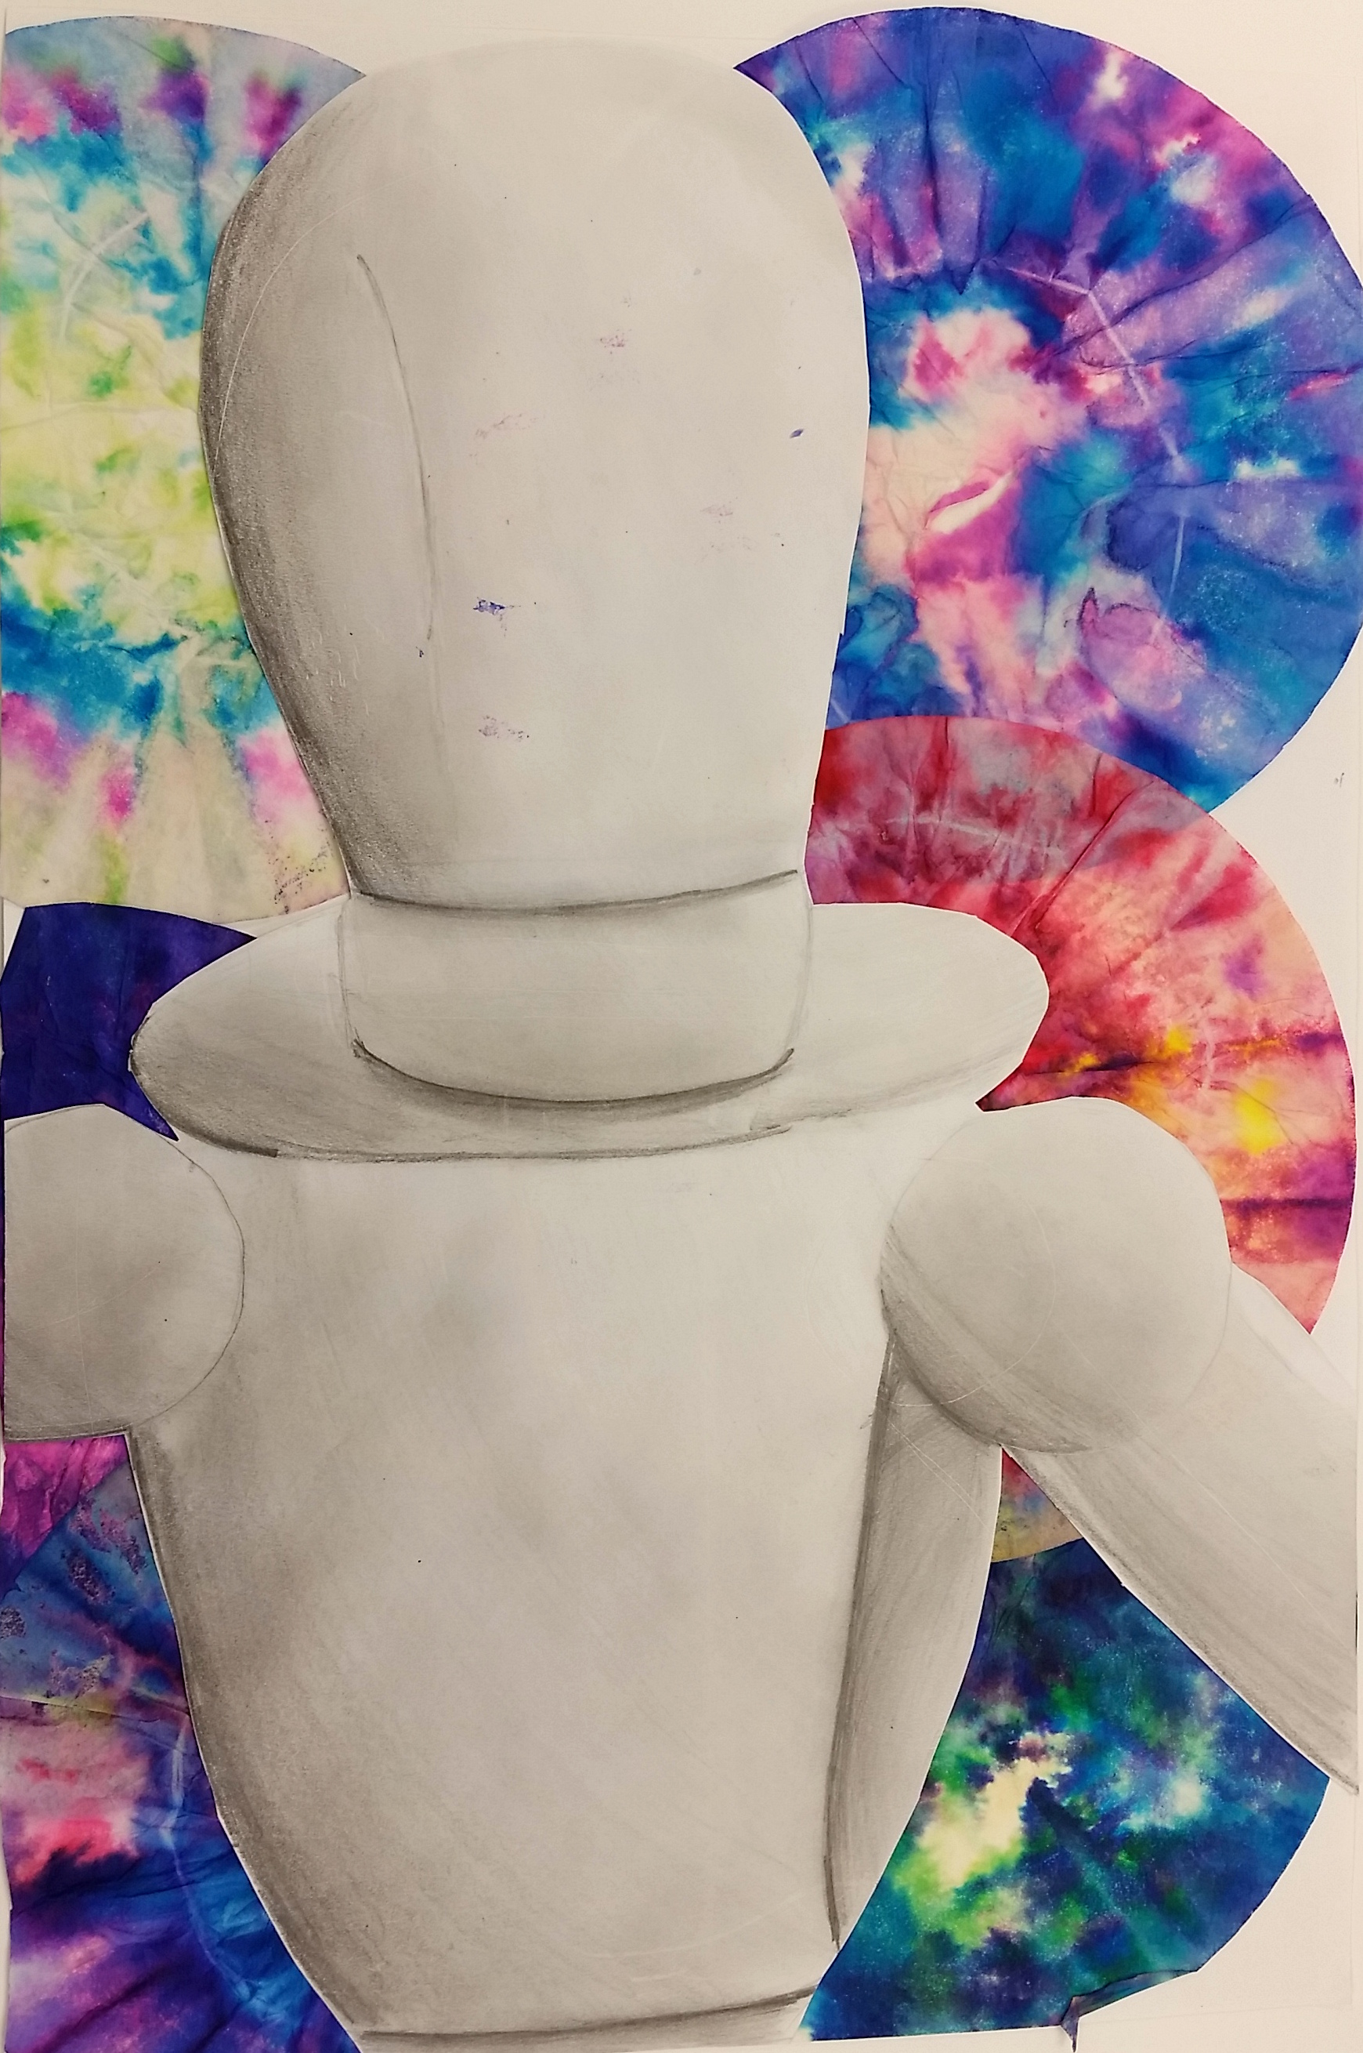
----------Skeleton / Figure Drawing-------------------------------------

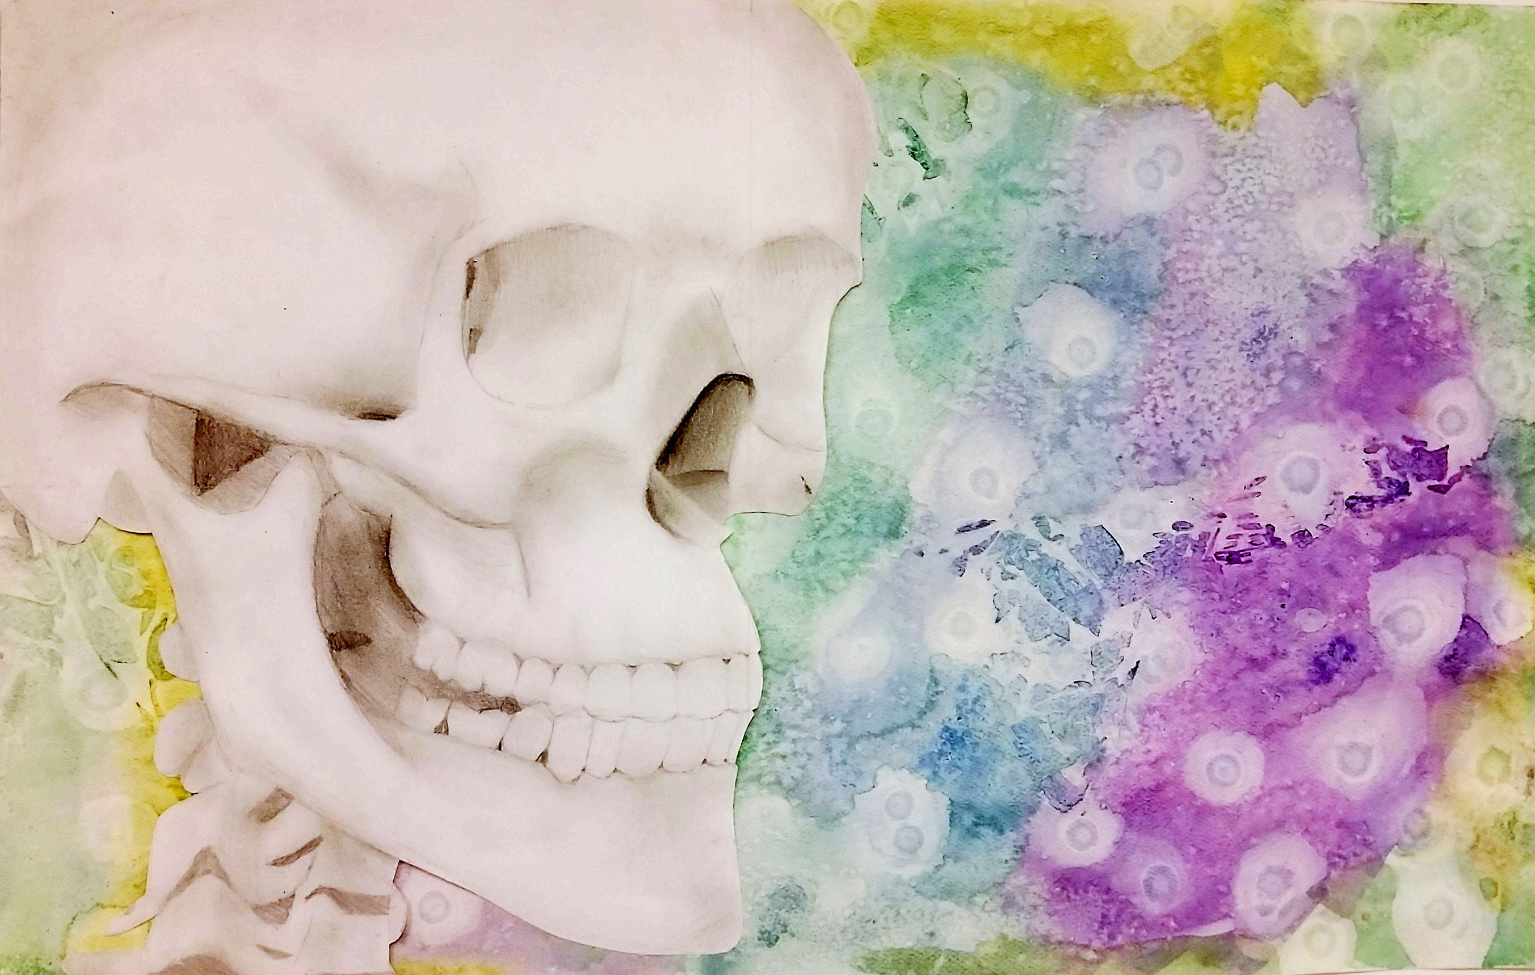
Objective: Students will create a shaded drawing, cropping in to find an interesting composition. They will place their shaded drawing onto background painted with textural techniques.

STEPS TO FOLLOW:
- Students will focus on creating an accurate contour drawing of a portion of a skeleton or drawing mannequin using a view finder.
- Next, students will add shading based on the light source within the classroom using shading pencils.
- The students will create a painted background using textural painting techniques of bubble printmaking, textured stamping, or watercolor with salts and rubbing alcohol drops.
- Students will then cut out their figure to place on the painted background surface.

Student Name:

Lesson: Value Drawings- Skeleton/Figure Drawing
Circle the number in pencil that best shows how well you feel that you completed that criterion for the assignment. |  | Excellent | Good | Average | Needs Improvement
Criteria 1 – Composition/Depth: Successful overall composition of figure. You have used a view finder to crop in and the subject goes of at least 3 sides of the paper. Subject matter well placed within the environment. |  | 10 | 9 – 8 | 7 | 6 or less
Criteria 2 – Values/ Shading: Student used a variety of values to create depth. Figure should have lights, darks, and midtones well developed within the artwork. |  | 10 | 9 – 8 | 7 | 6 or less
Criteria 3 –Proportion/Contours: Skeleton or mannequin was drawn with accurate proportions and contour lines. |  | 10 | 9 – 8 | 7 | 6 or less
Criteria 4 – Background: textures created within the background using chosen techniques. Color scheme is effective and does not take away from main subject. |  | 10 | 9 – 8 | 7 | 6 or less
Criteria 5 – Effort: took time to develop idea & complete project? (Didn’t rush.) Read the article and followed the steps within. Good use of class time? |  | 10 | 9 – 8 | 7 | 6 or less
Criteria 6 – Craftsmanship – Neat, clean & complete? Skillful use of the art tools & media? |  | 10 | 9 – 8 | 7 | 6 or less
Total: 60  (possible points) /60 pts | Grade:
