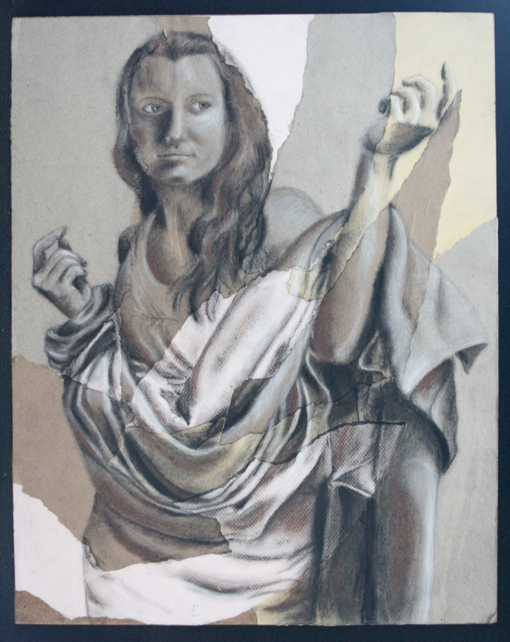
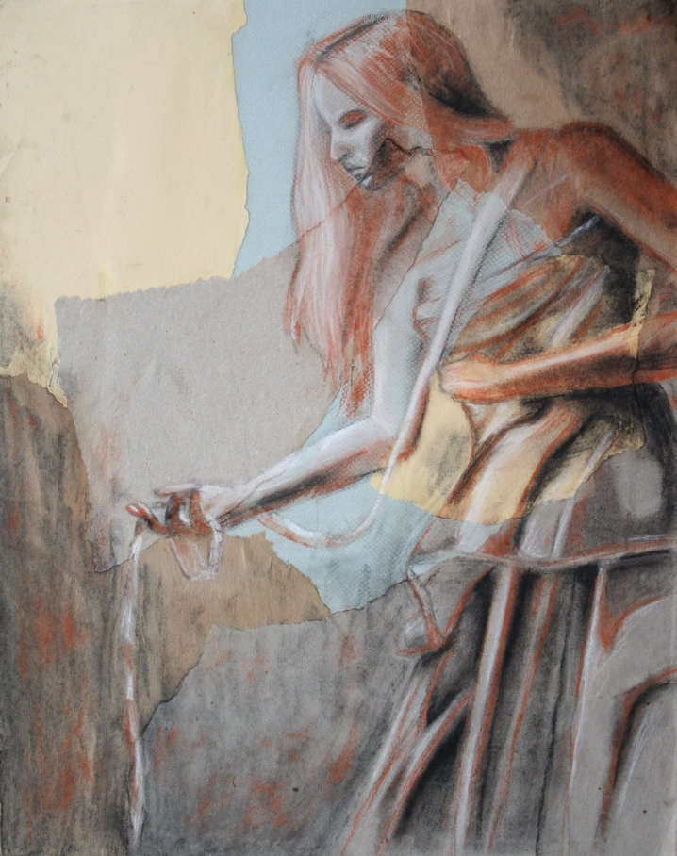
Renaissance
Requirements:
- One completed ¾ to full body self-portrait. This work should represent a renaissance pose and lighting with values.
- Strong, directional lighting with charcoal or conte crayon.
- Manipulated collage background in neutral tones.

GRADED ON:
- Overall Design/Composition
- Values/Lighting
- Craftsmanship
- Surface Manipulation

Objective:
You will create a self-portrait (full figure or ¾ figure) inspired by Renaissance portraiture. You will research the Renaissance portraits, the composition, poses, and lighting. You will need to plan out your clothing and poses and take digital images to refer to when drawing.

-----------------Self Portrait---------------

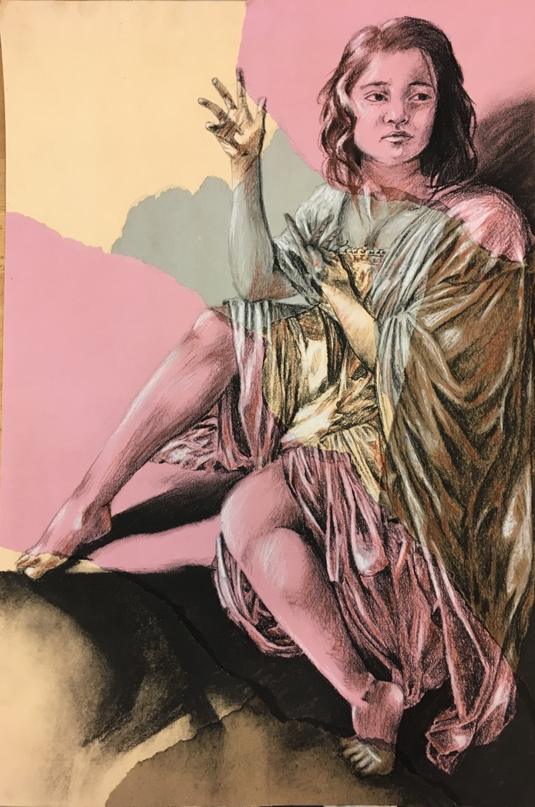
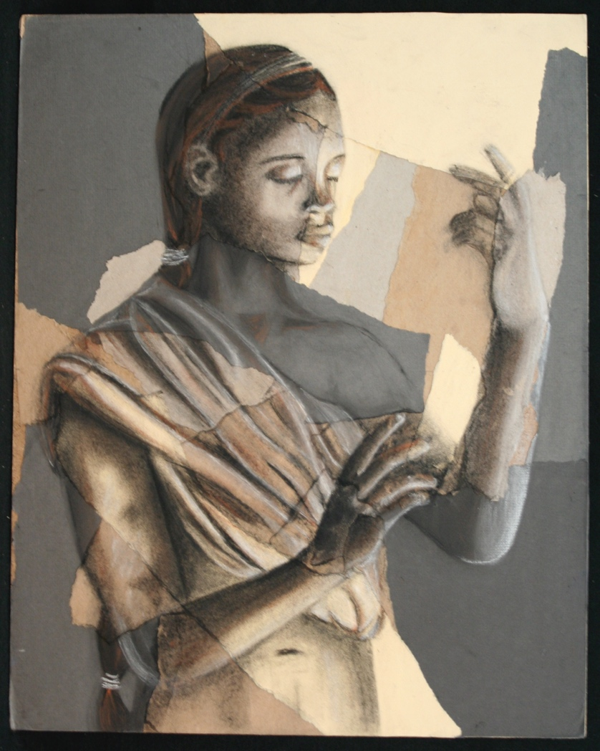
Student Name:

Lesson: Renaissance Portrait
Circle the number in pencil that best shows how well you feel that you completed that criterion for the assignment. |  | Excellent | Good | Average | Needs Improvement
Criteria 1 – Overall Design/ Composition: Overall composition includes a figure and adequately fills the negative space. Placement of figure works with the background. |  | 10 | 9 – 8 | 7 | 6 or less
Criteria 2 – Figure/proportion accuracy: Student used a photograph that they took to get proper proportions for the figure. |  | 10 | 9 – 8 | 7 | 6 or less
Criteria 3 –Values/Lighting. Student utilized the directional lighting from the photograph to have strong values of lights, mid-tones, and darks throughout the image. |  | 10 | 9 – 8 | 7 | 6 or less
Criteria 4 – Surface manipulation: Student used large, collaged papers to emphasize the figure. Papers are glued down evenly and cleanly. |  | 10 | 9 – 8 | 7 | 6 or less
Criteria 5 – Effort: took time to develop idea & complete project? (Didn’t rush.) Good use of class time? |  | 10 | 9 – 8 | 7 | 6 or less
Criteria 6 – Craftsmanship – Neat, clean & complete? Skillful use of the art tools & media? |  | 10 | 9 – 8 | 7 | 6 or less
Total: 60  (possible points) /60 pts | Grade:

