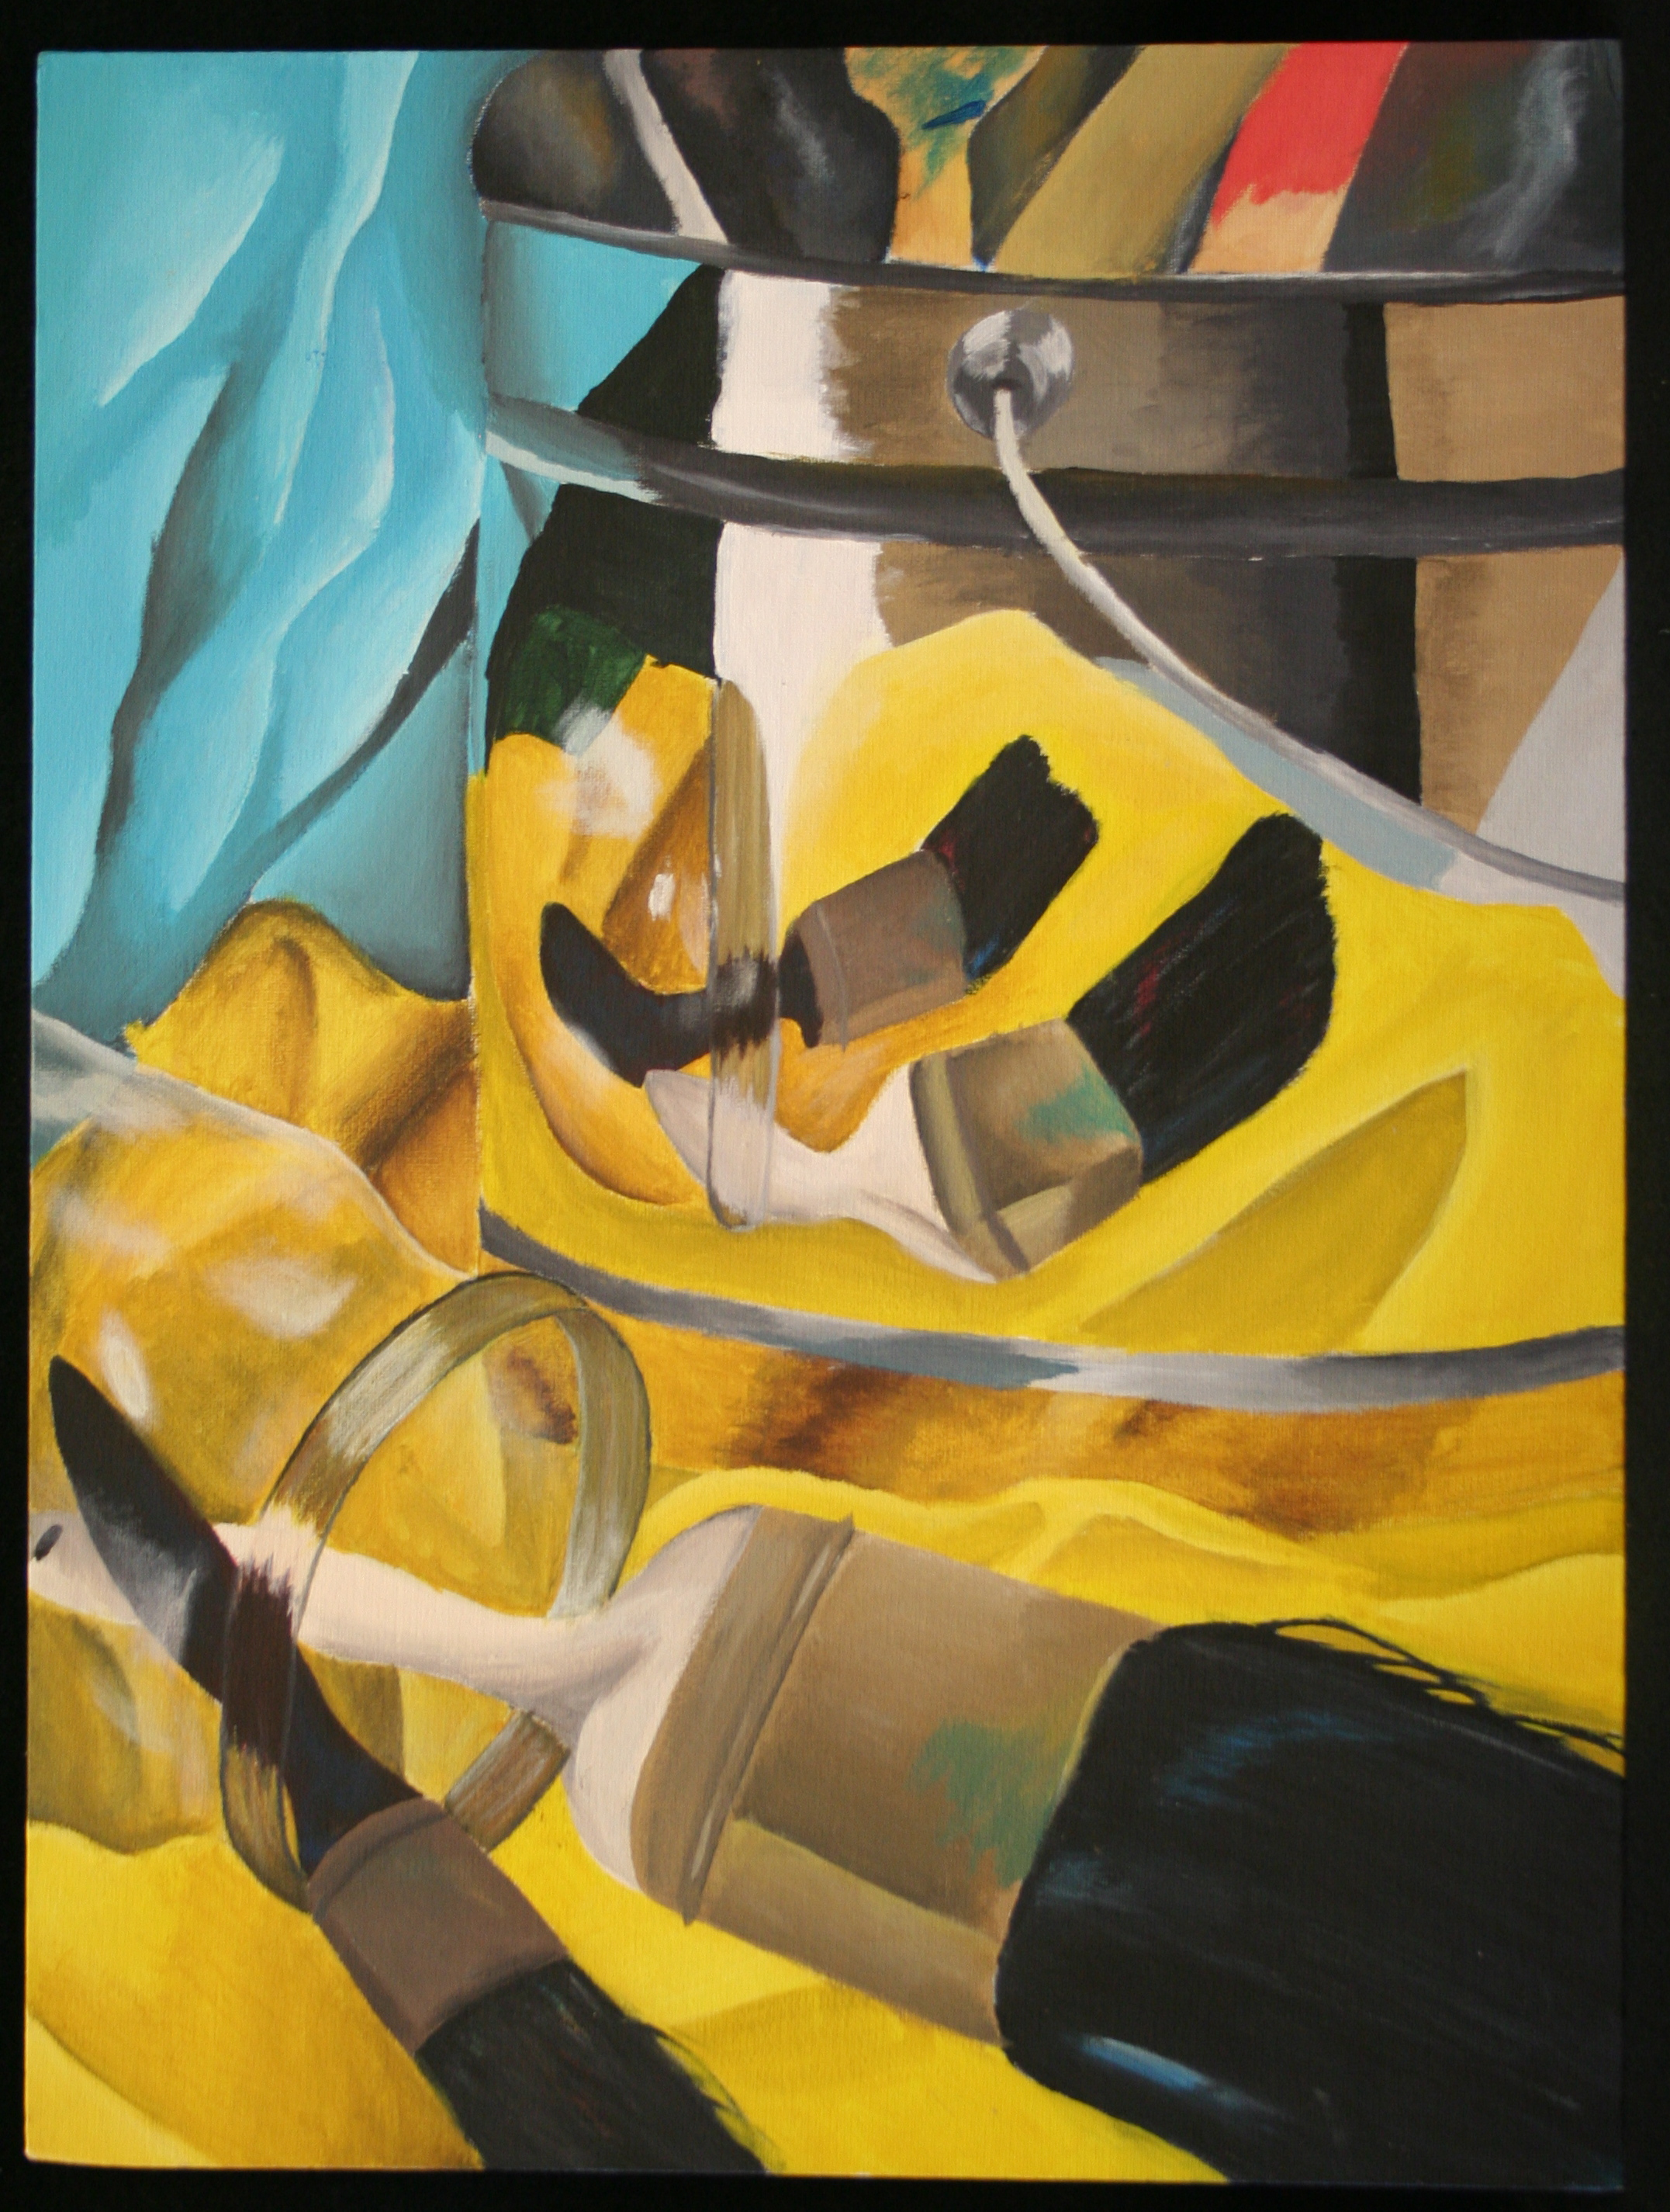

Reflective Still Life

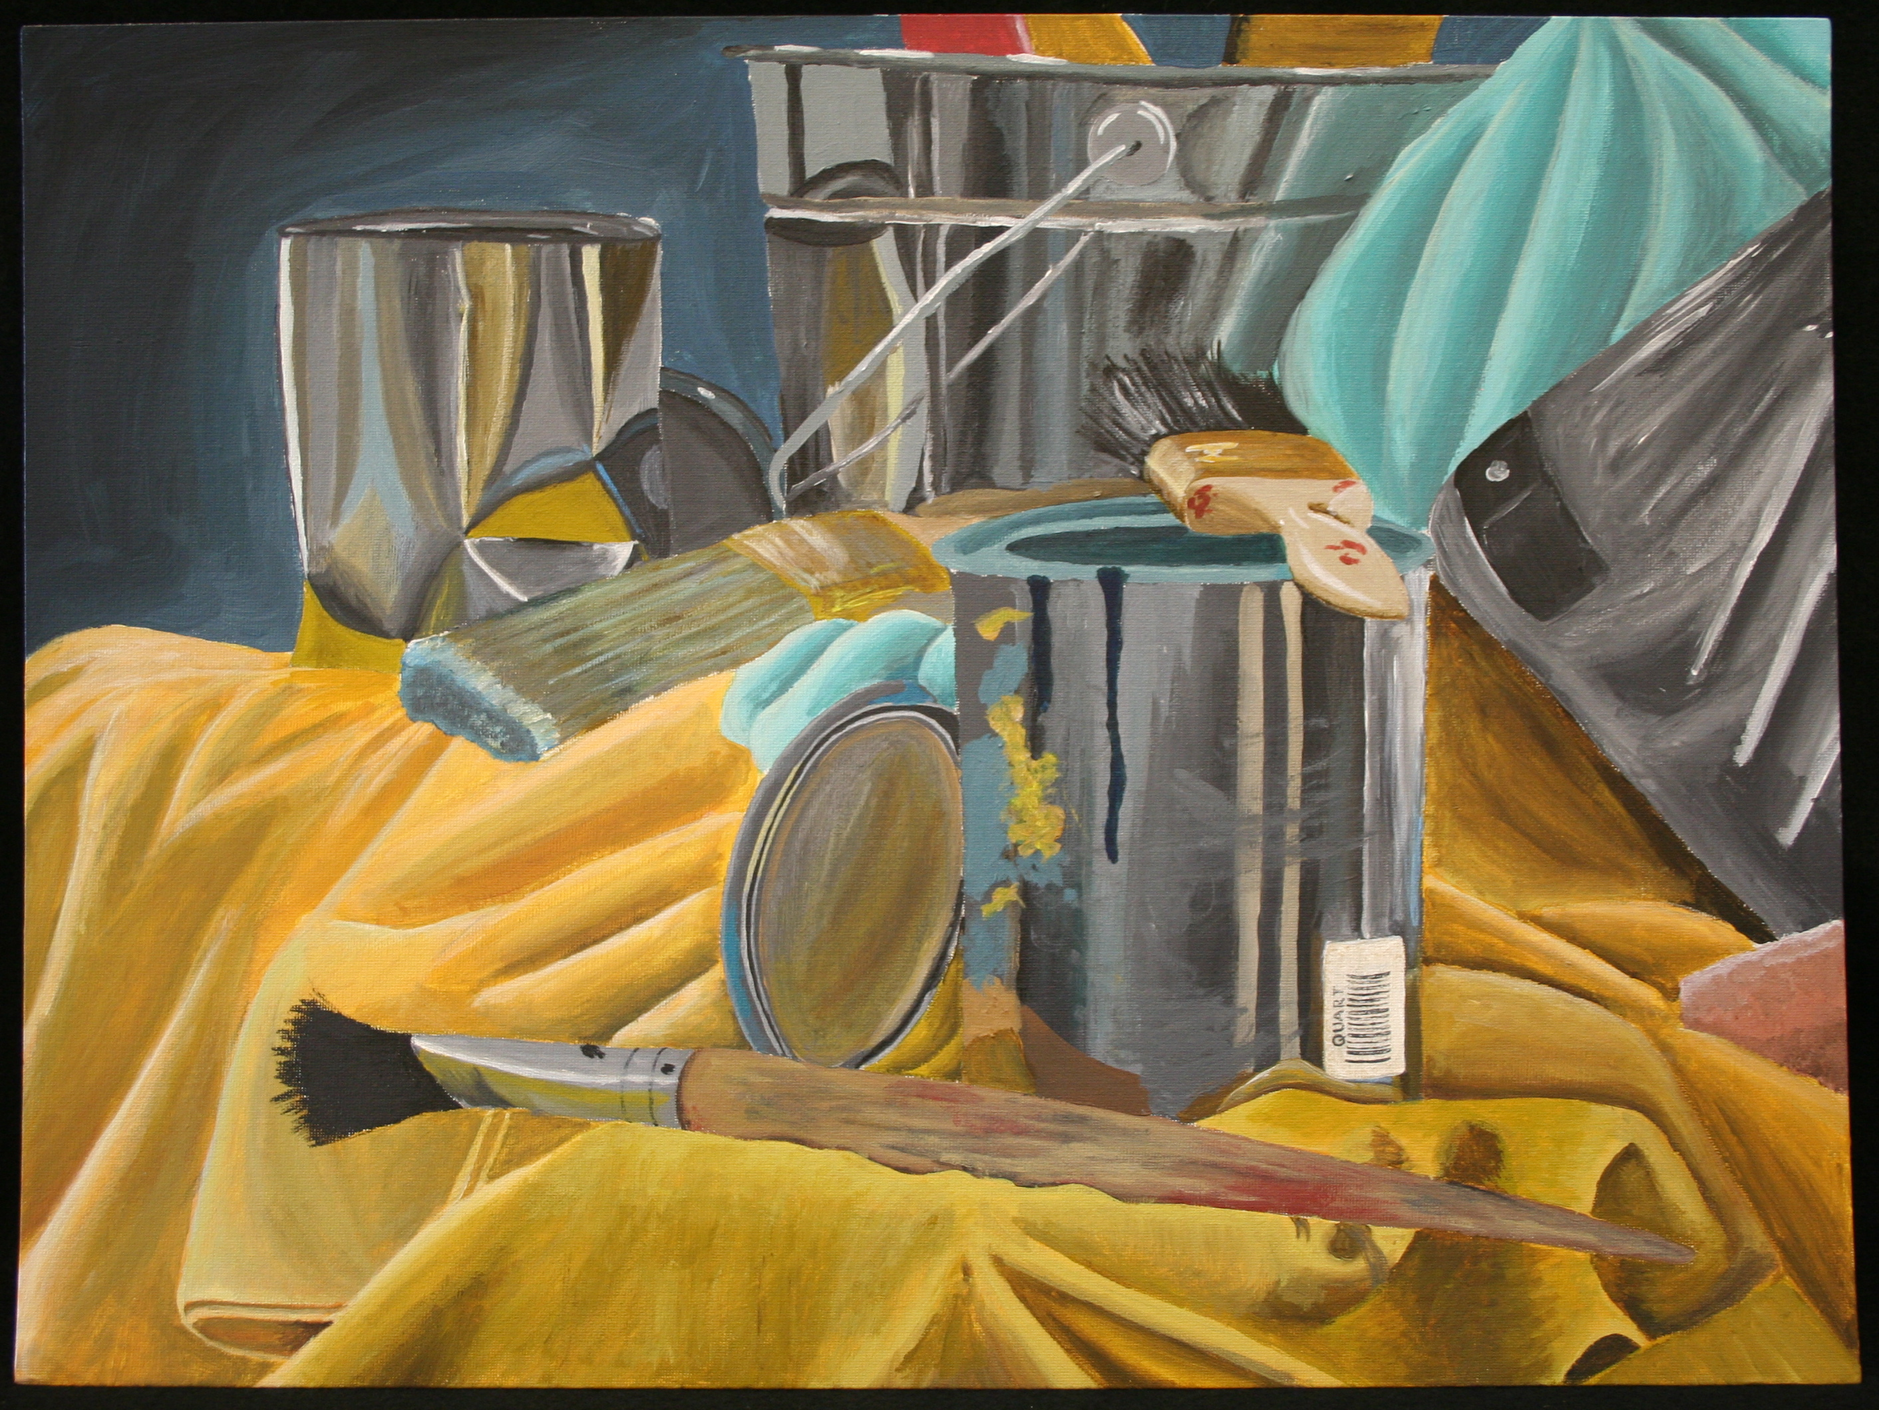

----------------Acrylic Paint on Canvas--------------------

**STEPS TO FOLLOW:**

1. First, you will use a template to create a viewfinder to use throughout your project.
2. You will use your viewfinder and your pencil as a measuring tool to create 2-3 thumbnail sketches of different compositions of the still life in your sketchbook. You should not draw the focal point in the center of your composition.
3. You will choose one of these compositions to use for your final Acrylic still life drawing.
4. You will use a pencil to draw the contours of the still life on your canvas.
5. You will practice blending and mixing colors with acrylic paint in your sketchbook that will match the colors in your still life. (is the metal really gray?)
6. You will add color and shading to your final draft with the acrylic paint.
7. Students may touch up the details with oil pastel.

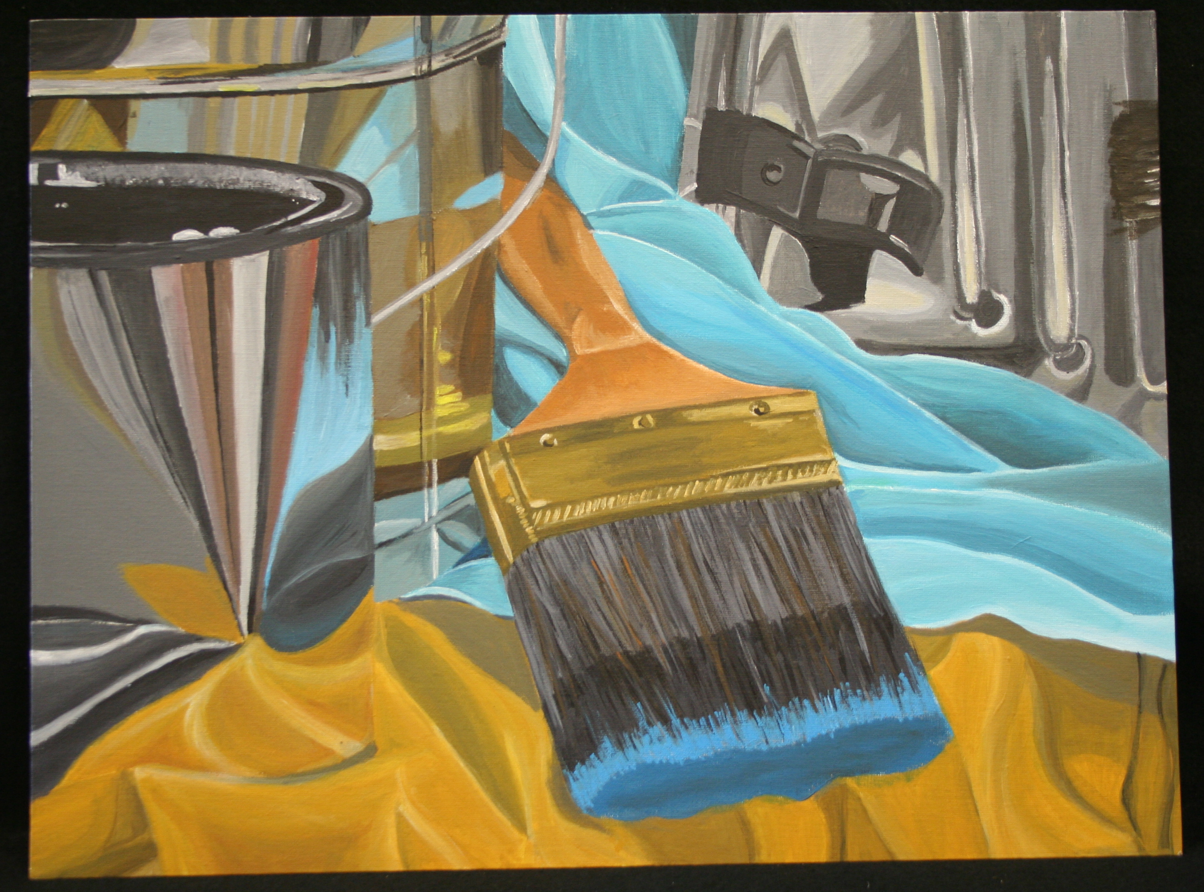

|  |  |  |  |  |  |
| --- | --- | --- | --- | --- | --- |
| **Student Name:**  **Lesson: Reflective Still Life** | | | | | |
| Circle the number **in pencil** that best shows how well you feel that you completed that criterion for the assignment. | | **Excellent** | **Good** | **Average** | **Needs Improvement** |
| **Criteria 1** – **Composition:** Student used a view finder to place the subject on the paper in the most interesting way possible. The student addressed the composition adequately. | | 10 | 9 – 8 | 7 | 6 or less |
| **Criteria 2** – **Reflective Surface:** Student successfully addressed the reflective surface and showed exploration in the surface value. | | 10 | 9 – 8 | 7 | 6 or less |
| **Criteria 3** – **Color**. Student utilized the medium appropriately and sought for accurate colors and values within the still life. | | 10 | 9 – 8 | 7 | 6 or less |
| **Criteria 4** – **Effort**: took **time** to develop idea & complete project? (Didn’t rush.) Good use of class time? | | 10 | 9 – 8 | 7 | 6 or less |
| **Criteria 5** – **Craftsmanship** – Neat, clean & complete? Skillful use of the art tools & media? | | 10 | 9 – 8 | 7 | 6 or less |
| **Total: 50 Grade:**  **(possible points) /50** pts |  |  |  |  |  |