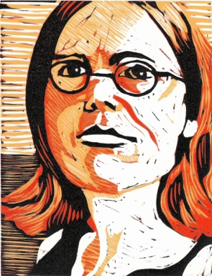
Printmaking

--------------- Reduction Portrait-------------------------------------

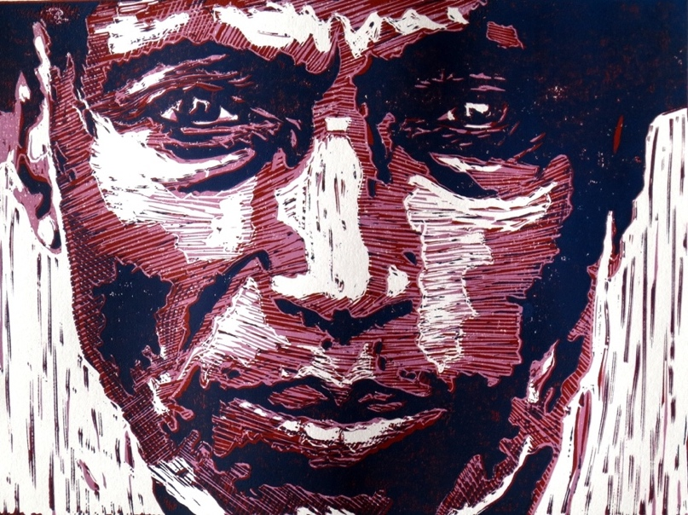
STEPS TO FOLLOW:
- Mrs. Denison will take a photo and change it on Photoshop to make it b&w with 3 layers.
- Next, Ms. Denison will show you how to grid your portrait and draw your image onto the 4x6 paper.
- Then, you will transfer your drawing onto your 4x6 linoleum block.
- Once you design is drawn out, you will carve out the WHITE areas using the Linoleum cutting tools.
- Once you have carved out all the white, you will then begin printing your first color layer. (see Mrs. Denison’s demo) Print at least 8 variations.
- Then carve out all the areas that you want to be the light color, and print on top of the previous prints.
- Last, you will display your prints, sign them properly, and turn in the images with the rubric.

Student Name:
Lesson: Reduction Portrait Printmaking
Circle the number in pencil that best shows how well you feel that you completed that criterion for the assignment. |  | Excellent | Good | Average | Needs Improvement
Criteria 1 – Reduction/ Registration: White is carved out and both colors are printed darker on top of the lighter. Layers are lined up evenly in proper registration. |  | 10 | 9 – 8 | 7 | 6 or less
Criteria 2 – Carving technique: Used a variety of gouges to create linear values in the portrait. Each layer is carved properly for the correct value. |  | 10 | 9 – 8 | 7 | 6 or less
Criteria 3 – Printing Technique – Print is evenly covered with ink. (not too much or too little ink used) Print is registered carefully in the center of the paper. |  | 10 | 9 – 8 | 7 | 6 or less
Criteria 4 – Display/ Signing: Prints are properly signed with edition number. Followed directions for the number of prints how to display them. |  | 10 | 9 – 8 | 7 | 6 or less
Criteria 5 – Effort: took time to develop idea & complete project? (Didn’t rush.) Good use of class time? |  | 10 | 9 – 8 | 7 | 6 or less
Criteria 6 – Craftsmanship – Neat, clean & complete? Skillful use of the art tools & media? |  | 10 | 9 – 8 | 7 | 6 or less
Total: 60  (possible points) | Grade:

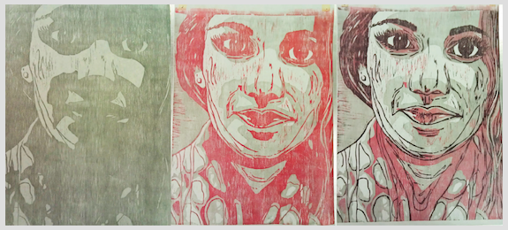
Fig. 1
Fig 1: Three samples of a reduction block in progress. The white is carved out of the first, the lightest color out of the second, and the medium color out of the third.

Fig 2: Once your design is drawn into the linoleum, you will cut out the WHITE areas using the linoleum cutting tools.

Fig 3 & 4: You will use the print block to create an edition of 4 QUALITY prints to turn in. You may print more, but you can only turn in 4.
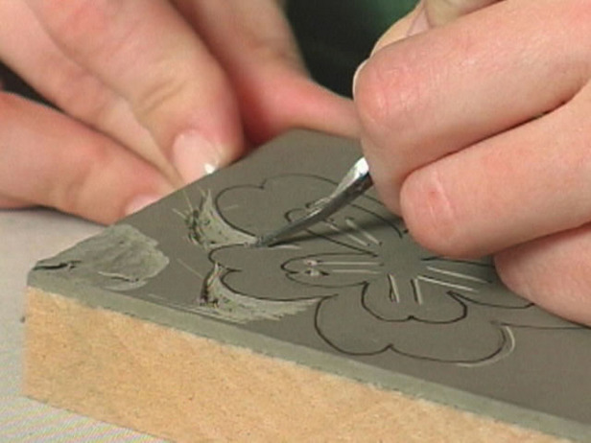

Fig. 2
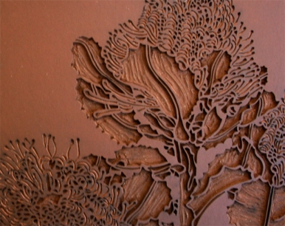
Printmaking Vocabulary
Edition: a series of prints made form the same plate
Proof: the first print made from a plate (not part of the edition)
Relief Printing: printing from a raised or depressed surface example: potato printing, rubber stamps, thumbprints
Plate: a flat surface used for printing - the image will be backwards on it
Brayer: a small roller used to apply the ink to the plate
Baren: an instrument used to create pressure between the plate, ink and paper
U-Gouge: tool that cuts out larger areas
V-Gouge: tool that cuts out finer lines

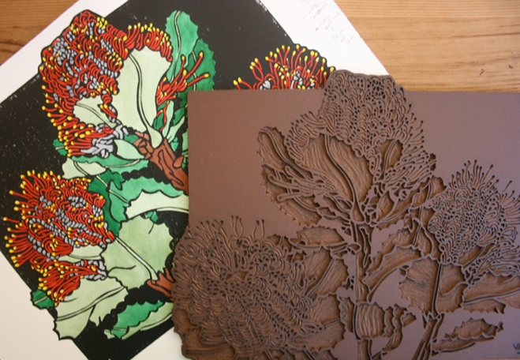

Fig. 3 & 4

