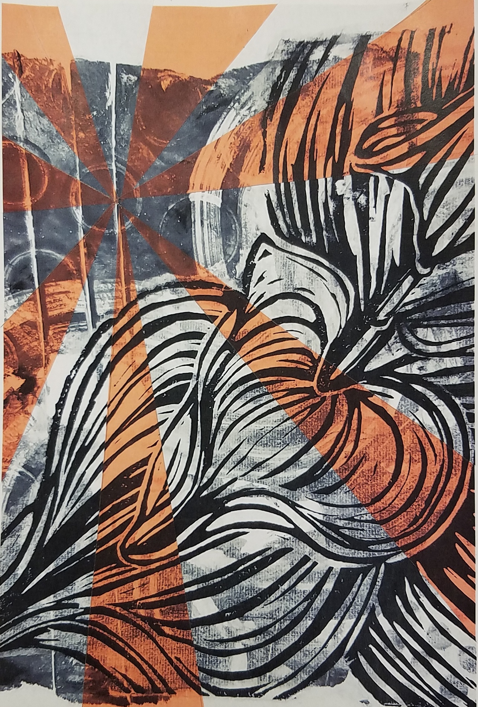

Objective:

Create a physically manipulated photograph using a **complementary**, **analogous, or monochromatic** color scheme.

**Photography Design**

Red

Orange

Yellow

Green

Blue

Purple

**Color schemes:**

**Complement-**  Two colors opposite each other on the color wheel.  Add black and white for value changes.

**Analogous**- Colors located next to each other on the color wheel, plus black and white for value changes and tones of gray.

**Monochromatic-** Tints and shades of the SAME color.

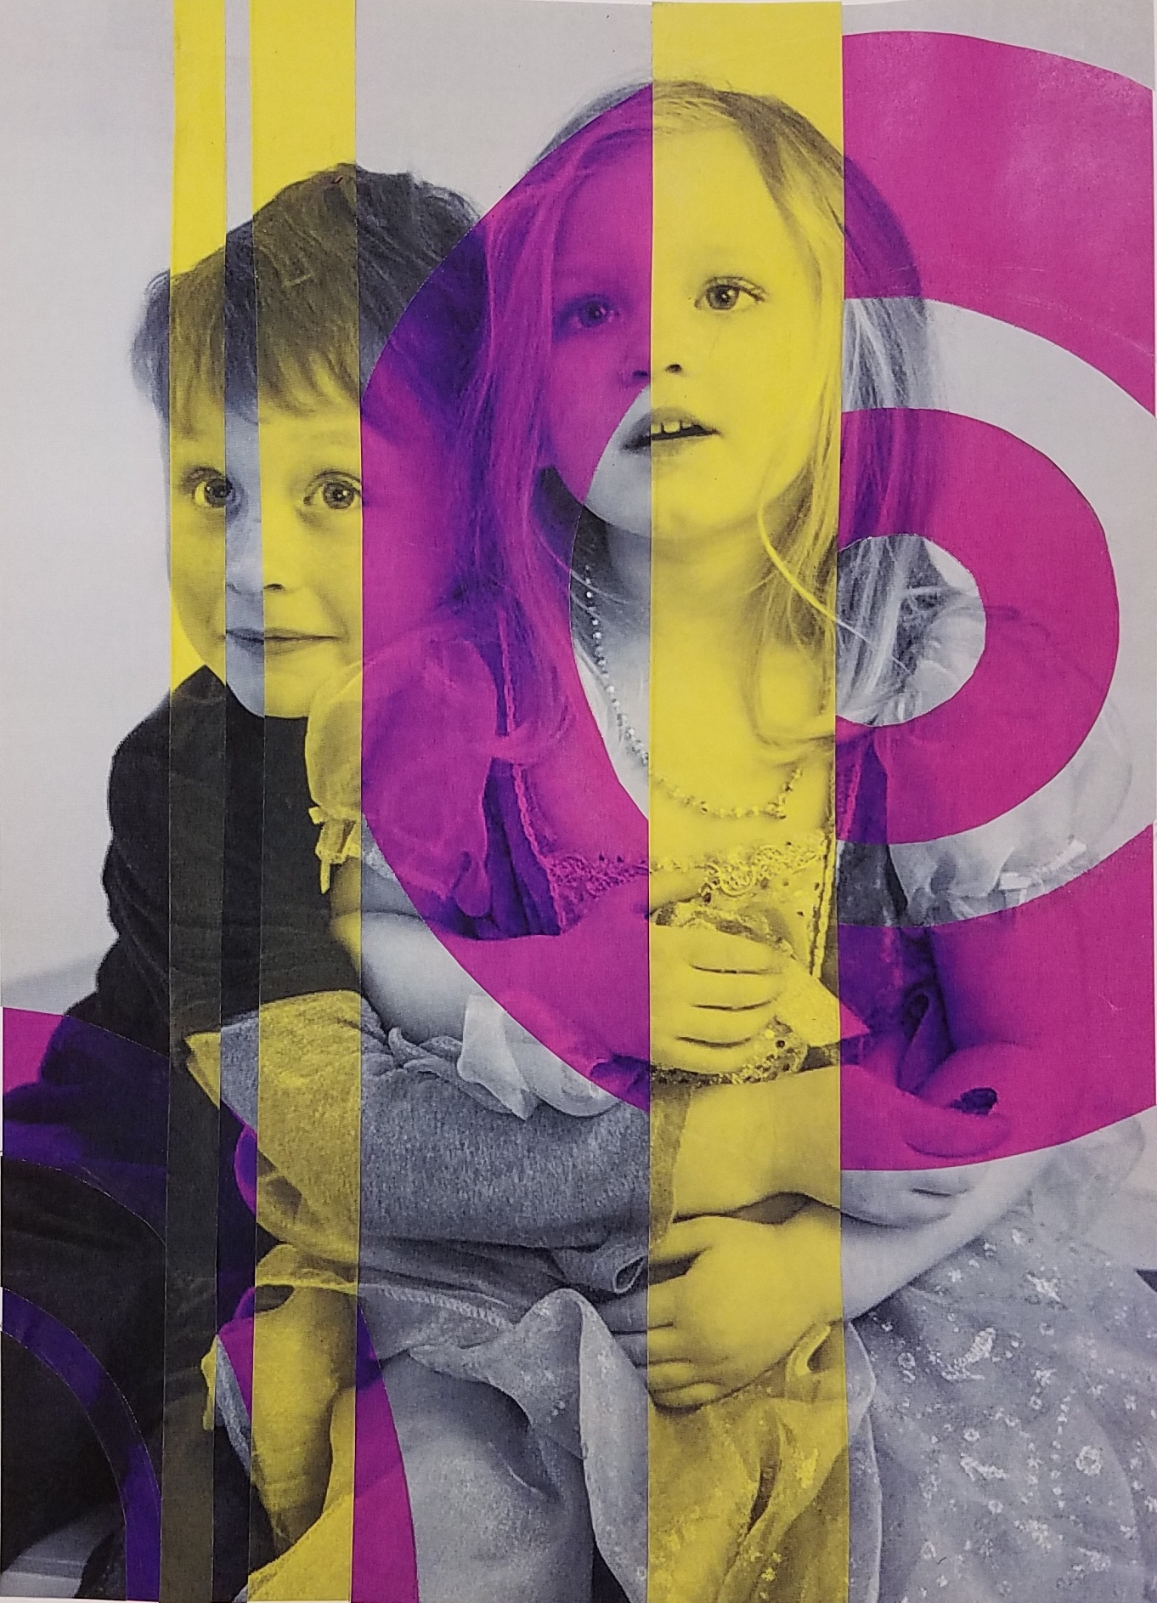

**Procedures:**

1. Pck out a school appropriate photograph from your device.
2. Follow the directions from my blog to manipulate the image 3 times. Once black and white, and two other colors within a chosen color scheme.
3. Next save the images with your name and upload them to the google drive for Mrs. Denison to print out.
4. Once you have all three copies of your photograph, sketch out a design to layer onto the black and white copy. (one could be using shapes and the other lines. or both with lines or both with shapes.).
5. Then collage the colored shapes/ lines on top of the black and white copy so that they line up perfectly with your image.
6. Grade yourself on the rubric (on back) and turn in to my box!

|  |  |  |  |  |  |  |
| --- | --- | --- | --- | --- | --- | --- |
| **Student Name:** | | | | | | |
| Assignment: **Photography Design** | | | | | | |
| Circle the number **in pencil** that best shows how well you feel that you completed that criterion for the assignment. | | **Excellent** | **Good** | **Average** | **Needs Improvement** |
| **Criteria 1** – **Composition** – Chosen point of emphasis. Overall successful design arranged with photograph. | | 10 | 9 – 8 | 7 | 6 or less |
| **Criteria 2** –  **Design** – Each color has a specific design focus and is used to enhance the photograph. | | 10 | 9 – 8 | 7 | 6 or less |
| **Criteria 3** – **Color** scheme selection and application (used one of the 3 color scheme options successfully. | | 10 | 9 – 8 | 7 | 6 or less |
| **Criteria 4** – **Effort**: took **time** to develop idea & complete project? (Didn’t rush.) Good use of class time? | | 10 | 9 – 8 | 7 | 6 or less |
| **Criteria 5** – **Craftsmanship** – Neat, clean & complete? Skillful use of the art tools & media? | | 10 | 9 – 8 | 7 | 6 or less |
| **Total: 50** (possible points) |  |  |  |  |  |



Procedures:

1. Get a piece of 8 x 10 inch newsprint, a ruler, pencil and compass. Look at the sample letter cases and styles and choose letters you think are interesting. On the newsprint use the ruler and compass if necessary to draw out a letter on the newsprint in the Aesthetic Center of interest. (use the division of thirds) Overlap the second letter so that it crosses over and creates new shapes. A third letter is placed either next to or over as well with the other two to create even more shapes.

2. Take the ruler and start to draw straight lines over the letters starting and stopping at different places for interest. ) try not to make the shapes too small. An option could be to use a compass for circles instead or even with the straight lines. Graphite and transfer the design onto illustration board.

3. Pick a complementary pair of colors from looking at the color wheel and choosing colors that are opposite each other. On a sheet of paper with many squares, mix the colors together using different amounts to achieve and number of different varieties of the complementary pair. Use black white and tones of gray to enhance these colors and give some different varieties.

4. When these squares are dry cut out with scissors the colors that you like the most having some almost white and pure to almost black and dull. Arrange them in a row from the lightest brightest to the dullest darkest colors. Choose 8 to 10 colors that gradually change in value and intensity.

5. Start in an area of interest and color two or three shapes with the brightest colors. Move out from there to paint the next brightest and so forth until you have come to all the colors in the group. If there are more shapes to color, start going back the other way in your scale with the values and stop when you run out of shapes.

6. The brightest colors are looked at first and will be the area of emphasis. The duller and darker colors seem to go back ward and will be less noticed. The letters will be seen in the design but slightly hidden.

7. Craftsmanship is very important and will make this look real good. Paint smooth shapes and be very careful about staying within the lines of the shapes.