Student Name:

Lesson: Pen & Ink Portrait Drawing
Circle the number in pencil that best shows how well you feel that you completed that criterion for the assignment. |  | Excellent | Good | Average | Needs Improvement
Criteria 1 – Composition/ Planning: Successful placement of figure within the composition. Student took a well-lit photograph in an interesting position to refer to. At least 3 pages of pen & ink techniques were explored before beginning the assignment. |  | 10 | 9 – 8 | 7 | 6 or less
Criteria 2 –Portrait accuracy: Successfully gridded the portrait and place it on the page with accurate proportions. |  | 10 | 9 – 8 | 7 | 6 or less
Criteria 3 – Incorporation of Pen & Ink Techniques: successful use of pen and ink techniques to create appropriate values within the image. Values must range from darks to lights. Should have lights, darks, and midtones well developed within the artwork. |  | 10 | 9 – 8 | 7 | 6 or less
Criteria 4 – Background. Student utilized magazine or newspaper collage to enhance the background in an interesting way. |  | 10 | 9 – 8 | 7 | 6 or less
Criteria 5 – Effort: took time to develop idea & complete project? (Didn’t rush.) Read the article and followed the steps within. Good use of class time? |  | 10 | 9 – 8 | 7 | 6 or less
Criteria 6 – Craftsmanship – Neat, clean & complete? Skillful use of the art tools & media? |  | 10 | 9 – 8 | 7 | 6 or less
Total: 60  (possible points) /60 pts | Grade:
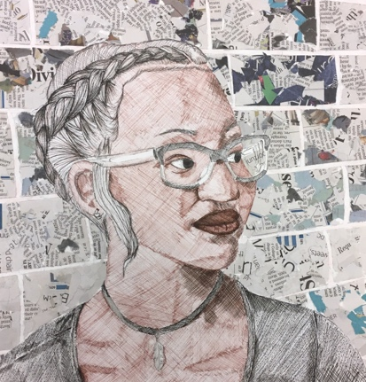
Pen & Ink Portrait

------------ with collage background -------------------------------------

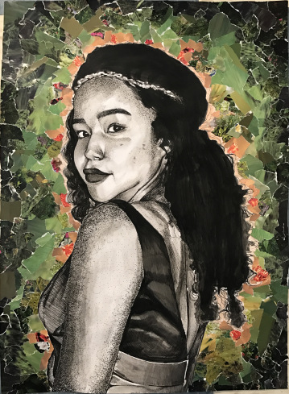
STEPS TO FOLLOW:
- Take some time for pen and ink discovery and document this in your sketchbook. Check out stippling, hatching, cross-hatching, scumbling, and inkwash (just to name a few).
- Next, take a photo of your subject with dramatic lighting and print it out.
- Use a grid system to grid the drawing and your paper. (you may pick the size paper you need)
- Using pencil first, create your portrait with accurate proportions onto your final paper using the grid.
- Use at least two of the pen and ink techniques that you explored to create values within your portrait.
- Add an interesting background with newspaper or magazine collage. See Mrs. Denison’s blog for examples.

