Student Name:

Lesson: Animal Patterned portrait painting
Circle the number in pencil that best shows how well you feel that you completed that criterion for the assignment. |  | Excellent | Good | Average | Needs Improvement
Criteria 1 – Composition/ animal accuracy: Overall composition includes an animal focal point that has accurate contour lines. The animal is slightly off-center using the rule of thirds for interesting placement. |  | 10 | 9 – 8 | 7 | 6 or less
Criteria 2 – Collaged papers/ color scheme: Student was able to choose a color scheme and evenly collaged their patterned papers to create the chosen animal. |  | 10 | 9 – 8 | 7 | 6 or less
Criteria 3 – Incorporation of decorative painted pattern. Student utilized MANY decorative patterns and symbols, into each collage paper as well as the background. |  | 10 | 9 – 8 | 7 | 6 or less
Criteria 4 – Background: Student created pattern in the background with bubble printmaking or watercolor techniques and then added additional pattern to unify the piece. Shading was also used in the background to make the animal stand out. |  | 10 | 9 – 8 | 7 | 6 or less
Criteria 5 – Effort: took time to develop idea & complete project? (Didn’t rush.) Read the article and followed the steps within. Good use of class time? |  | 10 | 9 – 8 | 7 | 6 or less
Criteria 6 – Craftsmanship – Neat, clean & complete? Skillful use of the art tools & media? |  | 10 | 9 – 8 | 7 | 6 or less
Total: 60  (possible points) /60 pts | Grade:
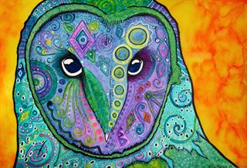
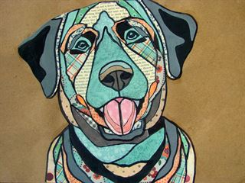
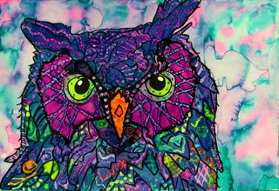
------------ Pattern Painting --------------------------------
STEPS TO FOLLOW:

- Find a close-up image of an animal (or take a photo of your own!)
- Use Pixlr to desaturate the image and then click on adjustment-> posterize. And then print out as a 5x7.
- Next, create a gridded drawing to enlarge your portrait.
- You will create at least 3 patterned collage papers with a color scheme and choose an additional 3 papers to use for your collage.
- Then use the patterned paper to create each section of your animal. More patterns can be painted on top of the paper as well.
- Then, outline each section with thick black contour lines.
- You will cut out the animal portrait and glue it to the painted background paper. (This may also have more patterns added to it.)
Animal Portrait

