Sketchbook Choices

For your next sketchbook, you will choose between the options below. Be sure to read the directions and look closely at the examples for expectations on quality. I will take these up on WEDNESDAY of next week. (this should take at least 1 hour, but you have all class period to work on this)

- Paper “Doll”---Use magazine and scrap paper (or junk mail) to create a figure. (This could be human, animal, robot, alien, etc.) This can be loose or glued into your sketchbook. You can add details with pen, pencil, marker, etc.

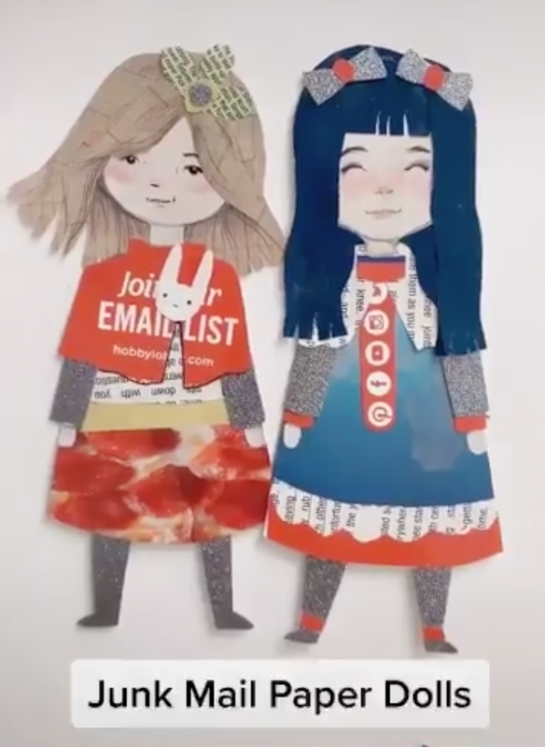

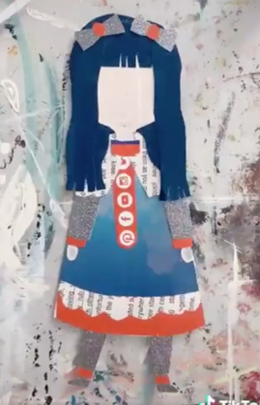
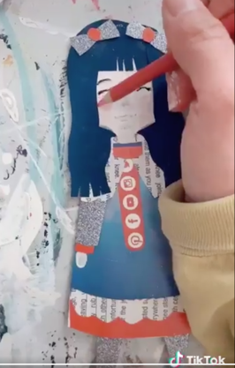
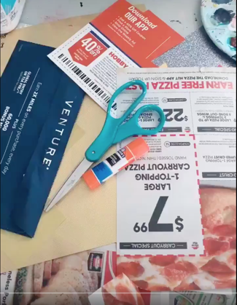
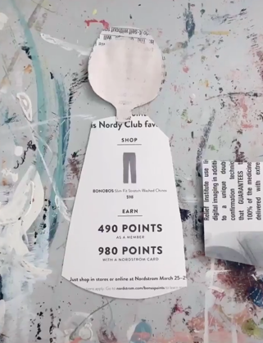
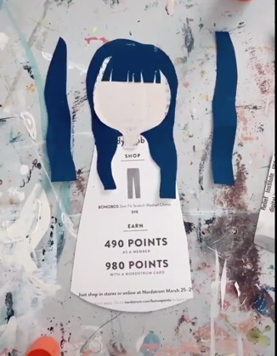
Gather supplies
Use other magazines/ paper to create details.
Layer on individual body parts for colors/textures
Start creating the body shape
Add final touches with marker, pencil, pen, etc.

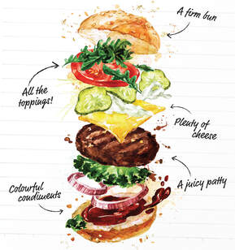
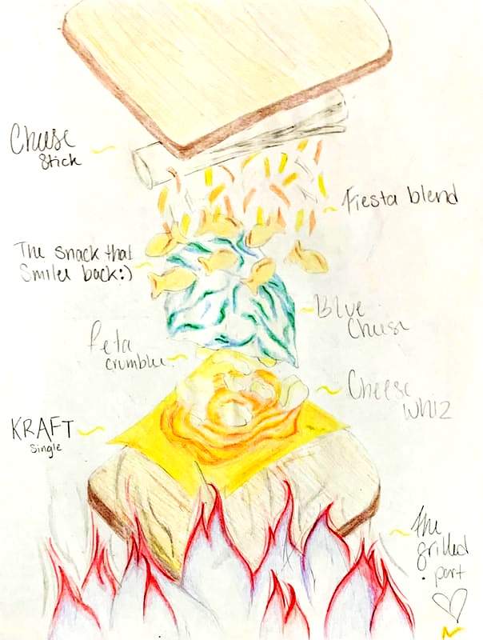
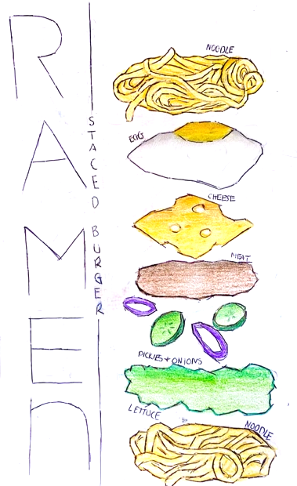
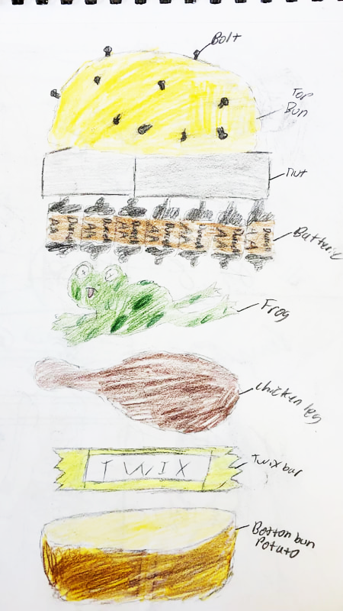
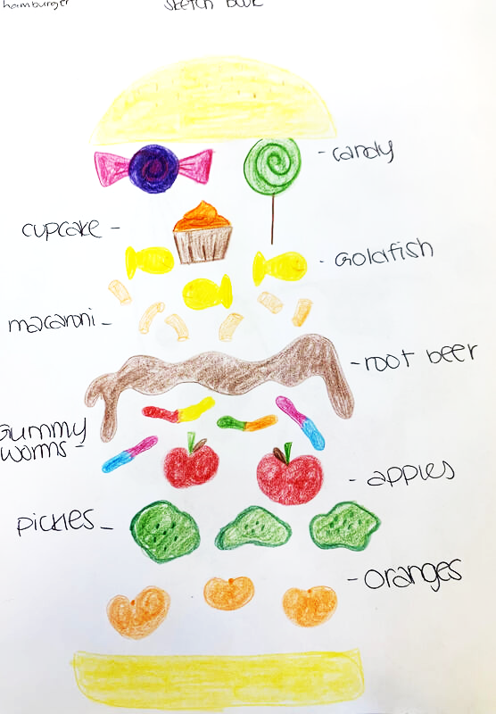
- Stacked Sandwich—Draw a deconstructed sandwich or burger with unusual toppings. (Be creative. Toppings don’t have to be edible). You must add color. Annotate your ingredients.
Previous student examples:

