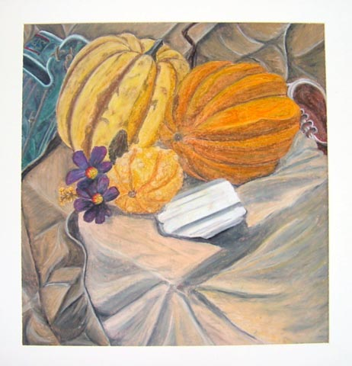

Still Life

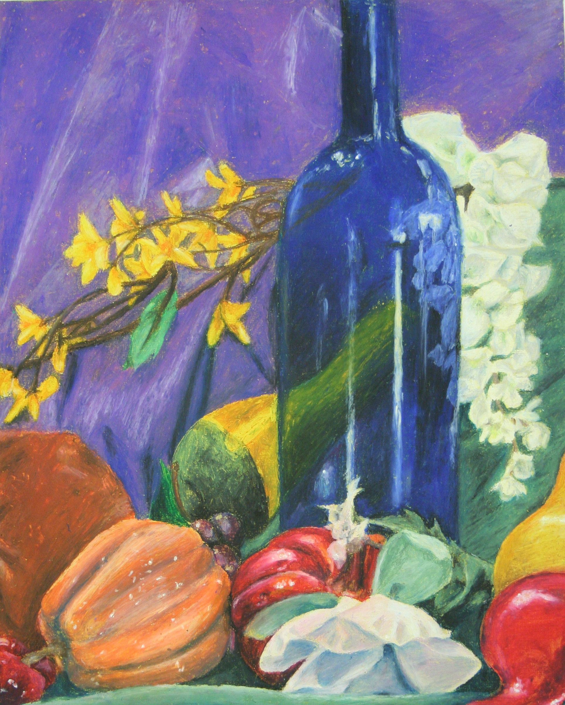

**STEPS TO FOLLOW:**

1. First, you will create a watercolor wash background and then layer at least 5 different “visual Journal” prompts to create a background with depth, visual interest and mixed media.
2. You will use a template to create a viewfinder to use throughout your project.
3. You will use your viewfinder and your pencil as a measuring tool to create 2-3 thumbnail sketches of different compositions of the still life in your sketchbook. You should not draw the focal point in the center of your composition.
4. You will choose one of these compositions to use for your final oil pastel still life drawing.
5. You will use a pencil to draw the contours of the still life on your background paper that you added your mixed media layers to.
6. You will practice shading with oil pastels and/ or acrylic paint in your sketchbook.
7. You will add color and shading to your final draft with the oil pastels and/or acrylic paint.

---Oil Pastel or Acrylics on Activated Background---

|  |  |  |  |  |  |
| --- | --- | --- | --- | --- | --- |
| **Student Name:**  **Lesson: Oil Pastel Still Life** | | | | | |
| Circle the number **in pencil** that best shows how well you feel that you completed that criterion for the assignment. | | **Excellent** | **Good** | **Average** | **Needs Improvement** |
| **Criteria 1** – **Accuracy:** Student chose an appropriate subject to draw and successfully enlarged that area of the still life using the pencil as a measuring tool. Subject is drawn accurately. | | 10 | 9 – 8 | 7 | 6 or less |
| **Criteria 2** - **Color:** Student understands the concept of value within each color. Oil pastels or Acrylic paints are mixed to get the accurate color of the objects they are looking at. | | 10 | 9 – 8 | 7 | 6 or less |
| **Criteria 3** – **Composition**. Student used a viewfinder to place the subject on the paper in the most interesting way possible. | | 10 | 9 – 8 | 7 | 6 or less |
| **Criteria 4** – **Background: s**tudents used at least 5 “visual journal” layers in the background to add depth and interest. | | 10 | 9 – 8 | 7 | 6 or less |
| **Criteria 5** – **Effort**: took **time** to develop idea & complete project? (Didn’t rush.) Read the rubric and followed the steps within. Good use of class time? | | 10 | 9 – 8 | 7 | 6 or less |
| **Criteria 6** – **Craftsmanship** – Neat, clean & complete? Skillful use of the art tools & media? | | 10 | 9 – 8 | 7 | 6 or less |
| **Total: 60 Grade:**  **(possible points) /60** pts |  |  |  |  |  |