Visual Art Comp I
Standards
a. Creates contour drawings from observation.
b. Uses value to model geometric forms with rendering, hatching/cross-hatching.
c. Combines contour and value in drawing from direct observation.

EQ: How can the illusion of 3-D form be created on a flat surface?

Set Up:
Crumble a sheet of notebook paper to have creases and folds. Place it with a strong light source.
Notebook paper drawing:
Step One: Light line sketch, shade with edges.

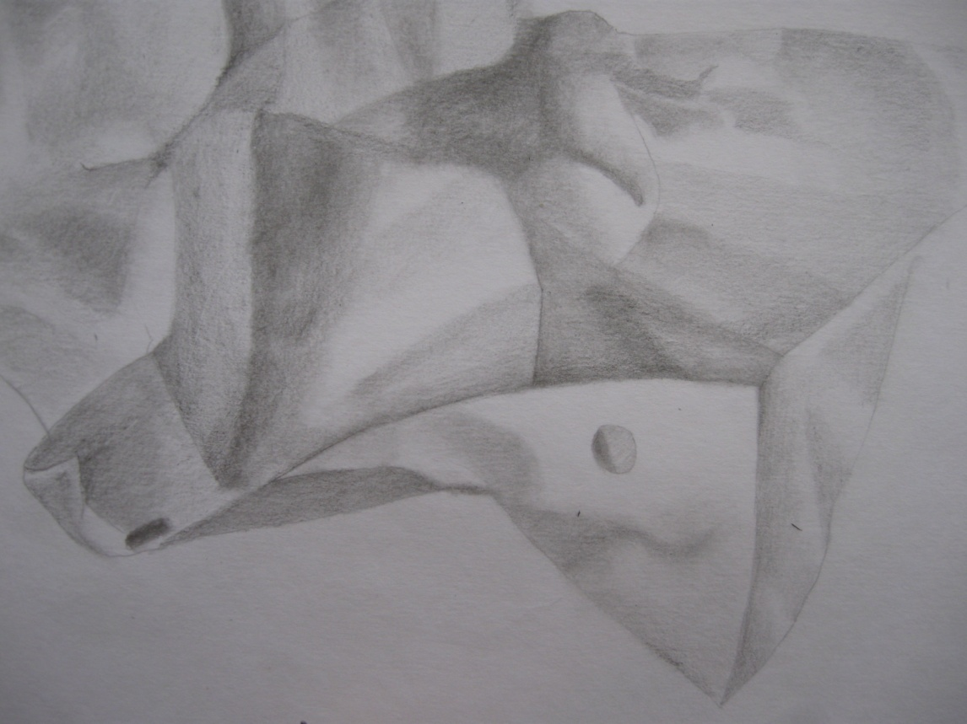
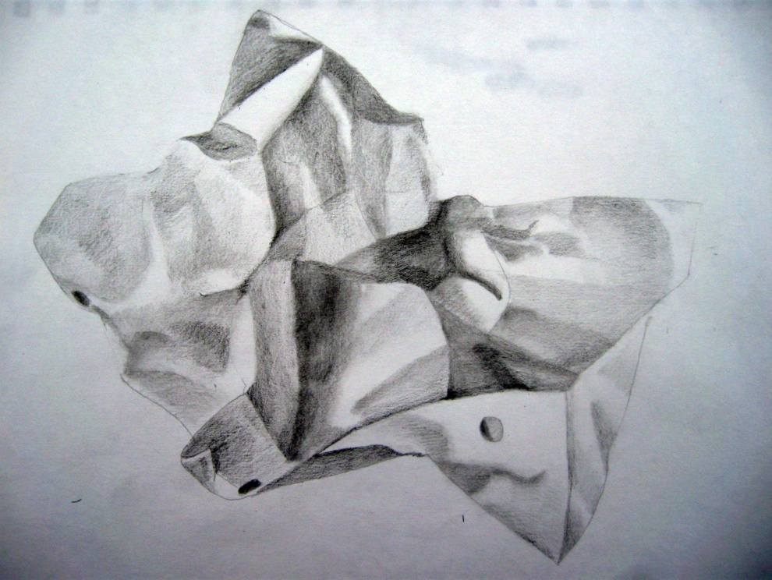

Step Two:
Add Blue lines that follow the folds and bends, red lines, cast shadow
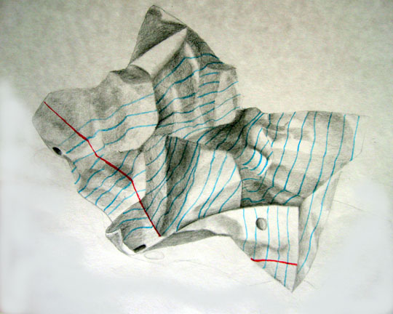

Begin drawing - 60 minutes

