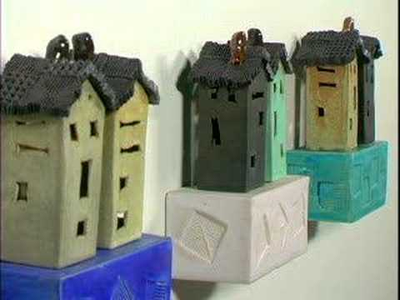

- Play the Art21 video here:
https://youtu.be/7Pc_QNzv87k

- During the video:
  - Students should have sketchbook open to a blank, page.
  - Write down at least 2 phrases from the video that stand out to you

- After the video:
  - Write a paragraph summary in your sketchbook about Mike Murphy. Describe his process and artistic goals.
  - Fill the page with color and imagery that reminds you of Murphy’s work. This can be a direct study of a specific artwork of his, or personally relevant imagery that simply imitates his style.

- Students should photograph their completed sketchbook assignment and upload to their blog on the “other” page. Then they should turn in the page to you.

- Work independently on projects after you turn in your page.

