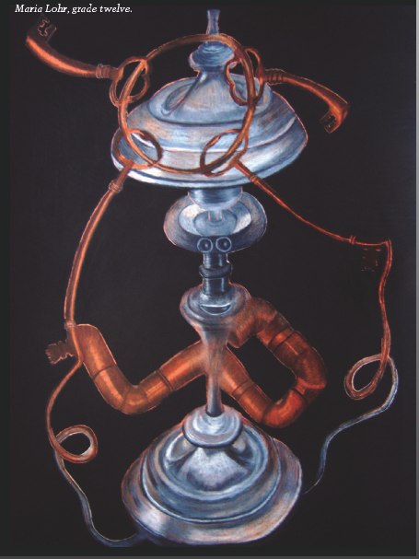

Objective:
- To create an abstracted still life from ordinary metalic objects
- Students can contribute to the still life from found objects
- Use the still life as inspiration to create fused together objects in a surreal or fanciful way

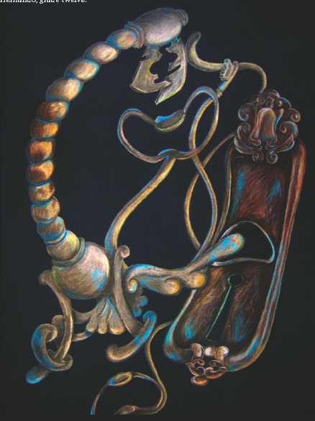
Criteria:
- Think about animating objects and “breaking the rules of nature” to create a world where solid objects can bend, melt, and fuse into each other.
- Eliminate distracting texture and detail from objects, especially in areas of transition from one object to the next.
- Use similar light and shadows on all fused forms to create three-dimensional effect on all pieces.
- Use subtle transitions of color and value between objects to blend forms together and create a whole unit.
- Draw the composition in the center of the paper to create a floating, unified object in space.
- Complete the drawings by coloring the background with black Conté crayon.

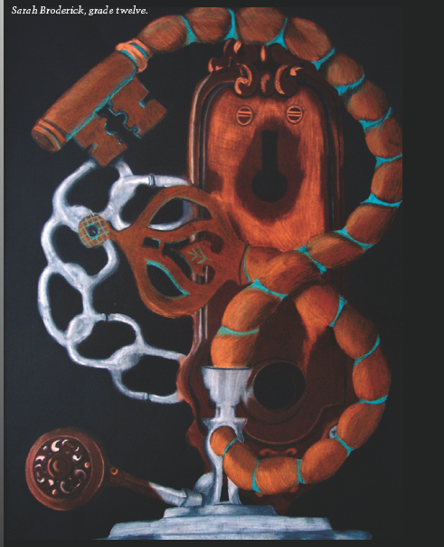
Procedures:
- Create a still life with common household objects. Preferably metallic items like chrome, stainless-steel tools and appliances.
- Choose your favorite objects and visualize them fused together, metamorphosing into a new form.
- Create several practice sketches of your ideas. (at least 5) Try to include a surrealistic aspect in the objects by adding anthropomorphic characteristics. Use your imagination to dream up new creatures. (See the criteria above)
- Then select the best one to enlarge onto the 12x16” black paper.
- Use the metallic colored pencils, along with black, white, browns and blues to add shading throughout the composition with similar light and shadows.
- Add black Conté crayon to the background to complete the composition.

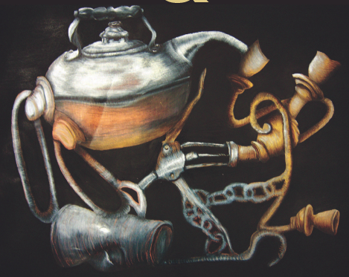
***Notice how the objects are fused together in a surreal manner. Also, the objects seem to have human characteristics.
Materials:
- Common household objects, preferably metallic items
- Colored pencils in bronze, gold, silver, cool grays, black, white, sienna brown, burnt ochre, light umber, dark umber, light blue
- 12x16” black paper
- Black Conté crayon

Answer the following questions before you turn in the rubric:
- Did you contribute to the still life by bringing in a discarded or recycled metallic object?
- Did you complete five preliminary sketches of your planned composition?
- Does each object melt, bend, and fuse into the next?
- Are unnecessary details and/or textures eliminated to create a new form?
- Do all objects appear three-dimensional with similar light and shadows?
- Are subtle transitions used between objects?
- Have anthropomorphic characteristics been incorporated?
- Is the composition balanced and floating in the center of the paper?
- Is the background colored in black Conté?

Student Name:
Assignment:
“Metal”morphosis
Circle the number in pencil that best shows how well you feel that you completed that criterion for the assignment. |  | Excellent | Good | Average | Needs Improvement
Criteria 1 – Composition: balanced and floating in center of paper. Planned with at least 5 preliminary sketches. |  | 10 | 9 – 8 | 7 | 6 or less
Criteria 2 – Metallic Shading: Details eliminated/ objects appear 3D with similar light and shadows. |  | 10 | 9 – 8 | 7 | 6 or less
Criteria 3 – Melting/Anthropomorphic Characteristics: subtle transition between objects appearing to fuse together. Anthropomorphic characteristics used. |  | 10 | 9 – 8 | 7 | 6 or less
Criteria 4 – Effort: took time to develop idea & complete project? (Didn’t rush.) Good use of class time? |  | 10 | 9 – 8 | 7 | 6 or less
Criteria 5 – Craftsmanship – Neat, clean & complete? Skillful use of the art tools & media? |  | 10 | 9 – 8 | 7 | 6 or less
Total: 50 x 2  (100 possible points) | Grade:

