1. 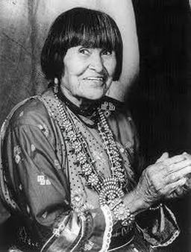

Maria Martinez---Preview research!!!

Our next summative piece is inspired by the artist, Maria Martinez. **Maria Martinez did NOT use glazing on her pots.  Do some research to answer the following questions:**

1.  Who was Maria Martinez?

2.  How are her ceramic vessels so shiny?

3.  How did she get that black color?

4.  How did she and her husband create the designs and what technique did she use to build her vessels?

5.  With the time left, draw out 2-3 ideas for pottery shapes that you could create for our next project inspired by Maria Martinez.  What types of designs could you add to the finished pottery?