Student Name:
Lesson: Maria Martinez inspired Coil Vessel
Circle the number in pencil that best shows how well you feel that you completed that criterion for the assignment. |  | Excellent | Good | Average | Needs Improvement
Criteria 1 – Vessel Form: Created a successful vessel form with symmetry using coil building techniques. |  | 10 | 9 – 8 | 7 | 6 or less
Criteria 2 – Burnishing: Created a glossy coating by burnishing the surface before bisque firing. |  | 10 | 9 – 8 | 7 | 6 or less
Criteria 3 – Decoration: Creative, well-thought out patterns/designs symmetrically applied with good craftsmanship. |  | 10 | 9 – 8 | 7 | 6 or less
Criteria 4 – Effort: took time to develop idea & complete project? (Didn’t rush.) Good use of class time? |  | 10 | 9 – 8 | 7 | 6 or less
Criteria 5 – Craftsmanship – Neat, clean & complete? Skillful use of the art tools & media? |  | 10 | 9 – 8 | 7 | 6 or less
Total: 50  (possible points) | Grade:
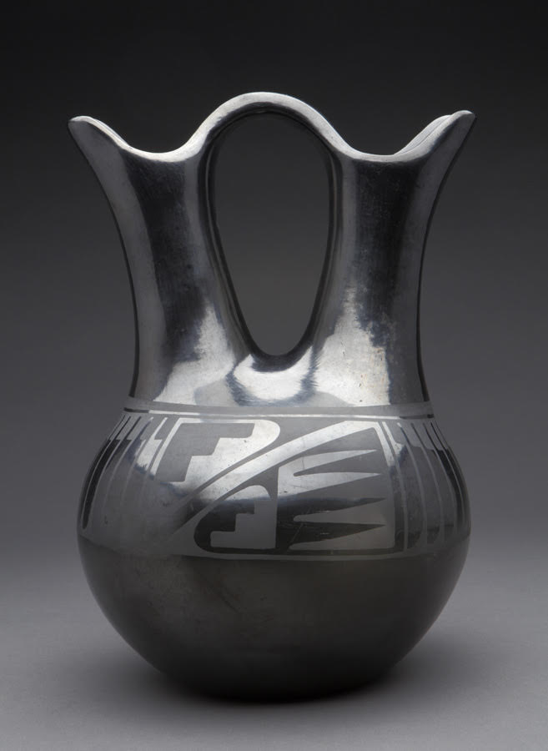
Maria Martinez
-------------Coil Pottery----------------
Step 1: First create 2-3 practice sketches of the how your vessel will look. Add practice designs on how you would like to decorate your pottery.

Step 2: Create 1 large pinch pots to use as the base. Next add coils onto the base slipping and scoring each time to ensure a good seal. Smooth out the coils both outside and inside. (see teacher demo)

Step 3: Be sure your vessel is symmetrical. Once completed, allow to dry.

Step 4: Next paint on the stain/slip to the surface of the dried clay. While it is still damp, burnish the clay with the back of a spoon for an even, smooth finish.

Step 5: Once the vessel is smoothed, add painted designs in the slip, or use the stencil method. (see teacher demo.)

Step 6: Then wait until it is completely bone dry and fire to cone 04.

Step 7: Once the vessel is fired, turn in this rubric with the vessel.

