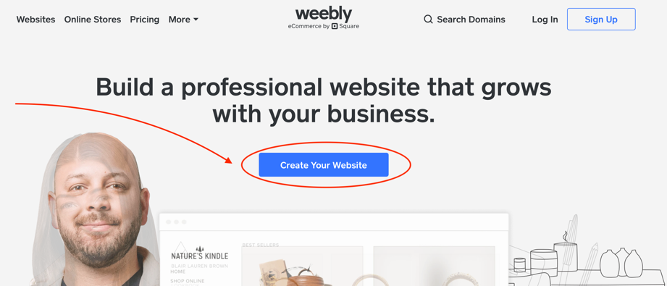
Making a Weebly website:

- Go to www.weebly.com
- Click “Create your Website”
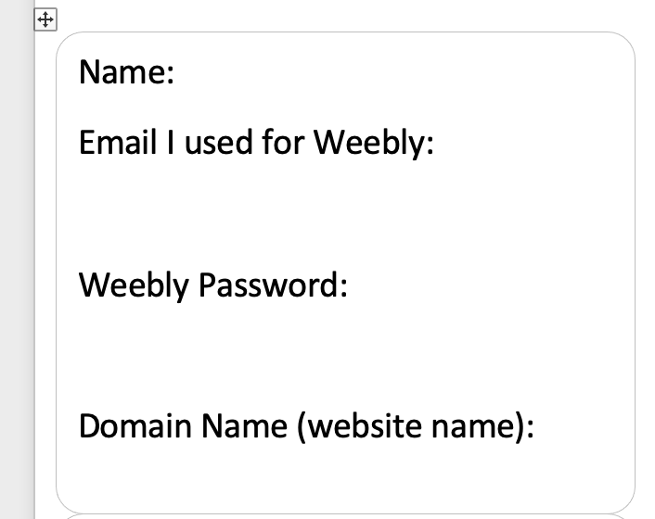
- Fill out the information it prompts you to fill out, and hit continue

- Write down the email you used to sign up for weebly AND your password on the sticky tab I gave you in class.

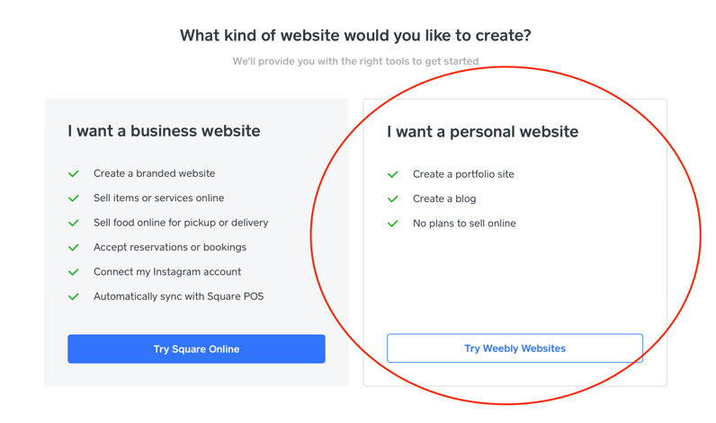
- When it asks what website you’d like to create, click “personal.”

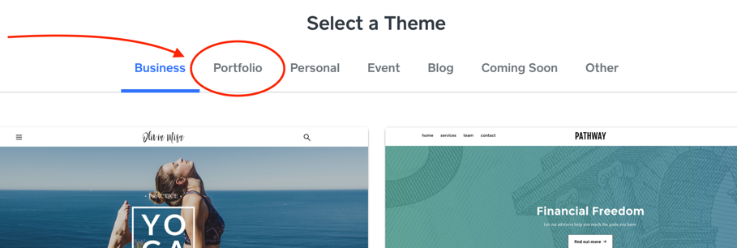

- When asked to select a theme, click “portfolio.”

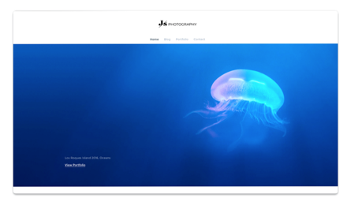
- Pick the one that has a jelly-fish. (don’t worry, we will customize later). Then click “start editing.”

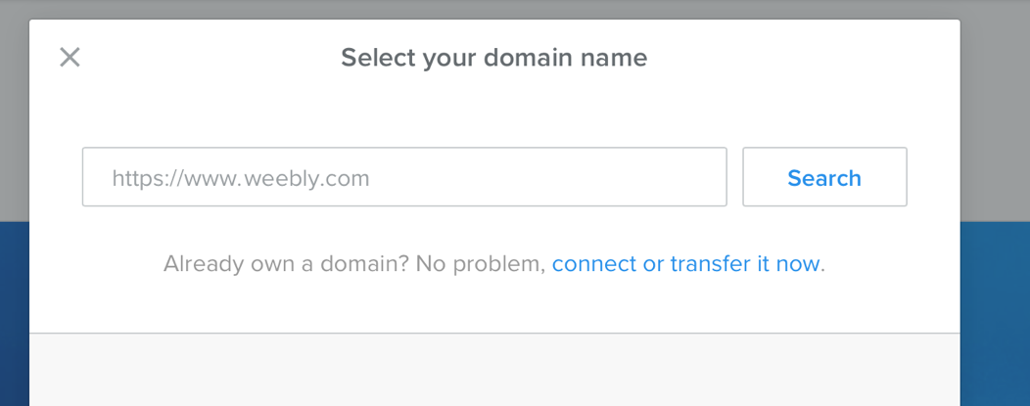
- Next, it will ask you to select a domain name. Pick something with your name and art in the title, such as “JessicasJazzyDrawings”, or “MilosAmazingArtPortfolio”, or “TheFantasticArtOfFredrico”, etc. Then click “search”

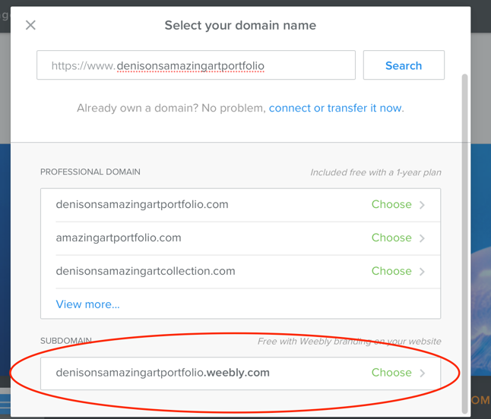
- Choose the one that has “.weebly.com” at the bottom. This one is FREE to use.

- Be sure to write down the domain name on the sticky tabs that I gave you in class. (you will turn this in to me after you take a photo of it first.)

- Push “Publish” right away to save all changes. You will get a confirmation like the one below:

- Once you have published, then click on “pages” and then the “+” in order to add a new page.

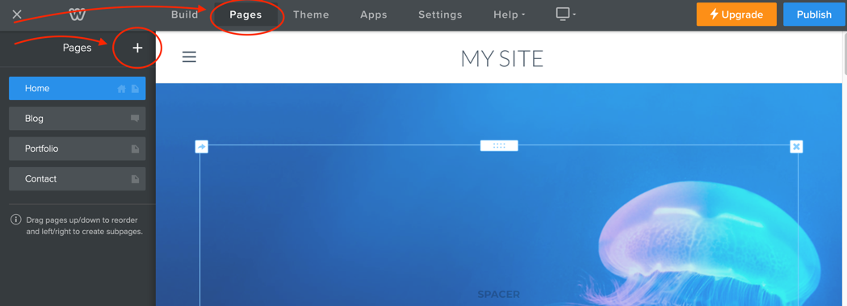

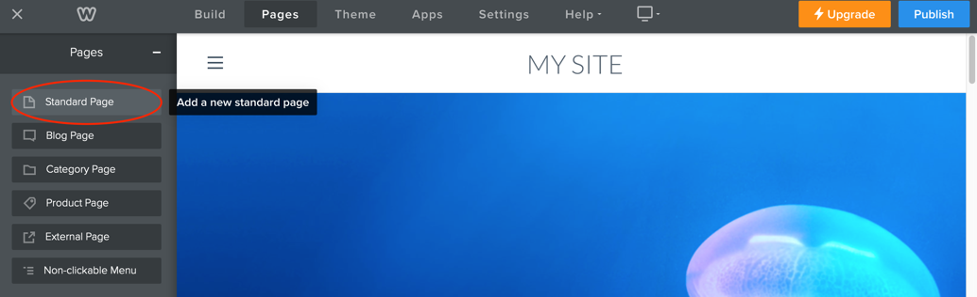
- Now, click on “Standard Page”

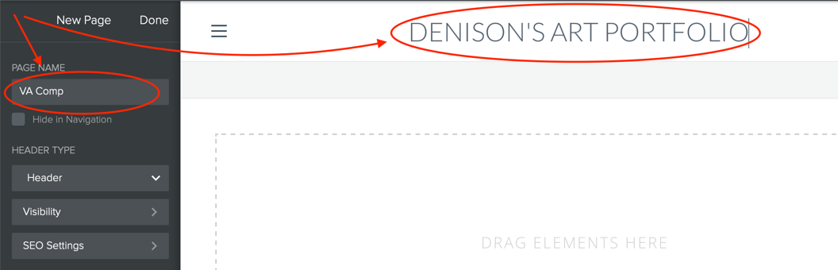
- Rename the page with your class name. (ex: VA Comp or Drawing and Painting 1). Rename the “My Site” with your name and art portfolio. Then click “Done.”

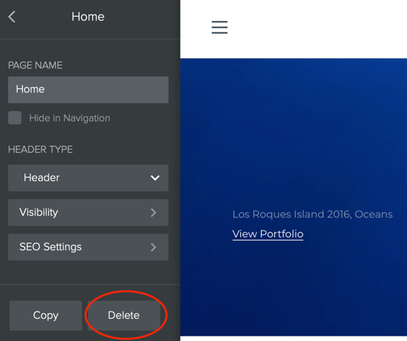

- Now we need to delete all the other pages. So go into each one and click delete, until the only one that is left is the one for your art class.

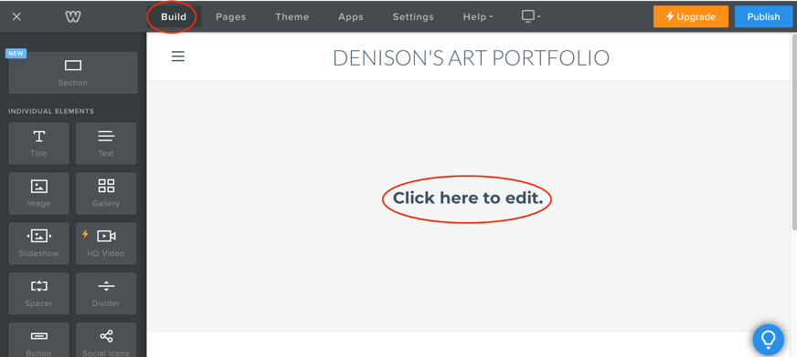

- Now click on “build” and then change the “click here to edit” to your class name. (you could also customize the background photo behind this text as well if you wanted.)
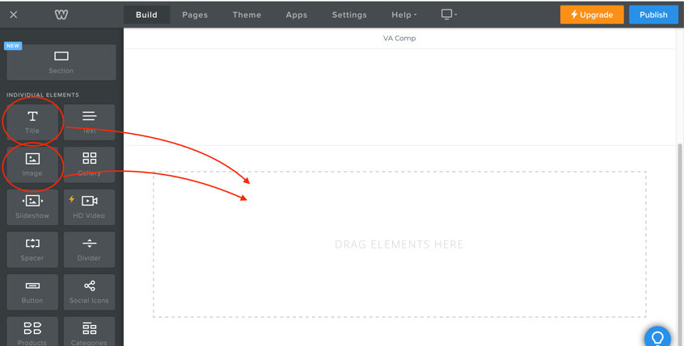

- You will then drag the Title tile and the Image tile into the “drag elements here” section in order to upload photos and name each one. (You can just put a blank tile in place right now. We will work on uploading photos of our art at a later date.)

- Be sure to click “Publish” before you log out to make sure everything is saved.

- Hand the sticky note with your weebly information to Mrs. Denison! Congrats! You have made a digital portfolio site!!!!

