PART ONE: MAKING A WEBSITE FOR YOUR PORTFOLIO ON WEEBLY

- Go to http://students.weebly.com
- Login (your username is your student id #+art; password is leonardo1)
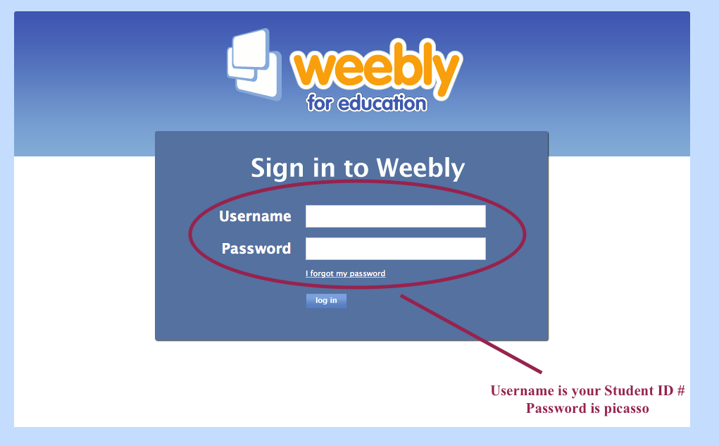
Username is your student ID+art (ex: 123456art) Password is leonardo1
- Click on “edit site” (see picture below)

- It will prompt you to pick a domain name for your site. Choose something artsy that includes your first or last name: (ex: DenisonDesigns.weebly.com OR CreativeChristy.weebly.com OR thewickedartofryan.weebly.com )
  - be sure whatever you choose is school appropriate!
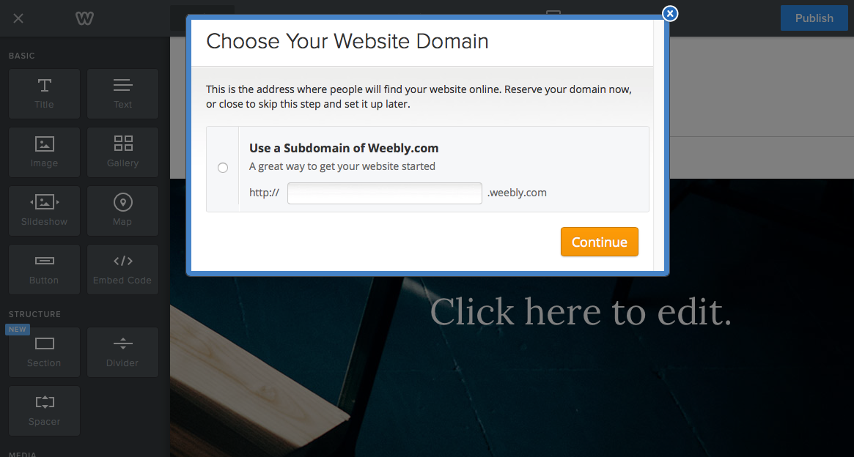
- Your website will begin by looking like this (see below)
  - You will change “my site” to a name of your choice (make sure it includes your first name!).
  - Change the headline to “My Art Page” (the home page will become your “my Art” page
  - Change the background image by clicking “edit image”

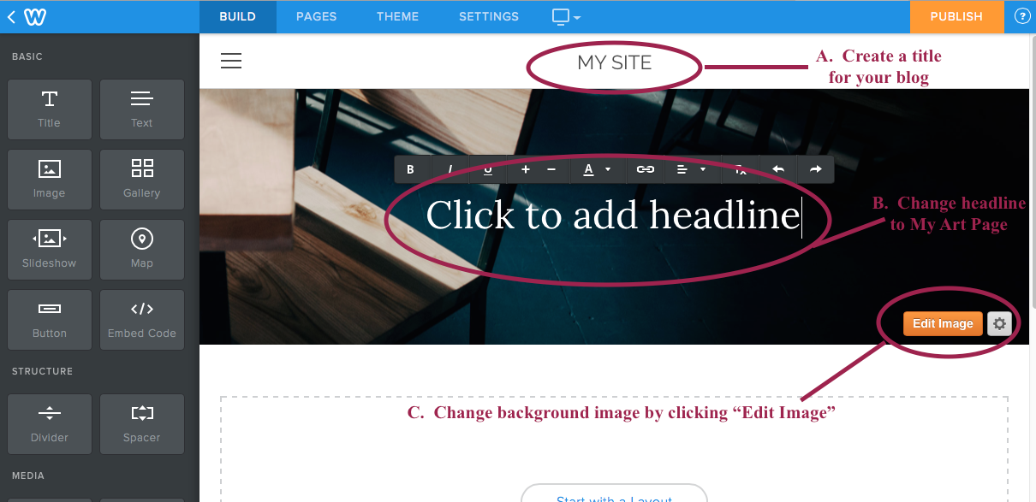

- Change the main image on your website to something that represents you and your ideas/thoughts about Art. You can search the internet and find an image or you can use an image you already have. The image should be appropriate for school and not include images of violence, drug use, cursing, or rude language or dress. To change the image, click on “edit image.” The website will walk you through the process. Once you are done, click “SAVE” at the top right of the screen.

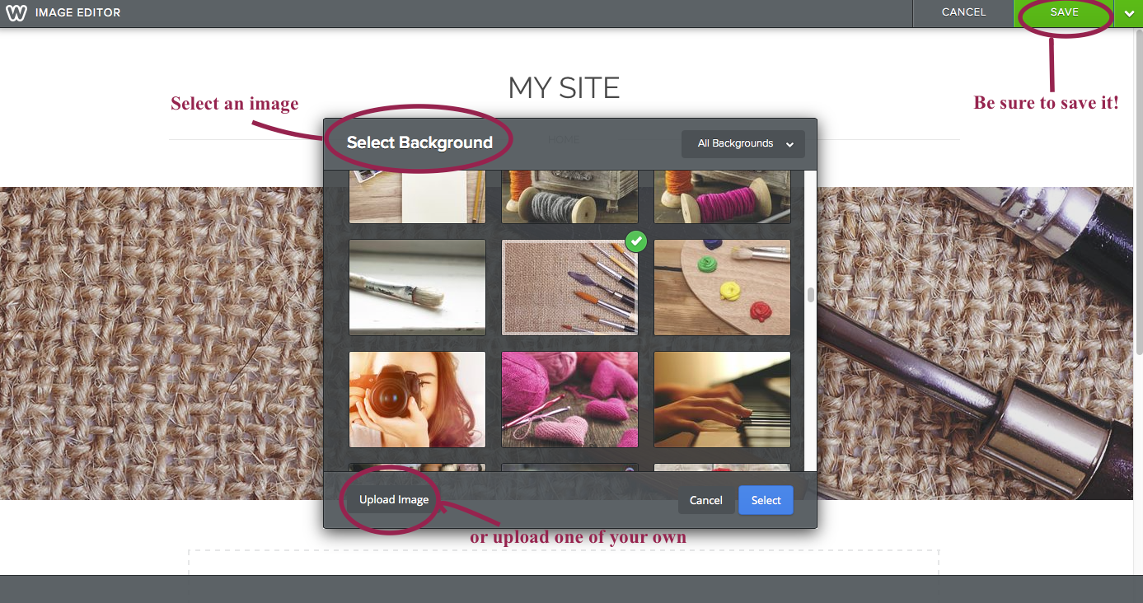

- Pick a design theme for your website by clicking on “design” at the top of the page (see example below). You can pick any theme you like. For this example, I am going to keep the same theme.
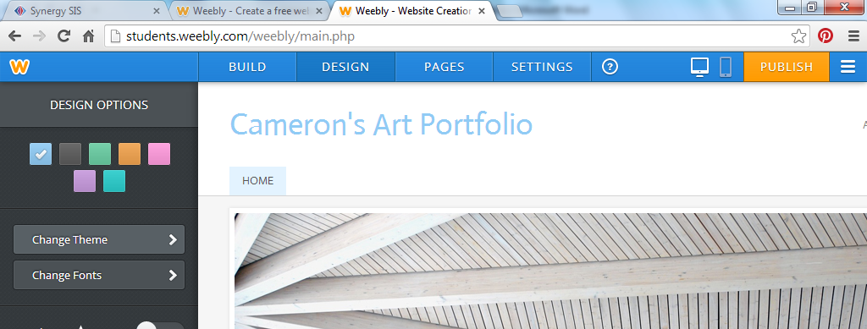

- Change the main image on your website to something that represents you and your ideas/thoughts about Art. You can search the internet and find an image or you can use an image you already have. The image should be appropriate for school and not include images of violence, drug use, cursing, or rude language or dress. To change the image, click on “edit image.” The website will walk you through the process. Once you are done, click “SAVE” at the top right of the screen.
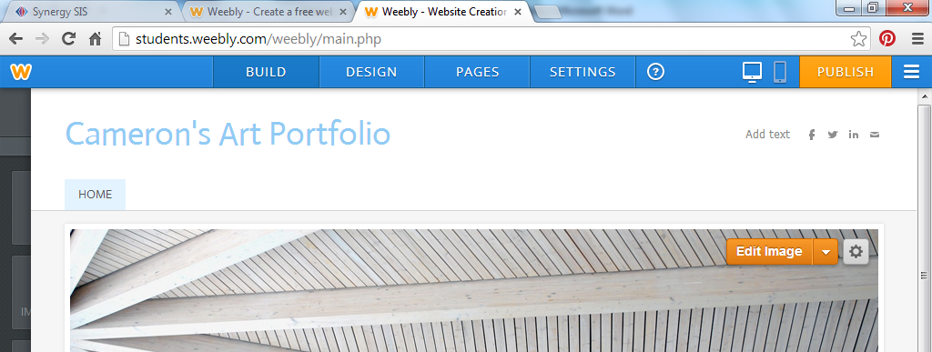
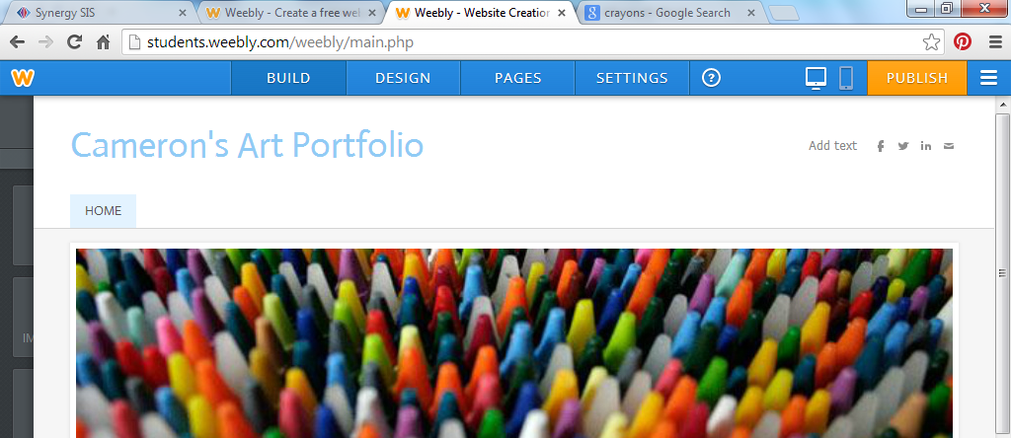

- You are now ready to publish. Click on “Publish” in the top right corner, and your website will go “live” and people can now view it.

Continue on to Part 2 Below:

Making Pages for the Website

PART TWO: MAKING PAGES FOR YOUR WEBSITE
We will make pages for our websites wherein we will place different assignments. Follow these steps to make your pages.

- Click on “pages” at on the top menu (see example below)
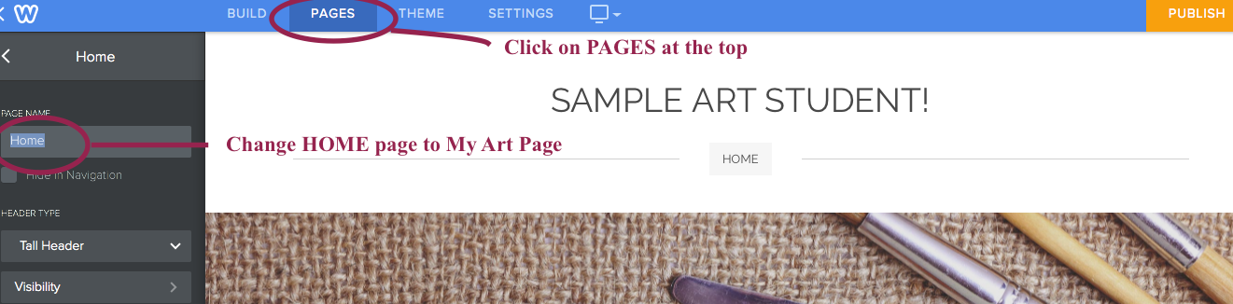

- Click on “Add a Page” and choose “Standard Page”

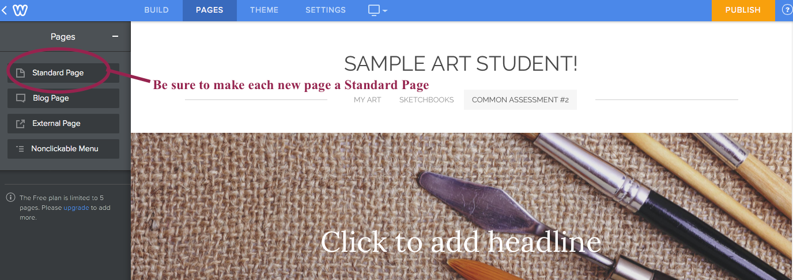

- Continue following the steps for part 2 again, and make additional standard pages, so you should have a total of 3 pages: (4 pages for AP Students and Photography Students)
  - “My Art” page
  - “Sketchbook” page (Concepts Page for Photo students)
  - “More Artwork” page (this you can use for previous artwork; art you do on your own, photographs, etc.)
  - For AP and Photography only: “Final Portfolio Images” page

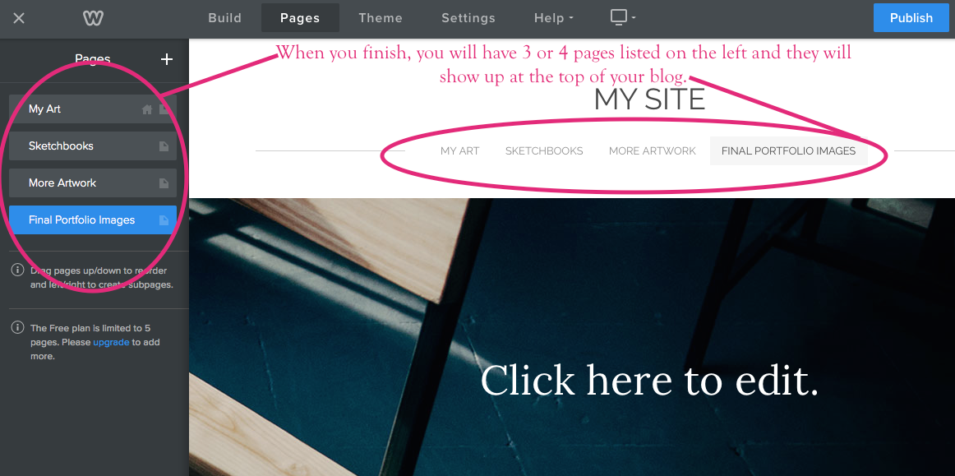

Continue on to Part 3 Below:

Adding images and elements to your pages

PART THREE: ADDING IMAGES AND ELEMENTS TO YOUR PAGES
The pages will be where everything you do in VA Comp is added. Project will go on the “MY ART” page, sketchbooks on the “SKETCHBOOK” page, etc. You can add pictures and elements to these pages using the following steps:

- Once on the BUILD tab, Click on “Image” and drag it over to the part of your screen that reads “drag elements here”
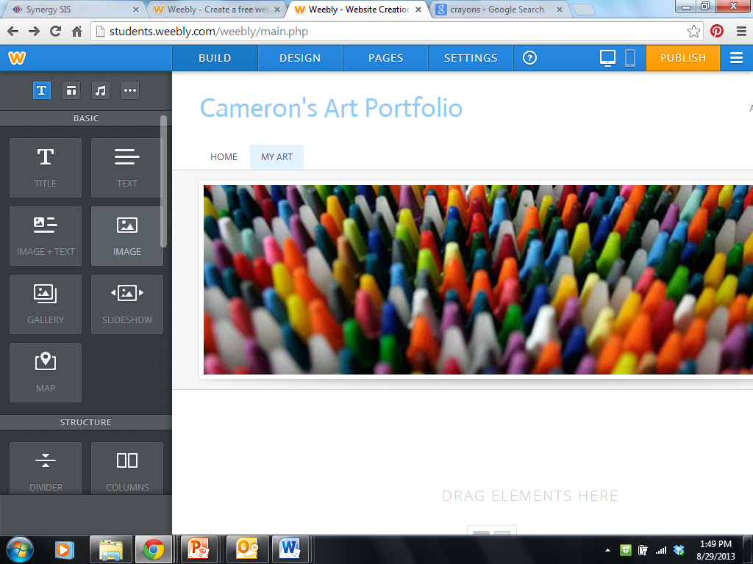

- Click on “upload image” and follow the directions to upload an image of your art.
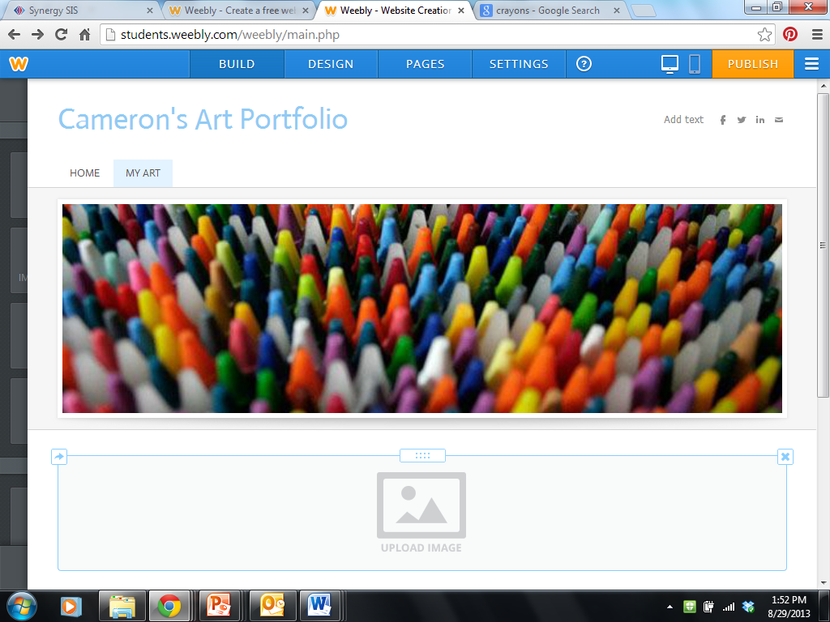

- You can resize the image after you upload it.
- Don’t forget to click “Publish” so your changes will go live!!!

