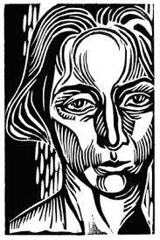
Printmaking

--------- LINOCUT Black and White--------------------------------

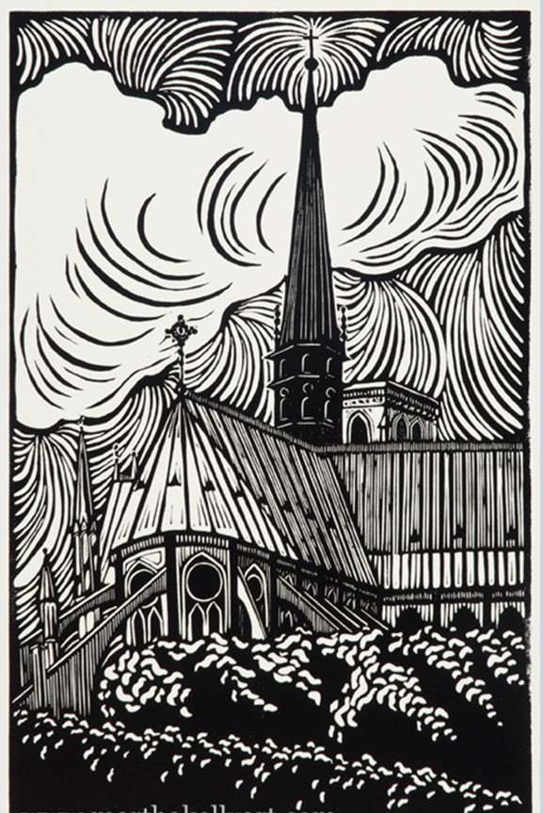
STEPS TO FOLLOW:
- Brainstorm several ideas of what would make a good black and white print. (landscape, portrait, animal, insects, flowers, etc.) You may want to use your photographs as a subject matter and draw at least one or two thumbnail sketches.
- Next, pick the best design to enlarge and do a 6x8 value drawing of the image. Be sure to fill the space and have an even amount of lights and darks.
- Then, you will transfer your design onto the 6x8 linoleum block.
- Once you design is transferred, you will begin carving out the WHITE areas with the linoleum cutter.
- Once you have carved out all the white, you will then begin printing. (see Ms. Denison’s demo)
- You will need to turn in an edition of 5 good quality B&W prints, 3 quality on color, and 2 manipulated prints.

Student Name:  Lesson: Linoleum Relief Printmaking |  |  | Class Period:
Circle the number in pencil that best shows how well you feel that you completed that criterion for the assignment. |  | Excellent |  | Good | Average | Needs Improvement
Criteria 1 – Drawing Element: original subject is well drawn and added value. |  | 10 |  | 9 – 8 | 7 | 6 or less
Criteria 2 – Composition: good use of positive/negative space. Subject matter fills the space and there is a good focal point. |  | 10 |  | 9 – 8 | 7 | 6 or less
Criteria 3 – Carving technique: Used a variety of gouges to create linear movement in the design. The carving should create a variety of values within the element. About 50/50 black/white ratio is maintained within the print carving. |  | 10 |  | 9 – 8 | 7 | 6 or less
Criteria 4 – Printing Technique – Print is evenly covered with ink. (not too much or too little ink used) Print is registered carefully in the center of the paper. Print is signed in pencil. |  | 10 |  | 9 – 8 | 7 | 6 or less
Criteria 5 – Effort: took time to develop idea & complete project? (Didn’t rush.) Good use of class time? |  | 10 |  | 9 – 8 | 7 | 6 or less
Criteria 6 – Craftsmanship – Neat, clean & complete? Skillful use of the art tools & media? |  | 10 |  | 9 – 8 | 7 | 6 or less
Total: 50  (possible points) | Grade:

Fig 1: Three designs of periodic elements. You will shade your best design to see which areas will be black or white on your print.

Fig 2: Once your design is drawn into the linoleum, you will cut out the WHITE areas using the linoleum cutting tools.

Fig 3 & 4: You will use the print block to create an edition of 3 QUALITY prints to turn in. You may print more, but you can only turn in 3.
Fig. 1
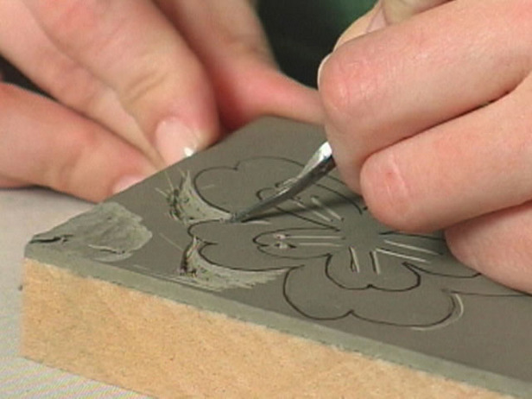

Fig. 2

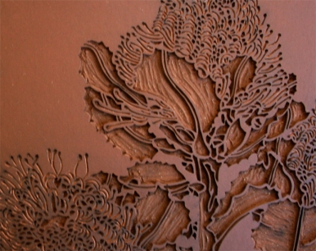
Printmaking Vocabulary
Edition: a series of prints made form the same plate
Proof: the first print made from a plate (not part of the edition)
Relief Printing: printing from a raised or depressed surface example: potato printing, rubber stamps, thumbprints
Plate: a flat surface used for printing - the image will be backwards on it
Brayer: a small roller used to apply the ink to the plate
Baren: an instrument used to create pressure between the plate, ink and paper
U-Gouge: tool that cuts out larger areas
V-Gouge: tool that cuts out finer lines

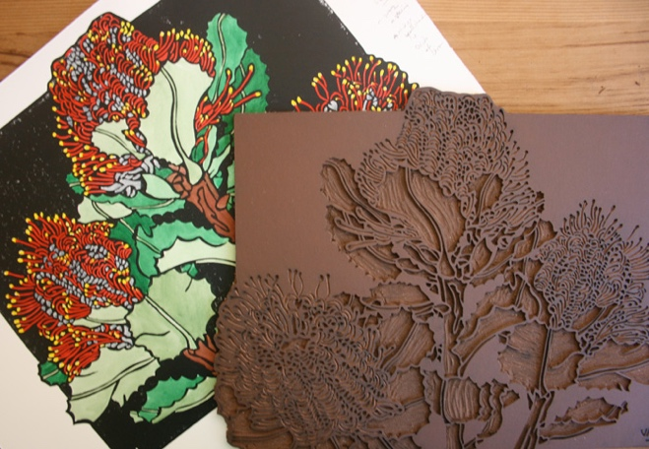

Fig. 3 & 4

