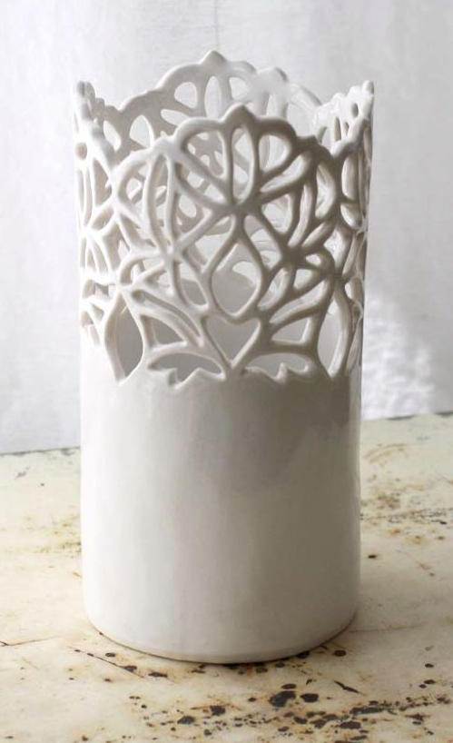
Step 1: First create 2-3 practice sketches of the overall shape of your slab lantern. Include what designs you will pierce into the slab to create the negative space.

Step 2: Next, decide on the size of your lantern (diameter and height). Wrap newspaper around the PVC pipe with your chosen diameter and tape it to itself (NOT the pipe.) Then make a prototype out of poster paper to figure out the size of the slab you will need.

Step 3: Use the prototype poster to figure our how big of a slab to create. Roll out your slab and cut to the appropriate size.

Step 4: Wrap the slab around your PVC pipe that is covered with newspaper and attach it to itself. (slip and score) Smooth out the seams.

Step 5: Begin drawing out your design lightly onto the lantern slab.

Step 6: Once your design is transferred, begin cutting out the negative space.

Step 7: Wrap up completely each night so that it doesn’t dry too quickly and crack.

Step 8: When you are finished cutting out the negative space design, remove the PVC pipe and newspaper from the inside.

Step 9: Create finishing details. Focus on CRAFTSMANSHIP!!
Allow to dry SLOWLY to avoid cracks or warping.

Step 10: Once it has been bisque fired, use ONE glaze inside and out to finish.

Lantern
---------soft slab with piercings----------------
Student Name:
Lesson: Lantern
Circle the number in pencil that best shows how well you feel that you completed that criterion for the assignment. |  | Excellent | Good | Average | Needs Improvement
Criteria 1 – Structure/ Functionality: Created a successful slab construction with no cracks or visible seals. Lantern is functional. The surface of the lantern is free of structural cracks crumbling or ragged edges. |  | 10 | 9 – 8 | 7 | 6 or less
Criteria 2 – Negative Space Design: Clay was removed in a meaningful way to create a successful design. |  | 10 | 9 – 8 | 7 | 6 or less
Criteria 3 –Surfacing: Creative, well-thought out glazing and/or surfacing techniques applied with good craftsmanship. ONLY ONE GLAZE USED INSIDE AND OUT!!! |  | 10 | 9 – 8 | 7 | 6 or less
Criteria 4 – Effort: took time to develop idea & complete project? (Didn’t rush.) Good use of class time? |  | 10 | 9 – 8 | 7 | 6 or less
Criteria 5 – Craftsmanship – Neat, clean & complete? Skillful use of the art tools & media? |  | 10 | 9 – 8 | 7 | 6 or less
Total: 50  (possible points) |  | Grade:

