Directions:
- First read the article on Alberto Giacometti and fill out the Artist’s Profile on Giacometti using the information gained from the article.
- Next, sketch out some ideas for your own Giacometti inspired figure in the space provided on the back of this sheet. (no fewer than 3 sketches)
- Remember, you may add props to your figure as long as your figure is elongated like Giacometti’s figures.
- Then, you will okay your final sketch with Ms. Cooper.
- You will get two wire hangers, one for the head, shoulders, and arms, one for the body and legs.
- You will then cut out a torso, hands and feet with scraps of cardboard.
- Put these together with small strips of masking tape.
- You will then use papier-mâché to add texture to the armatures.
- Once the papier-mâché has dried, we will glue the sculptures to the base, and paint the sculptures black.
- Last, we will rub a metallic paint onto the sculptures to give it a “finished” look.
Assemblage: Identity Box

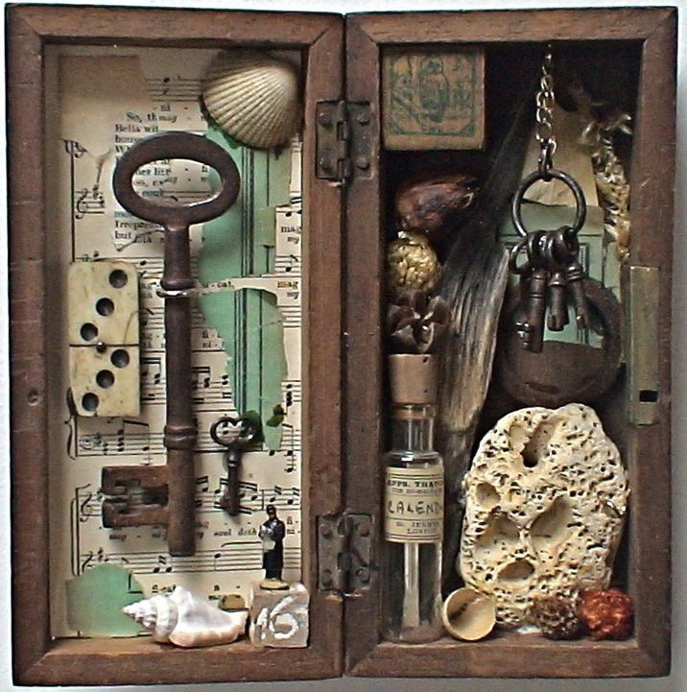
- Interpret the work of Lucas Samaras and Joseph Cornell.
- Describe their use of diverse symbols and objects to signify new meaning and identity.
- Define and explore personal and cultural identity.
- Identify and compile materials related to personal and cultural identity.
- Create “identity boxes” with artistic representation of your internal and external identity.

Before you begin….

Project Criteria:
The box that the students will create a box is symbolic in that the outside
of the box represents the external self and the inside of the box represents
the internal self, or what one is choosing to reveal. You can use readymade
objects, drawings, symbols, written expression & minimal logos to
represent your identity. The outside should represent your external
The box that you will create is symbolic in that the outside of the box represents the external self and the inside of the box represents the internal self, or what one is choosing to reveal. You can use readymade objects, drawings, symbols, written expression & minimal logos to represent your identity. The outside to represent your external identity, the inside of the box represents your internal identity.

External Identity—refers to how other individuals interpret who you are and what your public image is as a consequence of what you do, say, and how you look.

Internal Identity—refers to how you see your ideal self and who you want to be. This is the identity you wish others to see.
In your sketchbook:
Alter two pages in your sketchbook and divide it in half. Create 2 category lists Internal & External identity traits on one page. On the second page, create a list of objects that you can incorporate into the box design that represent these traits. (baby items, mementos—any object that represents something about you or has special significance.)

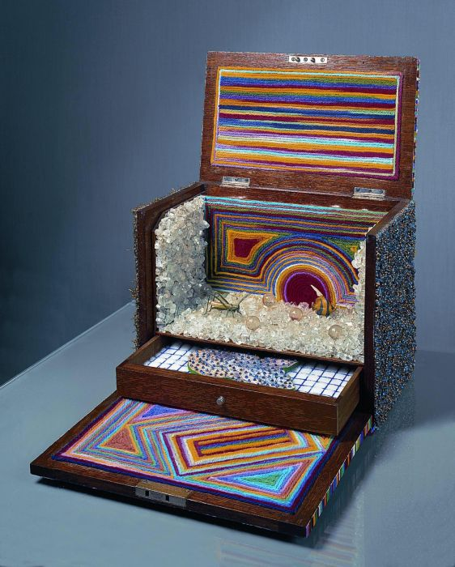
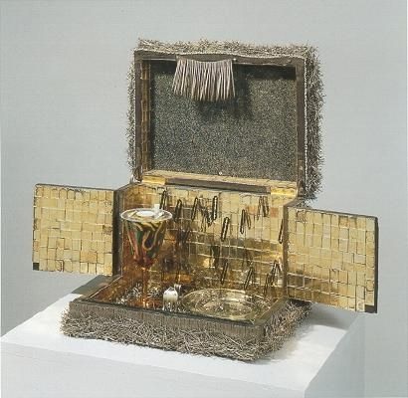

Assignment:
Assemblage: Identity Box
Circle the number in pencil that best shows how well you feel that you completed that criterion for the assignment. |  | Excellent | Good | Average | Needs Improvement
Criteria 1 – Sketchbook planning: Creation of a internal/ external identity traits list. Added list of possible items. Overall plan of the construction of the box. |  | 10 | 9 – 8 | 7 | 6 or less
Criteria 2 – Creative use of materials: The items on the outside represent external identity traits. The items on the inside tell a story of your ideal self. Items are well thought out and added. |  | 10 | 9 – 8 | 7 | 6 or less
Criteria 3 – Assemblage Construction: The craftsmanship and organization of how the items fit together is interesting and unified. |  | 10 | 9 – 8 | 7 | 6 or less
Criteria 4 – Effort: took time to develop idea & complete project? (Didn’t rush.) Good use of class time? |  | 10 | 9 – 8 | 7 | 6 or less
Criteria 5 – Craftsmanship – Neat, clean & complete? Skillful use of the art tools & media? |  | 10 | 9 – 8 | 7 | 6 or less
Total: 50 x 2  (100 possible points) | Grade:

