**Hot Off the Press**

Advanced Drawing/ AP 2D Design

**Objective: Students will create a work of art based on an article from the newspaper. Students will incorporate the actual newspaper into the artwork in an innovative way. Students should use their knowledge on composition, media exploration, and color to create a narrative work that is evocative to the viewer. The overall goal is to have a visual representation to your reaction of the article, not just the facts.**

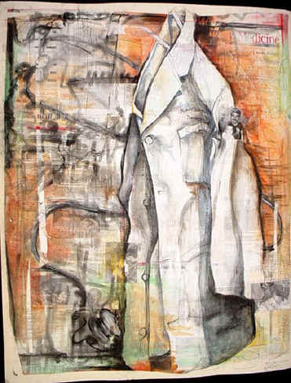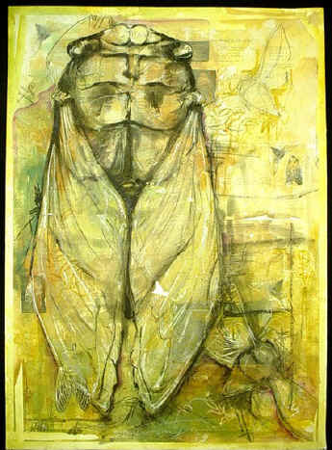

**Directions:**

* Begin by selecting a newspaper to read.
* Read through each section and mark articles of interest.
* Limit to five articles.
* Create a brainstorming list. Below each article list 10 concrete and abstract concepts that come to you after reading each article.
* Narrow down the most visual ideas to **two** and create two thumbnails for each. Remember to think outside the box. **Think like an artist who is reacting to the article** not one who is just stating the fact.
* Review thumbnail, color, and media choices with the Mrs. Denison and begin.

SURFACE MANIPULATION IS A MUST!!!---SEE OPTIONS!

**Objective: Kell High School has the EXCLUSIVE privilege of creating artwork for this year’s inductions to the Atlanta Sports Hall of Fame. This is a VERY prestigious honor! Each student will select one of this year’s inductees to create an artwork that will be presented at the induction ceremony on February 16th.**

**Atlanta Sports Hall of Fame!!!**

**DIRECTIONS:**

1. **Select one of the 5 inductees from this year.**
2. **Research their contribution to ATLANTA sports.**
3. **Collect and print out images that you can use in your artwork.**
4. **Sketch out ideas in your visual journal—mind maps are great too!**
5. **Gather your materials, and GO!!**

**--You must include:**

* **A portrait of the inductee (this must be accurate so that he or she will be recognized and it should be the main focal point.) Collaging several images of the inductee within the work would be acceptable.**
* **At least 3 mixed media layers**
* **SURFACE MANIPULATION** Here are some ideas for manipulating your surface:
* 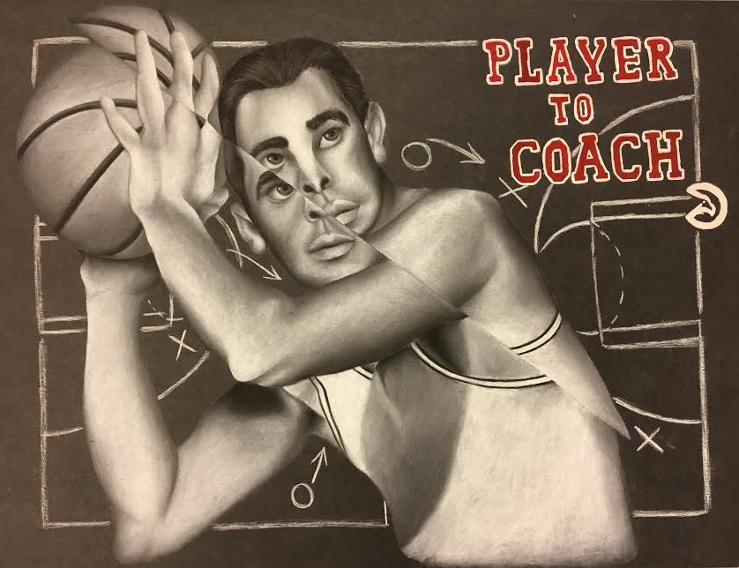Collage white paper on white paper; collage newspaper, then watercolor wash; collage neutral toned paper; collage recycled art or magazines, then use watered down gesso to unify background; collage patterned paper.
* Create works on cardboard, then rip through to the textured layer of cardboard.
* Draw on top of maps, paper bags, dress patterns, paint chips, on top of a broken down box.
* Bright watercolor abstraction for the surface, then draw on top with charcoal or ink.
* Paint on top of collaged 3D relief items such as computer parts, discarded CDs, discarded computer discs, etc.