Student Name:

Lesson: Exotic Environments
Circle the number in pencil that best shows how well you feel that you completed that criterion for the assignment. |  | Excellent | Good | Average | Needs Improvement
Criteria 1 – Composition: Overall composition is well thought out with layered tropical plants. Nothing is too clustered on top of one another and there is not too much negative space either. |  | 10 | 9 – 8 | 7 | 6 or less
Criteria 2 – Zentangle Patterns: Each tropical plant has its own style of Zentangle patten within using black sharpie designs. Good craftsmanship is used within each design. |  | 10 | 9 – 8 | 7 | 6 or less
Criteria 3 – Background: The background is covered in a thin wash of watercolor. Shading has been added around the plants with watercolor colored pencils and then blended in to the background wash. |  | 10 | 9 – 8 | 7 | 6 or less
Criteria 4 – Effort: took time to develop idea & complete project? (Didn’t rush.) Read the article and followed the steps within. Good use of class time? |  | 10 | 9 – 8 | 7 | 6 or less
Criteria 5 – Craftsmanship – Neat, clean & complete? Skillful use of the art tools & media? |  | 10 | 9 – 8 | 7 | 6 or less
Total: 50  (possible points) /50 pts | Grade:

-------- Shape Collage & Linear Textures -------------------------------------

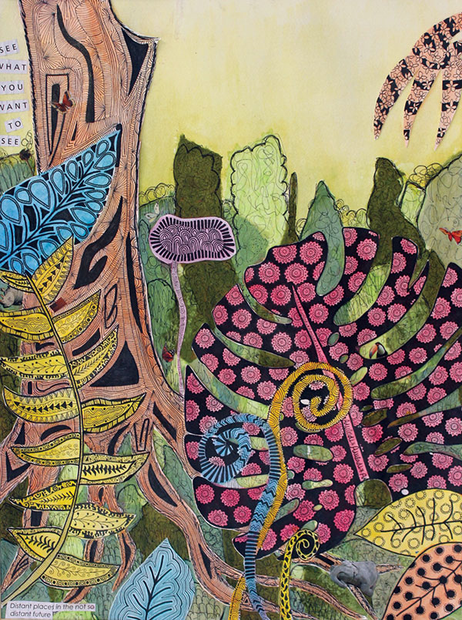
STEPS TO FOLLOW:
- First, you will research and draw at least 6-10 types of tropical plants in your sketchbook.
- You will then combine these plants to create a sketch of an exotic environment.
- Next, you will pick a selection of colored papers to draw out each of your tropical plants.
- Cut these out and collage them to your background page.
- You will then create a watercolor wash on the background.
- Then, you will cover the collaged paper shapes with sharpie zentangle patterns.
- Finally, you will need to shade around plant shapes with colored pencil that will blend into the background wash.

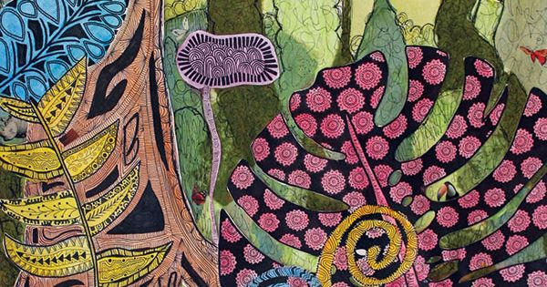

Symbolic Design #3
Symbolic Design #2

