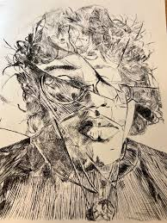
Etching

--------- Dry point on Plexiglass--------------------------------

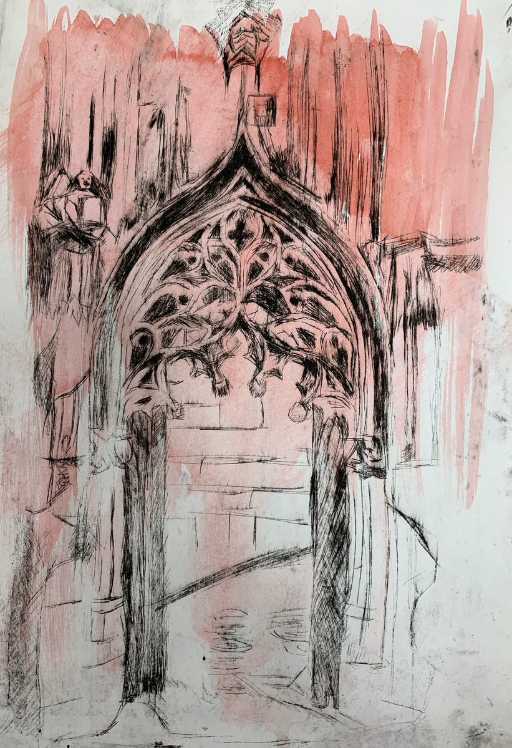
STEPS TO FOLLOW:
- Brainstorm several ideas of what would make a good dry-point etching. (landscape, portrait, animal, insects, flowers, etc.) You may want to use your photographs as a subject matter and draw at least one or two thumbnail sketches.
- If using a photograph, then edit it to black and white and put a “drawing” filter onto it. Print this out as a 5x7 or 6x8
- If working from a drawing, be sure to draw it out as a 5x7 or 6x8 and be sure to include values.
- Place the Plexiglass overtop of the drawing or photograph and scratch out the contour lines with the scratch tool. Use hatching/cross-hatching/ scumbling tools to add values.
- See demo for how to add the ink/ wipe off the excess/ soak the paper/ and print!
You will need to turn in an edition of 5 good quality B&W 1 chine collé and at least 1 manipulated print.

Student Name:  Lesson: Linoleum Relief Printmaking |  |  | Class Period:
Circle the number in pencil that best shows how well you feel that you completed that criterion for the assignment. |  | Excellent |  | Good | Average | Needs Improvement
Criteria 1 – Drawing Element/ etching technique original subject is well drawn and added value. Good use of scratch tool to add hatching/cross hatching, etc. |  | 10 |  | 9 – 8 | 7 | 6 or less
Criteria 2 – Composition: good use of positive/negative space. Subject matter fills the space and there is a good focal point. |  | 10 |  | 9 – 8 | 7 | 6 or less
Criteria 3 – Values: values are created with hatching/cross hatching/scumbling and other scratching techniques. Values also created by the amount of ink left on the plate. |  | 10 |  | 9 – 8 | 7 | 6 or less
Criteria 4 – Printing Technique – Print is evenly covered with ink. (not too much or too little ink used) Print is registered carefully in the center of the paper. Print is signed in pencil. |  | 10 |  | 9 – 8 | 7 | 6 or less
Criteria 5 – Effort: took time to develop idea & complete project? (Didn’t rush.) Good use of class time? |  | 10 |  | 9 – 8 | 7 | 6 or less
Criteria 6 – Craftsmanship – Neat, clean & complete? Skillful use of the art tools & media? |  | 10 |  | 9 – 8 | 7 | 6 or less
Total: 50  (possible points) | Grade:

Fig. 3 & 4

