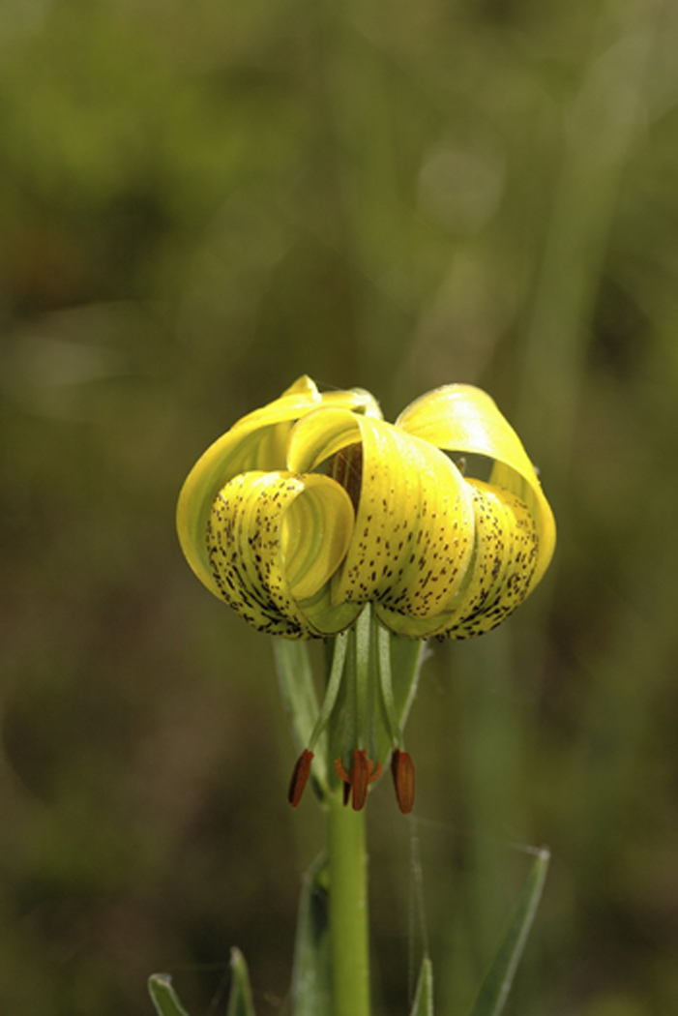

DRAWING & PAINTING 2 EMPHASIZES INDIVIDUALIZATION IN ADVANCED DRAWING, RECOGNITION OF UNDERLYING STRUCTURE COMMON TO ALL FORMS, AND INTRODUCES COLOR WITH PAINTS. BASIC PAINTING TECHNIQUES ARE INTRODUCED. STUDENTS ARE ENCOURAGED TO EXPLORE WATERCOLOR, ACRYLIC AND TEMPERA TECHNIQUES AND THE WORK OF RELATED ARTISTS. STUDENTS WILL ALSO BE EXPOSED TO A WIDE VARIETY OF CONTEMPORARY ARTISTS. GREATER SOPHISTICATION IN THE USE OF DRAWING AND INDIVIDUAL EXPRESSION IS EXPECTED. STUDENTS WILL USE A WIDE VARIETY OF MEDIA, TOOLS, PROCESSES, AND TECHNIQUES TO CREATE DRAWINGS THAT IMITATE THE REAL WORLD. SPECIFIC ATTENTION WILL BE PLACED ON FORMAL DESIGN AND COMPOSITION AS WELL AS EXPRESSION IN ART.

[www.kellhighschoolart.weebly.com](http://www.kellhighschoolart.weebly.com) julie.denison@cobbk12.org

Drawing & Painting II

GRADE BREAKDOWN:

* **Summative**-----------------------------------**70%**
* **Formative** -----------------------------------**20%**
* **Final Exam**(S)------------------------------**10%**
* **Unweighted Mastery Scale:** Graded 1-4

Policies & Expectations

**RESPECT:** Be respectful of others, their property, and their artwork.

**PHONES**: Phones are to be kept off and out of sight at ALL times during class hours, unless you have permission to use them.

**FOOD/ DRINKS:** ALL food, drinks, candy and gum are to be kept in backpacks at all times. Spills ruin dreams!

**INTEGRITY:** No cheating or stealing will be allowed. This includes taking work (designs or text) from the Internet.

**OFF LIMITS:** ALL storage areas, office areas, darkroom and still-life items are OFF LIMITS, unless you have permission.

**PASSES:** the Lanyard is your pass out—must wear around your neck. No passes during “Dead Time” (the first & last 15 min of class).

**SAFETY:** You are responsible for your own safety and the safety of others. Art equipment whether new or old is expensive and difficult to replace, therefore, you are expected to:

* + Understand techniques and procedures prior to using equipment.
  + Handle all art equipment properly
  + Report any accident to the teacher immediately
  + Learn the location of safety equipment and first aid.
  + Keep workstations clean and organized.
* **4 = Mastery**
* **3 = Adequate Progress**
* **2 = not adequate, shows growth**
* **1 = not adequate, little to no growth**

**In an effort to keep students engaged and reduce distraction, students are required to place their phone in the designated ‘Phone Lock Box’ as they enter class. Phones will stay there until the teacher gives students permission to retrieve them.**

*Students who refuse to give up their phone or have a phone that is seen during class will incur the following consequences:

1st offense: Teacher warning

2nd offense: Teacher phone call home

3rd offense: Teacher detention

4th offense: Administration Referral

Cell Phone Policy

**REQUIRED SUPPLIES**

1. 8 ½ x 11” Sketchbook
2. 2 paintbrushes various widths
3. White eraser (Magic Rub brand)

**\*\*\*\*\*\*\*OR\*\*\*\*\*\*\***

**Bring in a $10.00 lab fee donation and all of the above supplies will be provided for you!!!! Can also be done on MyPaymentsPlus.**

Here is a list of recommended art supplies if you want to buy supplies to use at home:

* PRISMA Colored pencils (set of 12)
* Large Kneaded eraser
* Charcoal sticks
* Graphite Pencils H, 6B
* Watercolor set
* SHARPIE Pens (black fine, and extra fine point)
* Hand held pencil sharpener

*ABOVE ITEMS CAN BE PURCHASED AT: Michael’s, Blick, or Hobby Lobby.

Supplies Needed:

Class information, syllabus, and pacing guide will be available on my BLOG:

[www.kellhighschoolart.weebly.com](http://www.kellhighschoolart.weebly.com)

Please view the blog frequently to stay informed!!!!

**Altered Book**

**(worth 2 summative grades):**

**You will be required to get a used hardback book with at least 50 pages to use as an artwork. We will be working periodically throughout the semester on experimental techniques feature a theme of your own choosing.**

* Collaged paper layers
* Use of a Quote
* Famous painting interpretation
* Border OR Photo Transfer
* Use of a Pocket
* Use of a Niche
* Cover design (your choice!)

**Summative: 70%**

**This category is worth 70% and is what we will spend the majority of our time on this semester.**

**We will be working on the following projects this semester:**

* Contour Portraits
* Watercolor Batik
* Alphonse Mucha Inspiration
* Abstract Exploration
* Renaissance Self Portrait
* Reflective Still Life
* Map Painting series
* Gustav Klimt Scratchboard
* Altered Book

**Formative: 20%**

Sketchbooks and altered books will alternate in this category.

You will need to get or make a sketchbook for this class. We will be working in the sketchbook daily. Sketchbooks and altered book assignments will also be worked on weekly and homework and should be turned in on Wednesdays. You will be getting a sketchbook handout with detailed instructions and additional images and examples can be on my blog: <http://kellhighschoolart.weebly.com/sketchbooks-dp2.html>

You can also get bonus points in this class by going above and beyond the work required in your sketchbook!

**Other things that will be graded:**

**Responding: grades that talking about art (yours/others)writing about art, etc.** These could be Formative, Summative, or Unweighted.

**Presenting: grades that deal with picking artwork for shows, prepping art for shows, creating an online art portfolio.** Summative

**Connecting: grades that involve connecting what we are working on to art history, other subjects, or the world around us. Formative or Unweighted**

**Ticket out the Door: At the end of EACH CLASS PERIOD, you will take a photo of whatever you got done in class that day and send it to me through the Remind app. Formative or Unweighted**

**Online art presentation:**

**Part of your Summative grade will be a collection of your work that will be required to display in a digital online portfolio.**

* **You will take photographs of all your artwork this semester. (projects, altered book assignments, and sketchbook assignments)**
* **You will choose a digital platform to display your work. (weebly.com)**
* **You will send me a link to your online portfolio and we will have periodic checks throughout the semester.**
* **At the end of the semester, this will be worth a summative grades.**