Student Name:
Assignment:
Doll’s Head Assemblage Sculpture
Circle the number in pencil that best shows how well you feel that you completed that criterion for the assignment. |  | Excellent | Good | Average | Needs Improvement
Criteria 1 – Overall form: The overall creation is interesting and pleasing from multiple sides. |  | 10 | 9 – 8 | 7 | 6 or less
Criteria 2 – Creative use of materials: Students didn’t just throw together a bunch of items, but thoughtfully constructed a sculpture using a variety of assembled materials. Students were creative in the use of materials and choices they made. |  | 10 | 9 – 8 | 7 | 6 or less
Criteria 3 – Assemblage Construction: Students used problem solving skills to create a sturdy construction that was well put together. (pieces are not falling off, but carefully assembled and joined) |  | 10 | 9 – 8 | 7 | 6 or less
Criteria 4 – Effort: took time to develop idea & complete project? (Didn’t rush.) Good use of class time? |  | 10 | 9 – 8 | 7 | 6 or less
Criteria 5 – Craftsmanship – Neat, clean & complete? Skillful use of the art tools & media? |  | 10 | 9 – 8 | 7 | 6 or less
Total: 50 x 2  (100 possible points) | Grade:
Directions:
- First read the article on Alberto Giacometti and fill out the Artist’s Profile on Giacometti using the information gained from the article.
- Next, sketch out some ideas for your own Giacometti inspired figure in the space provided on the back of this sheet. (no fewer than 3 sketches)
- Remember, you may add props to your figure as long as your figure is elongated like Giacometti’s figures.
- Then, you will okay your final sketch with Ms. Cooper.
- You will get two wire hangers, one for the head, shoulders, and arms, one for the body and legs.
- You will then cut out a torso, hands and feet with scraps of cardboard.
- Put these together with small strips of masking tape.
- You will then use papier-mâché to add texture to the armatures.
- Once the papier-mâché has dried, we will glue the sculptures to the base, and paint the sculptures black.
- Last, we will rub a metallic paint onto the sculptures to give it a “finished” look.
Doll’s Head Assemblage Sculpture

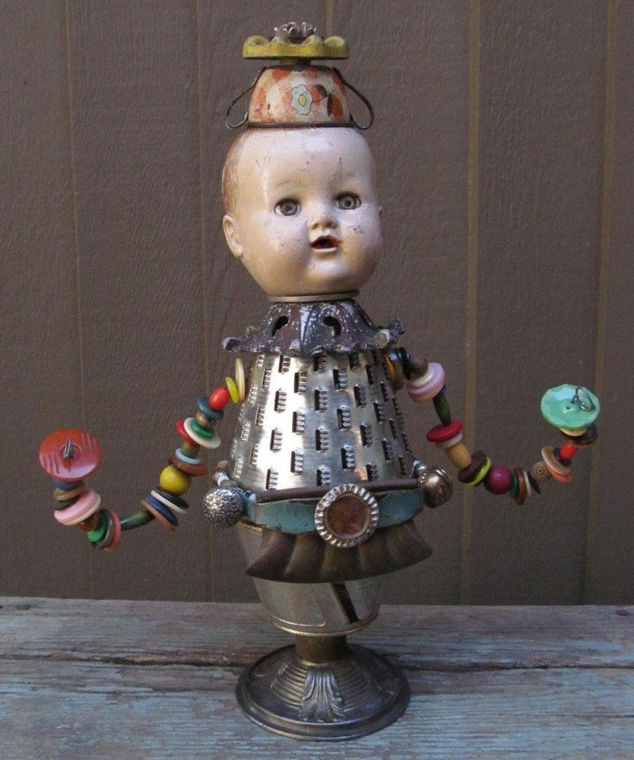
- Collect materials for your sculpture. (including a doll’s head)
- Use your visual journal to help envision how you could use these materials to create an assemblage sculpture.
- Begin assembling sculpture. Pay close attention to how you are joining various parts together. You could use glue, screws, brads, wire, fabric, etc.)
- Check construction as it should be sturdy.
- Once it is completed, photograph from multiple angles and post to your blog.

