Continuous Contour
------------------------ Portrait -------------------------------------

STEPS TO FOLLOW:
- Practice creating several continuous line portraits.
- Then, create 4-6 enlarged continuous line portraits using mirrors, photographs, or real life models.
- Then you will pick the most successful to outline with black sharpie.
- Then add LIMITED watercolor to enhance the lines you have created.
- When finished fill out the rubric and turn in to Mrs. Denison.

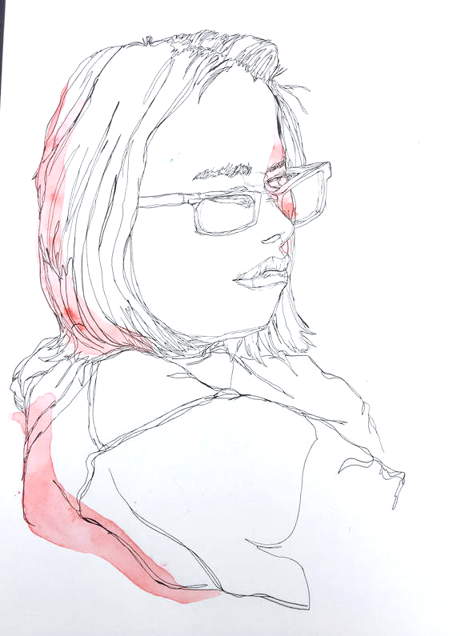
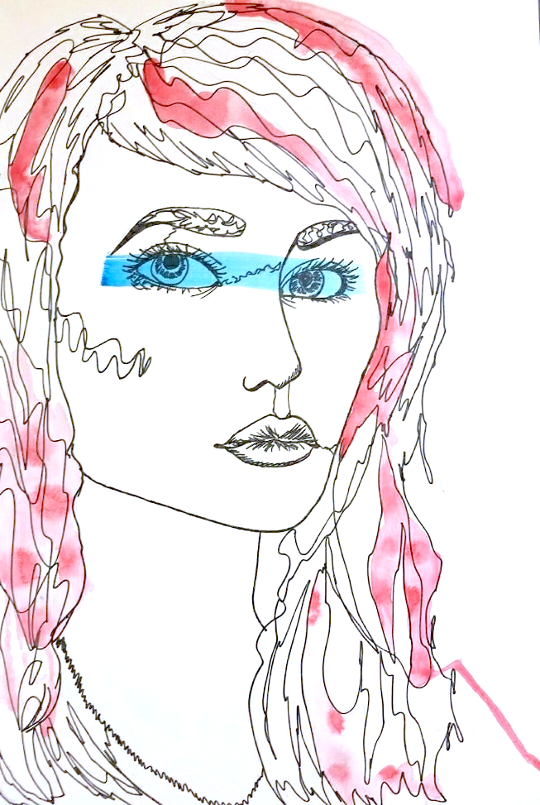

Student Name:
Assignment:
Contour with limited WATERCOLORS
Circle the number in pencil that best shows how well you feel that you completed that criterion for the assignment. |  | Excellent | Good | Average | Needs Improvement
Criteria 1 – Proportion: Accuracy of contours; Students concentrated on the accuracy of line, how one contour connected to another so the portrait looks like the model. |  | 10 | 9 – 8 | 7 | 6 or less
Criteria 2 – Continuous line: Students did not pick up the pencil to move from one contour to the next, but continued from one contour to the next. |  | 10 | 9 – 8 | 7 | 6 or less
Criteria 3 – Limited watercolor: students highlighted certain focal points with watercolor. The colors worked together and the amount of the watercolor was limited. |  | 10 | 9 – 8 | 7 | 6 or less
Criteria 4 – Effort: took time to develop idea & complete project? (Didn’t rush.) Good use of class time? |  | 10 | 9 – 8 | 7 | 6 or less
Criteria 5 – Craftsmanship – Neat, clean & complete? Skillful use of the art tools & media? |  | 10 | 9 – 8 | 7 | 6 or less
Total: 50 x 2  (100 possible points) | Grade:

