Colorizing Old Photos

Today’s Assignment:
You will colorize black and white photograph of Annie Leibovitz’s Disney series.
How to colorize photos.

1. Go to the STUDrive, Handouts, Denison, and then "Annie Leibovitz Photographs”
2. Choose your photo
3. Go to Pixlr.com
4. Click on the Butterfly (advanced)
5. Choose "open image from computer"
6. Go and find the Annie Leibovitz photograph you like
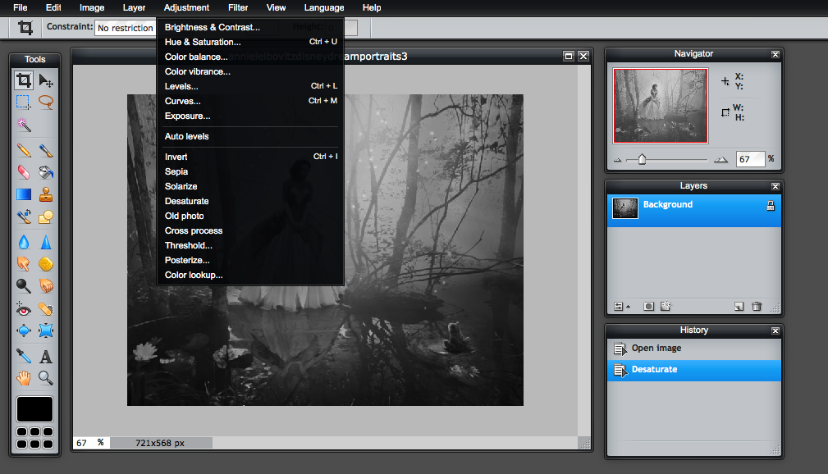
7. Your photo should now be open in Pixlr
8. Go to Adjustment and click Desaturate to make the photo become black and white

9.Click to create a new layer (see picture below)

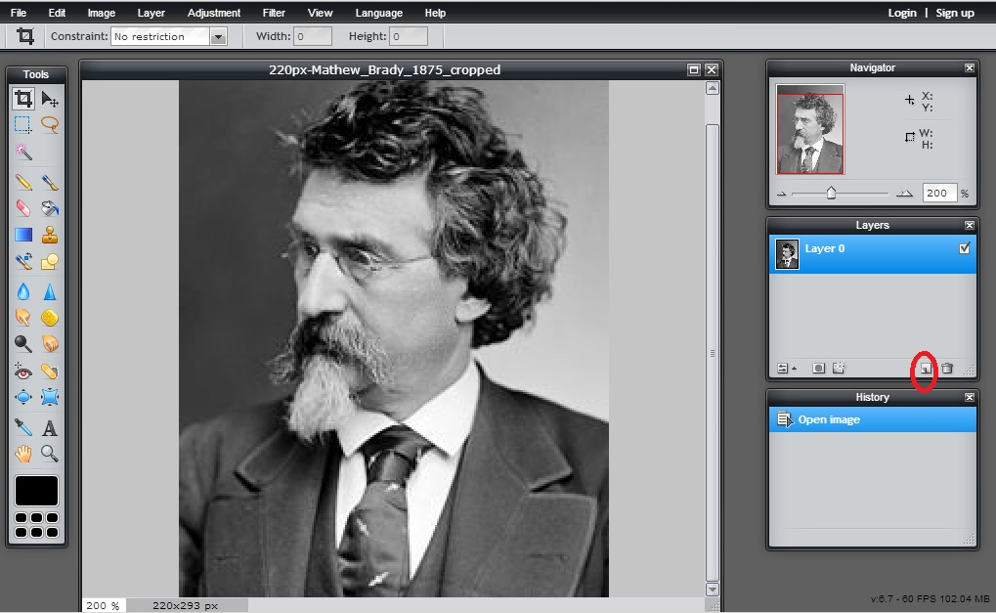

10. Use the magic lasso tool to draw an outline around an area you want to color (see picture below)
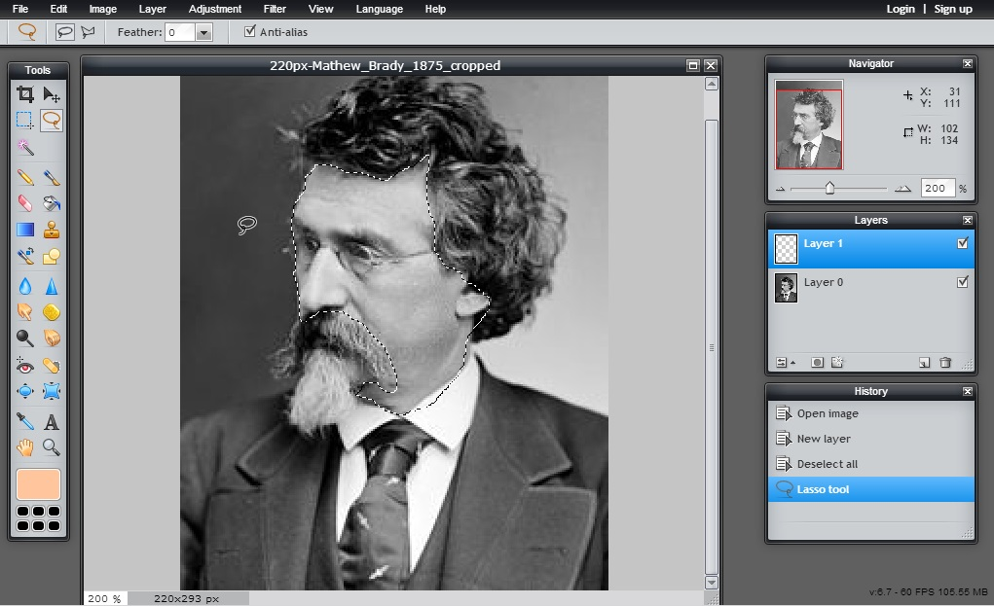

10. Click on the color chooser (in the bottom of the tool box) and choose a color. You probably want the color to be a pastel/pale version of the color you want (see photo below).
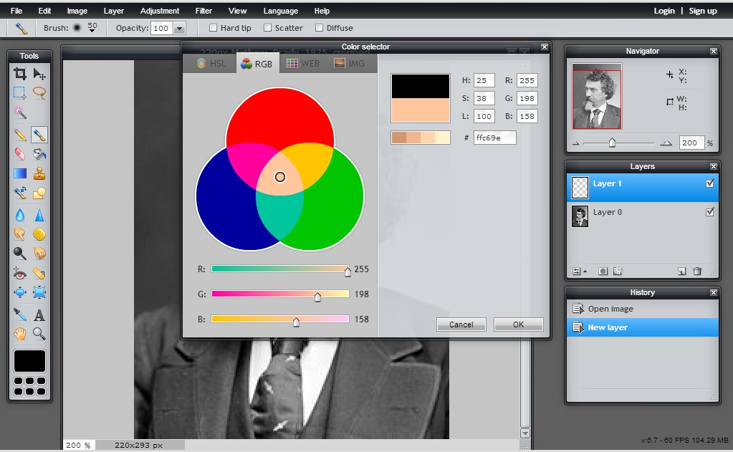

11. Click on the paintbrush tool. Turn the opacity on the paintbrush tool to 50% or lower (see photo below).
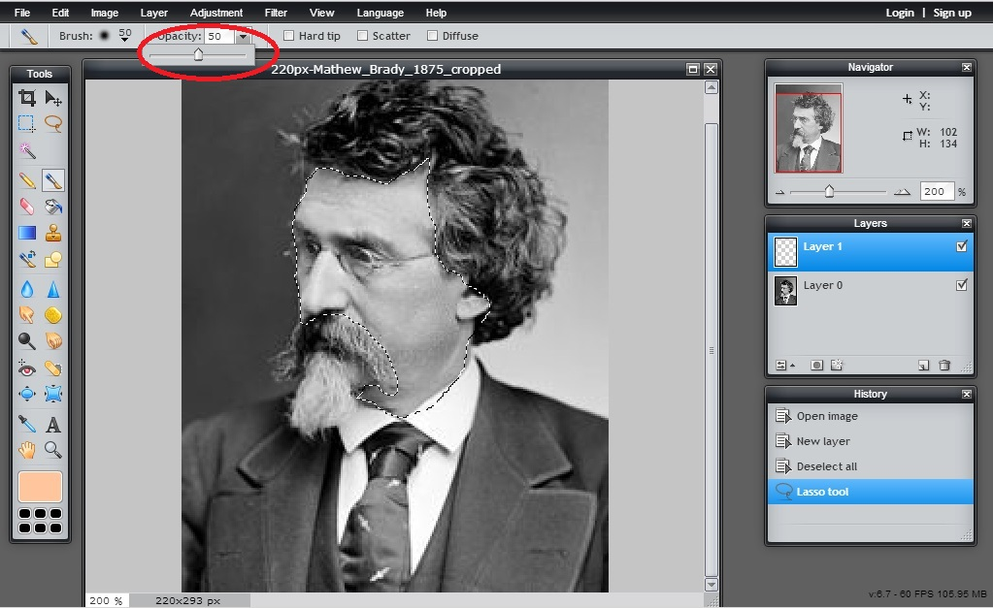

12. Use the paintbrush tool and paint in the area you highlighted with the magic lasso tool.
13. If the color is too dark (you can't see enough of the portrait peeking through), you can play with the opacity of the layer (see photo below).
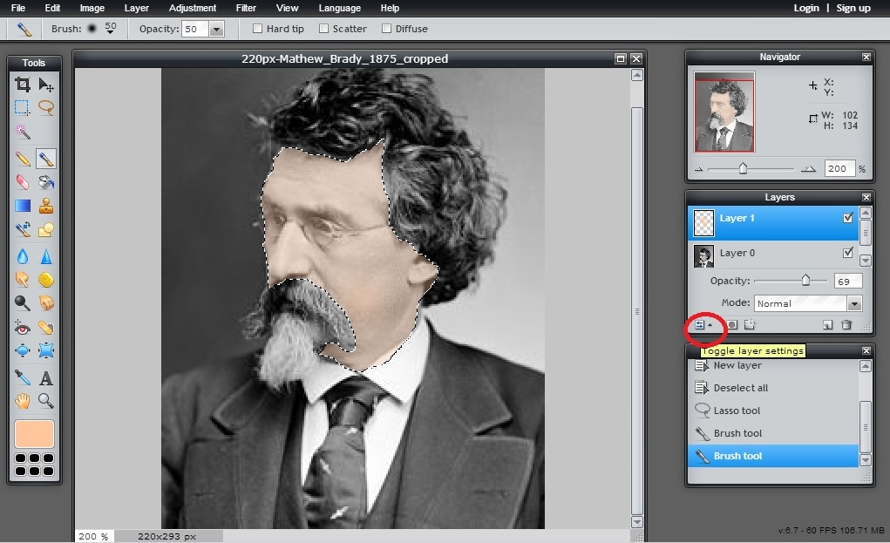

Repeat steps 8-13 until you are finished. Save as your name. SAVE OFTEN. Pixlr likes to crash!!!

