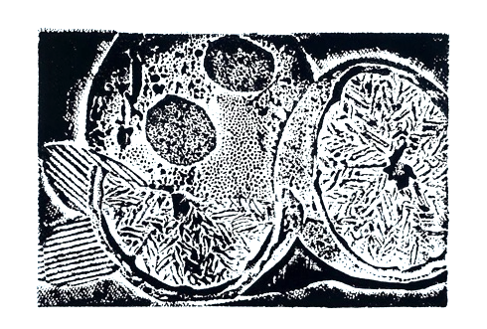
Collagraph

-------------------- printmaking--------------------------------

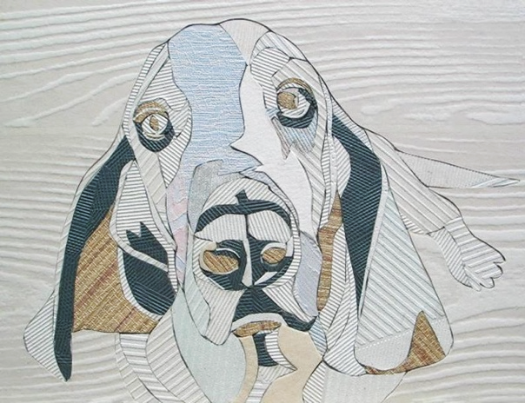
STEPS TO FOLLOW:
- Gather several various textures to use for your collaged plate.
- You may wish to plan out all of the image before you begin, or work organically, arranging the textures as you go.
- Lay out the various textures onto your plate to form your subject. (these can be objective OR non-objective images.)
- You may also use dry-point etching techniques to add details to your plate.
- Glue your textured items to the background.
- SEAL your entire plate and edges with matte medium. (dry overnight)
- Once your plate is sealed and dried, you may ink it up and try out a print. You may need to make adjustments before printing your final images.
- You will need to print 2 black in on white, 2 black ink on color paper, 1 using colored tempera, and at least 1 manipulated image.

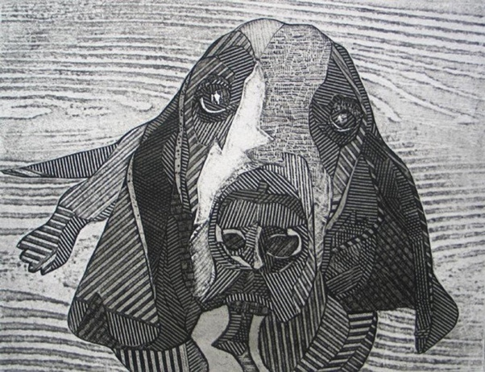

Student Name:  Lesson: Collagraph Printmaking |  |  | Class Period:
Circle the number in pencil that best shows how well you feel that you completed that criterion for the assignment. |  | Excellent |  | Good | Average | Needs Improvement
Criteria 1 – Texture Variety at least 3 different textures are used effectively within the print. |  | 10 |  | 9 – 8 | 7 | 6 or less
Criteria 2 – Composition: good use of positive/negative space. Subject matter fills the space and there is a good focal point. |  | 10 |  | 9 – 8 | 7 | 6 or less
Criteria 3 – Values: values are created with the different textured items. Values also created by the amount of ink left on the plate. |  | 10 |  | 9 – 8 | 7 | 6 or less
Criteria 4 – Printing Technique – Print is evenly covered with ink. (not too much or too little ink used) Print is registered carefully in the center of the paper. |  | 10 |  | 9 – 8 | 7 | 6 or less
Criteria 5 – Effort: took time to develop idea & complete project? (Didn’t rush.) Good use of class time? |  | 10 |  | 9 – 8 | 7 | 6 or less
Criteria 6 – Craftsmanship – Neat, clean & complete? Skillful use of the art tools & media? |  | 10 |  | 9 – 8 | 7 | 6 or less
Total: 60  (possible points) | Grade:

Not Recommended

- Sharp objects (tacks, etc)
- Glass
- Hard Metal objects (keys, etc)
- Ceramic objects
- Highly 3D and hard objects

Collagraph Printing Materials

Some materials are better than other for collagraphs. If you use a printing press, some items may damage the press or press blankets and are not recommended for use.
Recommended

- Fabric
- Tape—can be cut into any shape
- Cardboard—corrugated or not (old cereal boxes are great)
- Sponge pieces
- Soft plastic objects (straws, plasticware)
- Textured papers (wall paper samples work well)
- Drawing paper
- Watercolor paper
- String/yarn
- Matte board scrapes
- Puzzle pieces
- Other relatively flat and softer objects

