Student Name:

Lesson: Collaborative Collage
Circle the number in pencil that best shows how well you feel that you completed that criterion for the assignment. |  | Excellent | Good | Average | Needs Improvement
Criteria 1 – Overall Design Composition: Successful overall composition. Student filled the square and didn’t overwhelm the negative space. |  | 10 | 9 – 8 | 7 | 6 or less
Criteria 2 – Shape Collage: A simple shape or shapes were well used as the focal point and cut out of newspaper. Brown paper added if needed. |  | 10 | 9 – 8 | 7 | 6 or less
Criteria 3 – Line Design & Values. Student utilized the sharpie to add interest with line designs. Lines help the shape or shapes stand out. Lines and/or Values used with colored pencil to make shapes stand out and add interest. |  | 10 | 9 – 8 | 7 | 6 or less
Criteria 4– Effort: took time to develop idea & complete project? (Didn’t rush.) Read the article and followed the steps within. Good use of class time? |  | 10 | 9 – 8 | 7 | 6 or less
Criteria 5 – Craftsmanship – Neat, clean & complete? Skillful use of the art tools & media? |  | 10 | 9 – 8 | 7 | 6 or less
Total: 50  (possible points) /50 pts | Grade:
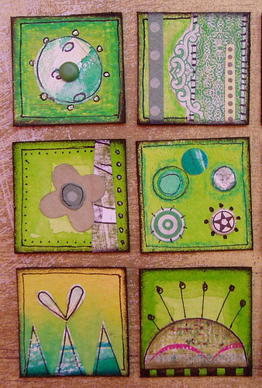
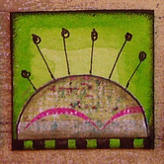
-Simple design collage & line drawing-------------------------------------
Requirements:

Objective: Create a simple design on a square watercolored paper.

You must include the following:

- A shape cut from newspaper. (Just black and white, no color.)

- Line design with thin sharpie.

- Add lines and/or value shading with colored pencil. (use the color of your background or one color next to it on the color wheel.)

- Be sure you have created an interesting, yet simple design that will be a unique addition to the collaborative artwork.

