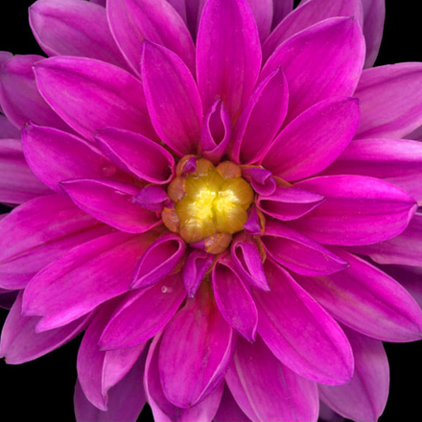

Summer Assignment

AP Drawing/2D Design

In preparation for all of the works that you will create next year, this summer I DARE you to a drawing and photo challenge! Have fun with this and if you decide to post any pictures to social media, use #KellArt and #cobbartrocks. Email me anytime with questions- Julie.denison@cobbk12.org

**Drawing Ideas**

Part 1: Drawing Challenge

1. Buy a new sketchbook or find a book to use as an altered book. It must be no smaller than 8.5” x 11” in size. We will use this all next year!
2. Complete 10 INVOLVED, LAYERED & INTERESTING drawings.

Look at this list of ideas or

search “altered book ideas”

on Pinterest or Google for inspiration.

Use **AT LEAST TWO IDEAS** for each of your ten drawings! Make sure each drawing has a focal point and shows a full range of value. You may use any media!

1. The offspring of two improbable animals
2. An unfit means of travel
3. An unlikely candy
4. A mysterious device
5. A monster performing a mundane task
6. A liquid in motion
7. An outlandish house
8. A science project gone wrong
9. Any word as graffiti
10. Something zombified
11. A make believe occupation
12. An animal with superpowers
13. An unlikely pair
14. A treehouse
15. A destructible force
16. Something on fire
17. Something breaking
18. Someone as you really see them
19. An action scene
20. You in 10 years
21. Your views on religion
22. Hope for the future
23. Your first love
24. Where you’d like to visit
25. Your earliest memory
26. Musical interests
27. Highs and lows of your life
28. Someone who fascinates you
29. A big problem
30. Something you miss

Part 2: Photo Challenge

Use your phone and take 20 photos using the prompts below. Create really **dynamic/ interesting compositions** and don’t forget to edit!

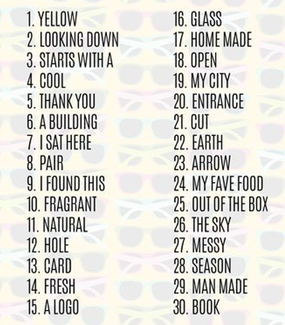

**P**

**H**

**O**

**T**

**O**

**I**

**D**

**E**

**A**

**S**

Part 3: Research

**Research!** Visit the AP Central website for the portfolio you are submitting **often** to see sample portfolios and to become familiar with requirements. [http://apcentral.collegeboard.com/studio2d](http://apcentral.collegeboard.com/studio3d) or <http://apcentral.collegeboard.com/studiodrawing>

**List 10 ideas for a series of work** (whereby the artworks are connected to one another by style, medium or imagery/theme etc) Think very seriously about what you would like to do for your Concentration. – (The third section of your portfolio). Your Concentration MUST be something PERSONAL to you- Something that you will enjoy spending a great deal of time working on and exploring. A concentration must show development of thought and depth in a related body of artworks. List these in your visual journals.