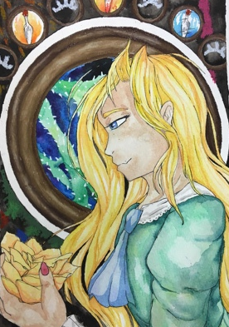
Alphonse Mucha

-------- Decorative Watercolor Painting -------------------------------------

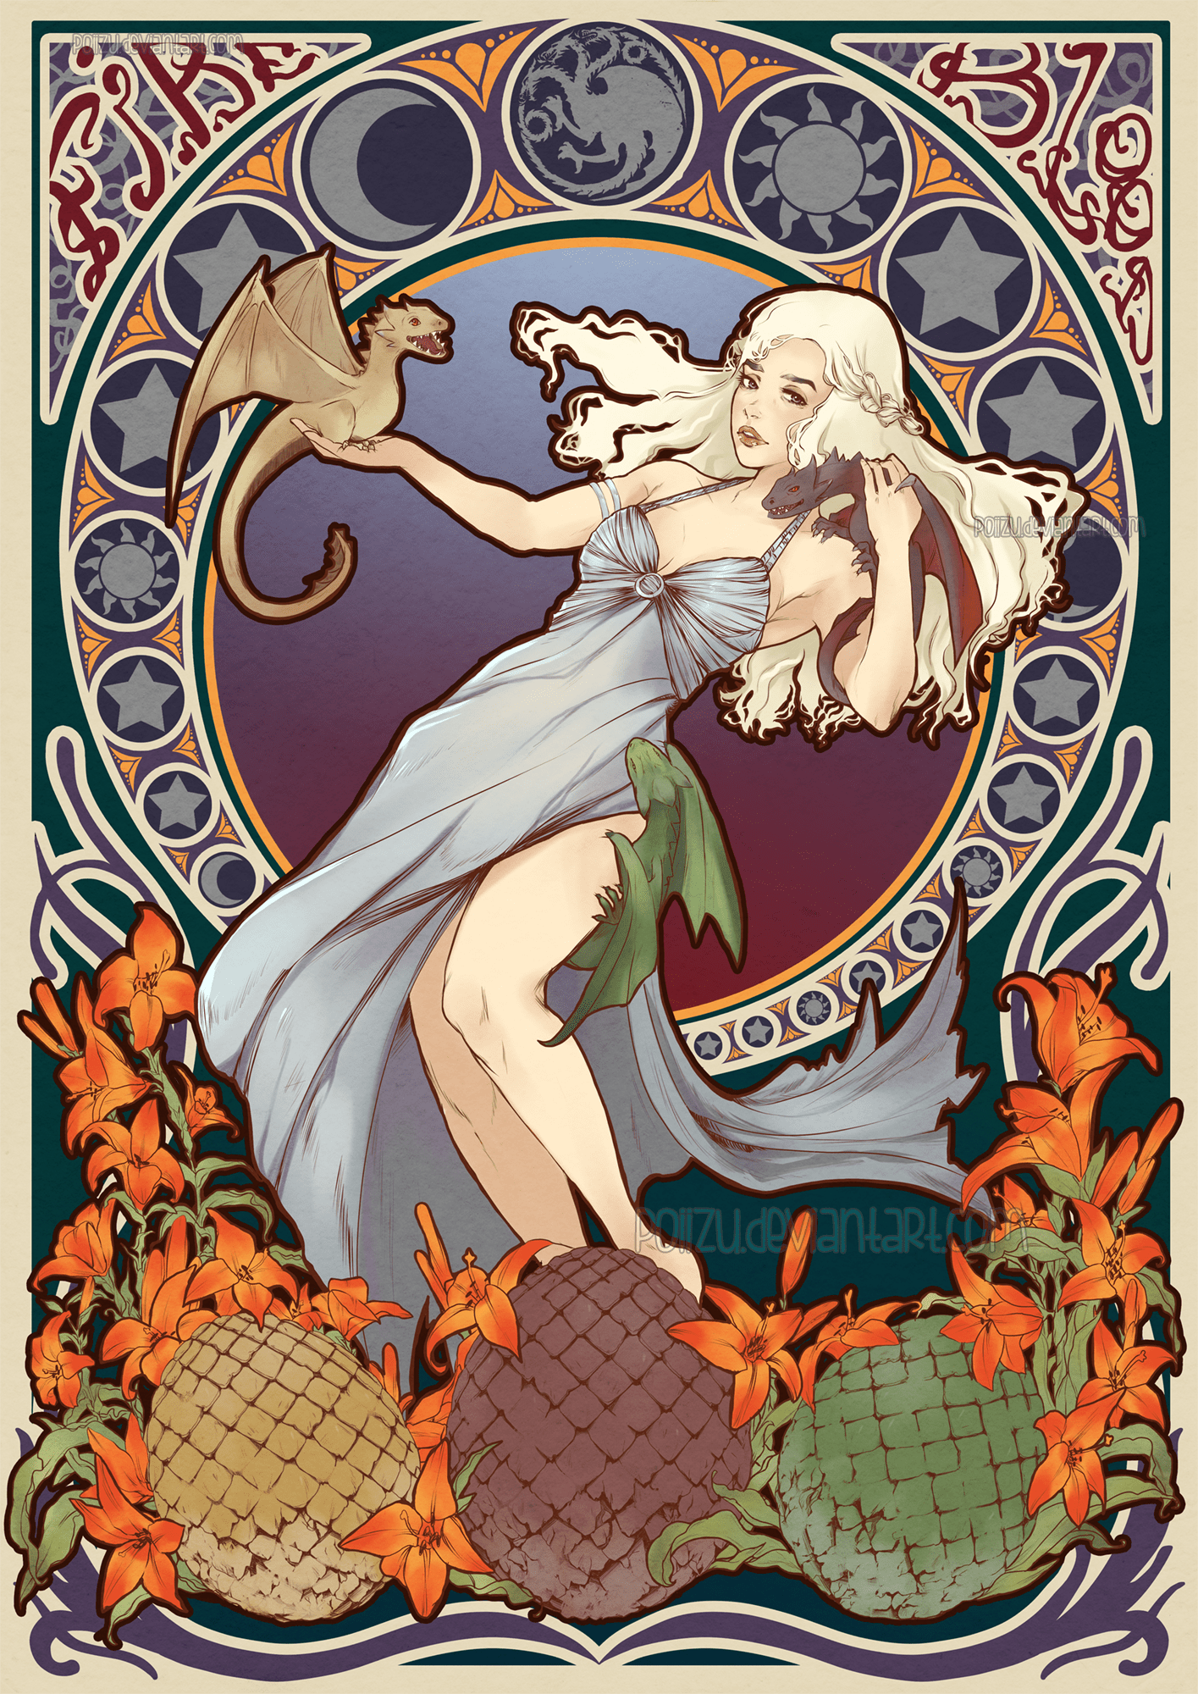
STEPS TO FOLLOW:
- Select a figure from pop culture, literature, fantasy, or even a friend’s portrait. Collect several images to refer to as well as symbols of that figure or subject matter.
- Next, create at least two thumbnail sketches combining some of the decorative imagery of Alphonse Mucha with your subject matter and symbols.
- Then you will pick the most successful to draw out carefully on watercolor paper. (must be highly decorative)
- Outline your image with various thicknesses of sharpie marker.
- Then add watercolor within to create the values within the image. Be sure to have a range of values dark, medium and light within the watercolor.
- Other media can be added to enhance the values such as water-soluable colored pencils or oil pastels.
- When finished fill out the rubric and turn in to Mrs. Denison.

Student Name:

Lesson: Alphonse Mucha Inspired Painting
Circle the number in pencil that best shows how well you feel that you completed that criterion for the assignment. |  | Excellent | Good | Average | Needs Improvement
Criteria 1 – Composition: Overall composition is includes a figure and adequately fills the negative space. Placement of figure and other imagery in most interesting way possible. |  | 10 | 9 – 8 | 7 | 6 or less
Criteria 2 – Figure: Student used a photograph that they took to get proper proportions for the figure. (Other reference can be used if needed) |  | 10 | 9 – 8 | 7 | 6 or less
Criteria 3 – Incorporation of Decorative imagery. Student utilized MANY decorative designs, inspired by Art Nouveau, which are used throughout.. |  | 10 | 9 – 8 | 7 | 6 or less
Criteria 4 – Painting: Student used watercolors on the figure and other paint or mixed media on the decorative elements. Paint or other mixed media creates value range within the color |  | 10 | 9 – 8 | 7 | 6 or less
Criteria 5 – Effort: took time to develop idea & complete project? (Didn’t rush.) Good use of class time? |  | 10 | 9 – 8 | 7 | 6 or less
Criteria 6 – Craftsmanship – Neat, clean & complete? Skillful use of the art tools & media? |  | 10 | 9 – 8 | 7 | 6 or less
Total: 60  (possible points) /60 pts | Grade:

