Abstract Photo Composition

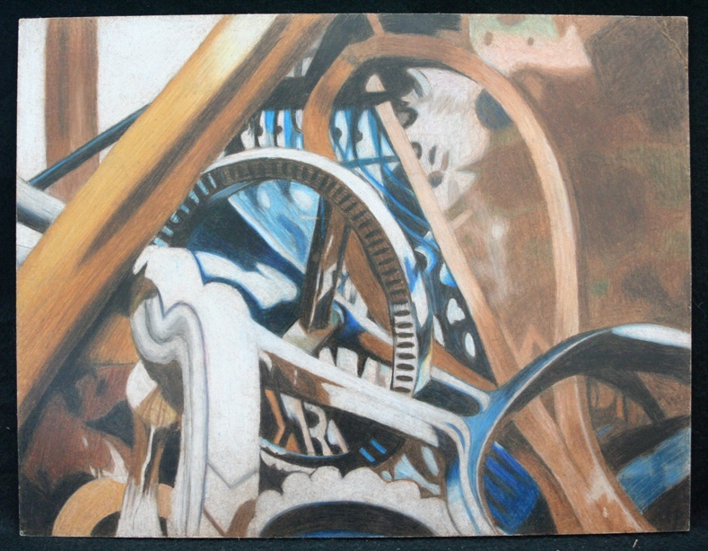
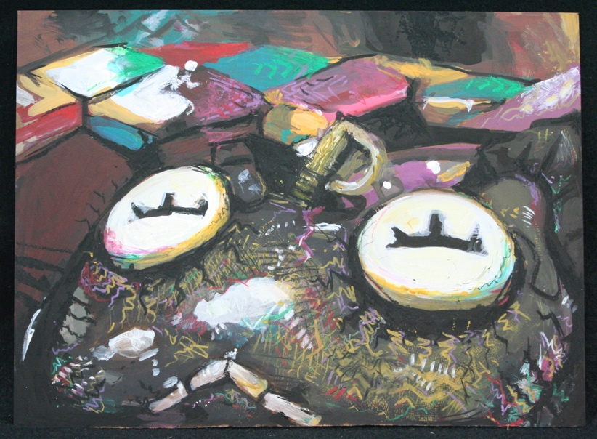
- Students will take at least 5-10 photographs of ordinary objects, taken so close the objects become abstracted.
- Students will pick the best composition to use on the hardboard surface.
- Students will use paint and texture techniques to add color and values.
- Other mixed media may be used on top of the paint and texture such as oil pastel, collage, or colored pencil.

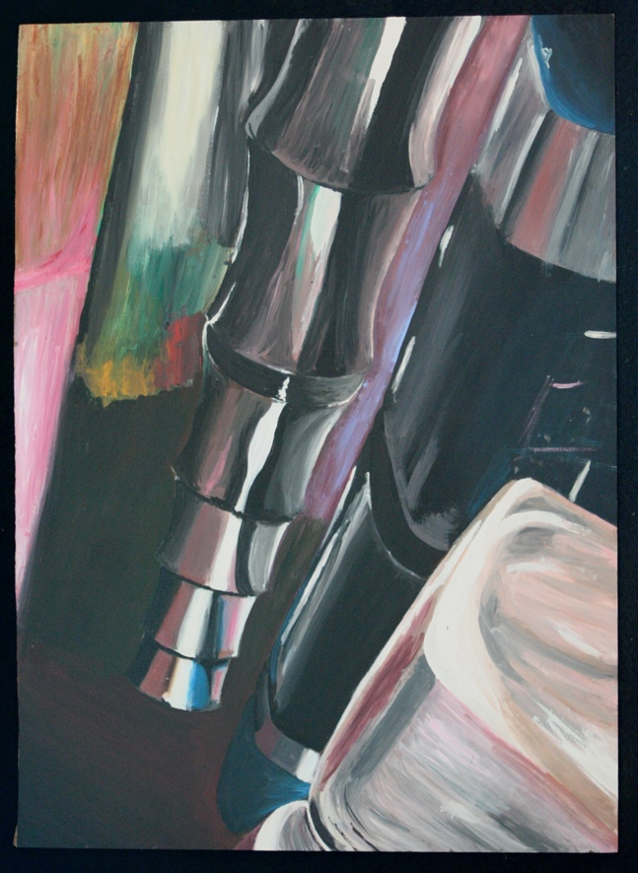
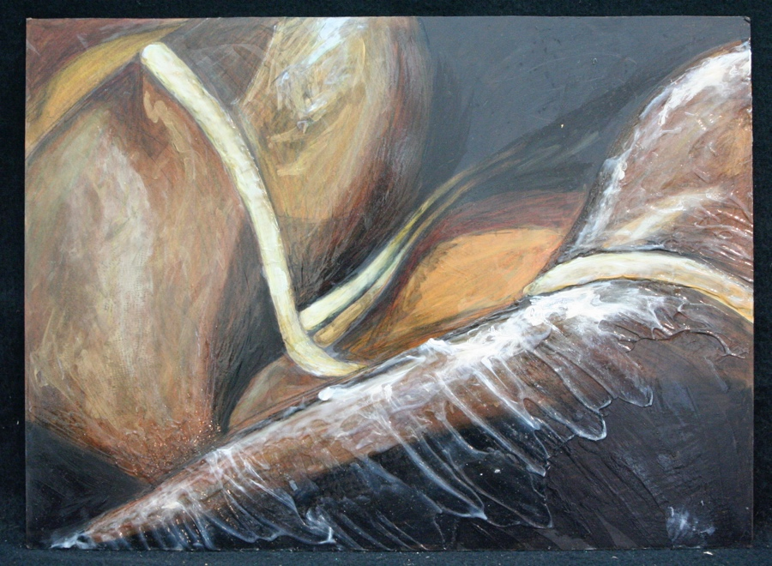

Student Name:

Lesson: Abstract Photo composition
Circle the number in pencil that best shows how well you feel that you completed that criterion for the assignment. |  | Excellent | Good | Average | Needs Improvement
Criteria 1 – Composition: students chose an interesting photo with depth and a good focal point. |  | 10 | 9 – 8 | 7 | 6 or less
Criteria 2 – Proportion: The students used the grid method to enlarge the photograph and create accurate proportions. |  | 10 | 9 – 8 | 7 | 6 or less
Criteria 3 – Paint/ Values: Students mixed colors accurately to match their chosen photograph. Students mixed both light and dark values to match the values within the photo. |  | 10 | 9 – 8 | 7 | 6 or less
Criteria 4 – Texture: Students used at least one method to add texture to their final image: gel medium, collage/ tissue paper or paper towel, stamping, brushwork, mark-making. |  | 10 | 9 – 8 | 7 | 6 or less
Criteria 5 – Effort: took time to develop idea & complete project? (Didn’t rush.) Read the article and followed the steps within. Good use of class time? |  | 10 | 9 – 8 | 7 | 6 or less
Criteria 6 – Craftsmanship – Neat, clean & complete? Skillful use of the art tools & media? |  | 10 | 9 – 8 | 7 | 6 or less
Total: 60  (possible points) /60 pts | Grade:

