Student Name:
Assignment:
Abstract Expressionist Subtractive Sculpture
Circle the number in pencil that best shows how well you feel that you completed that criterion for the assignment. |  | Excellent | Good | Average | Needs Improvement
Criteria 1 – Overall form: has a strong sense of movement and at least 2 piercings. |  | 10 | 9 – 8 | 7 | 6 or less
Criteria 2 – All Sides: carving is done from all sides, each side is unique, (not a mirror image of the first). |  | 10 | 9 – 8 | 7 | 6 or less
Criteria 3 – Emotion shown in sculpture: Your choice if color and movement carved into the sculpture helps to emphasize your chosen emotion. |  | 10 | 9 – 8 | 7 | 6 or less
Criteria 4 – Effort: took time to develop idea & complete project? (Didn’t rush.) Good use of class time? |  | 10 | 9 – 8 | 7 | 6 or less
Criteria 5 – Craftsmanship – Neat, clean & complete? Skillful use of the art tools & media? |  | 10 | 9 – 8 | 7 | 6 or less
Total: 50 x 2  (100 possible points) | Grade:
Directions:
- First read the article on Alberto Giacometti and fill out the Artist’s Profile on Giacometti using the information gained from the article.
- Next, sketch out some ideas for your own Giacometti inspired figure in the space provided on the back of this sheet. (no fewer than 3 sketches)
- Remember, you may add props to your figure as long as your figure is elongated like Giacometti’s figures.
- Then, you will okay your final sketch with Ms. Cooper.
- You will get two wire hangers, one for the head, shoulders, and arms, one for the body and legs.
- You will then cut out a torso, hands and feet with scraps of cardboard.
- Put these together with small strips of masking tape.
- You will then use papier-mâché to add texture to the armatures.
- Once the papier-mâché has dried, we will glue the sculptures to the base, and paint the sculptures black.
- Last, we will rub a metallic paint onto the sculptures to give it a “finished” look.
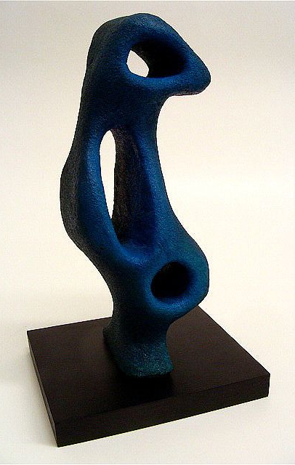
- Create a free-form practice sculpture with tools.
- Visual Journal sketches/ Thinking and planning questions.
- Show emotion through type of line/shape:
  - rounded, curved lines & shapes= happy/pleasing emotions
  - jagged, angular lines & shapes= angry/unhappy ones,
- In sketchbook, do at least 2 thumbnail sketches for a design for your sculpture. **MUST have at least 2 HOLES
- Draw out design on foam, sculpt from all sides to carve out your design
- Smooth it out with fingers or sandpaper
- Cover with watered down glue.
- Paint with acrylic paint

Abstract Subtractive Sculpture

